**The Perils and Possibilities of Digital Imaging**

The inclusion of Digital Imaging at the Foundation level offers a rich array of new visual and conceptual possibilities. The value studies done in a traditional drawing class take on new meaning when the implications of theatrical lighting are discussed. Interior spaces can be seen as settings for dramatic action, and gesture studies can be used to explore and choreograph movement.

First-year students generally love working with sequential imagery and are fascinated by digital imaging. Raised on movies, television, comic books and the Internet, they often find it natural to express their ideas through multiple images.

As a new addition to a traditional curriculum, digital imaging may seem daunting at first. Few of us have extensive experience in this area and we rarely have a familiar model on which to develop a complete course. As demonstrated by the following assignments, however, specialized equipment is not necessary and all of us already have the basic skills needed to teach time design effectively.

The following strategies can help you get moving:

1. Start where you are. If you are a painter, consider the temporal of drawing, such as

• Changes in light due to the passage of time

• Simultaneous actions within a single setting

• The implications of body language

If you are a sculptor, consider:

• Ways in which sequential experiences create conceptual content

Objects at rest and objects in motion

• Presence and absence; permanence and decay

• Ways to compress and expand both time and space.

If you are a graphic designer, explore:

• Juxtaposition as a way to heighten communication

• The advantages of very large or very small scale

• Public and private narratives

• Relationships between the audience and the artwork.

2. Use what you’ve got. If your classroom is equipped with tables, chairs, and a photocopier, explore time using storyboards, simple performance works, and visual books. If you have access to a computer lab, work with iMovie or PowerPoint to create simple sequences with temporal variations. If you have video equipment, encourage students to record their impressions and experiences in a “video sketchbook,” which can then be manipulated to create simple narratives.

3. Get help. If you are unfamiliar with specific equipment, get help from technical support personnel, your colleagues, or your students. Someone is sure to know how to use each basic piece of equipment.

4. Try it yourself. Make a sample design yourself before trying it out with your students. Direct experience is the best way to debug the problems, consider ways to critique the results, and determine the best timing for the assignment.

5. Have fun. Enthusiasm is infectious. When you are exhilarated by new ideas and fresh experiences, your students are likely to forgive your mistakes and support your initiatives.

sample syllabus: ART 1602: DIGITAL IMAGING FOUNDATIONS Syllabus

**ART 1602: Section 10, FALL 07 Monday/Wednesday 9:05-11:35, FAB 107**

Professor Jane Doe jdoe@fsu.edu Office Hours: Monday/Wednesday 11:45-12:30

**Course Description:** Introduction to the theory and practice of digital imaging and the basics of time-based art and design. Fulfills computer competency requirement for art majors.

**Class Format:**

Studio course, including hands-on work, critiques, demonstrations, and presentations.

Technical skills are most meaningful when paired with imagination, and this course will actively advance both. Throughout the semester, the instructor will consistently be pushing towards an integration of these new skills with the interests and ideas that are important to you as an individual.

**Course Objectives**: Upon successful completion of this course, you will be able to:

* Use basic vector, raster, layout, and video editing programs effectively;
* Effectively combine elements of temporal organization to create narrative and associative compositions;
* Effectively utilize the power of juxtaposition, implication and metaphor;
* Employ collaborative as well as individual approaches to creativity;
* Speak and write critically about personal and peer artworks and propose alternatives.

**Major Questions** for this course include:

* How are digital images constructed?
* How can ideas be expanded using digital means?
* What are the characteristics of time and how can they be visually manipulated?
* What is narrative and how many ways can it be used in art and design?
* What is non-narrative time design and when is it most effective?

**The Bottom Line**

Classes within the Art Department are unique within the University system in that you are actively encouraged to discuss and critique the work of your peers and to cite areas where it excels, and where it needs improvement. To achieve this, as participants in the class, we build an environment of trust, honesty, and strong listening skills. This course has a heavy workload. If your schedule is heavy, drop the course now. The class will require at least 6 hours of work outside of class time per week.

**Recommended Readings:**

Launching the Imagination: A Comprehensive Guide to Basic Design by Stewart, Adobe Photoshop CS2 Studio Technique (2005) by Willmore, Film Art by Bordwell and Thompson,

**Assessment Criteria:** Grades will be based on three major factors.

* Skill acquisition and application. Based on the assignments you complete, how confidently and effectively can you use a range of computer skills and compositional strategies? (40% of grade)
* Idea Development. Based on the sketches, rough drafts, and problem-solving proposals you submit, how many compositional possibilities did you invent? What range of ideation strategies are you using in creating effective work? (35% of grade)
* Learning Process. Based on attendance and participation, are your contributions to brainstorming sessions and critiques substantial? Do you take risks? (25% of grade)

Each art and design project presents its own unique challenges. The most “effective” solution is the one that most fully communicates your ideas.

Attendance: Attendance is required. Your grade will drop by one letter for every unexcused absence beyond three. It is impossible to fully “make up” missed demonstrations or critiques, and getting the information second-hand is inadequate. Arriving late also derails learning. If you miss more than 8 hours of class for any reason, you are likely to receive a final grade of C- or below. For details on University approved excused absences, go to: <http://www.fsu.edu/~fasenate/attendance.html>.

**Grades will be defined as follows:**

A = Outstanding competence. Expansive investigation of ideas; excellent composition and/or construction. All assignments completed on time, with at least one extra credit project done well. Insightful contributions to critiques. Goes well beyond minimum requirements.

B = Above average competence: Substantial investigation of ideas, very good composition and/or construction. All assignments completed on time, good contributions to critiques.

C = Average competence. Assignments done competently and completed on time.

D= Marginal work, due to two or more late projects, limited investigation of ideas, poor craft, incoherent compositions, minimal contribution to critiques. May have more than 3 absences.

F = Unsatisfactory work. Course failure due to minimal idea development, poor craft, disjointed compositions, lack of participation, late assignments. May have over 6 absences.

**Note**: One project will be accepted one day late without penalty. One additional late project will be accepted with a one letter-grade penalty for each day it is late.

**Incompletes**: A grade of Incomplete can only be assigned to students with an otherwise passing grade who are unable to complete the course due to some serious illness or personal tragedy. Incompletes are not given lightly.

**Attention**: Please silence your cell phone during class. If you are in the midst of a family crisis (such as a parent in the hospital), put it on vibrate and let me know that you may have to leave during class.

**ACADEMIC HONOR POLICY.** The Florida State University Academic Honor Policy outlines the University’s expectations for the integrity of students’ academic work, the procedures for resolving alleged violations of those expectations, and the rights and responsibilities of students and faculty members throughout the process.  Students are responsible for reading the Academic Honor Policy and for living up to their pledge to “. . . be honest and truthful and . . . [to] strive for personal and institutional integrity at Florida State University.”  (Florida State University Academic Honor Policy, found at <http://dof.fsu.edu/honorpolicy.htm>.)

**AMERICANS WITH DISABILITIES ACT (ADA):**

**IF THERE IS ANYONE WHO NEEDS AN ACCOMODATION DUE TO A DISABILITY, PLEASE BRING IT TO THE INSTRUCTOR’S ATTENTION.**

Students with disabilities needing academic accommodation should:

1. register with and provide documentation to the student Disability Resource Center;

2. bring a letter to the instructor indicating the need for accommodation and what type. This should be done during the first week of class.

For more information about services available to FSU students with disabilities contact the

Student Disability Resource Center, 97 Woodward Avenue, South, Florida State University, Tallahassee, FL 32306-4167 (850) 644-9566 (voice) (850) 644-8504 (TDD) sdrc@admin.fsu.edu http://www.fsu.edu/staffair/dean/StudentDisability/

(This syllabus and other class materials are available in alternative format upon request.)

**Basic Supplies:**

• An inexpensive digital camera • fine point felt pen

• At least 6 blank CD-R disks • 9”x12" or 11”x14" sketchbook

• portable storage device (mini flash drive or portable hard drive)

Other studio materials of your own choice for stop motion assignments

* + - * + **Meeting computer competency requirements:**
        + The final portfolio will consist of four basic projects and a capstone experience. We will focus on idea generation and use storyboarding throughout. The assignments will be as conceptually complex as possible, while the technology required will be as accessible as possible.

#### Course Information

Announcements, current photography exhibits, syllabus, resources, and several critical readings are posted on the online Blackboard site for this course. Students are required to remain familiar with the content of this evolving website. For login, go to https://campus.fsu.edu/webapps/login

**Proposed Lectures**

* Lecture 1: The Nature of the Digital
* Lecture 2: Basic Raster Techniques
* Lecture 3: How Things Move
* Lecture 4: Image and Narrative; The Kuleshov Effect and Montage Editing
* Lecture 5: Framing; Composition in Space *and* Time
* Lecture 6: Modeling Space with Light; Basic 3-point Lighting for Lens work
* Lecture 7: Digital Sound Synthesis, Recording, and Editing
* Lecture 8: Digital Media Formats; AVI to ZIP
* Lecture 9: Minimal Web; Publishing on the Web with Bare-Bones Tools

SAMPLE ASSIGNMENTS FOR DIGITAL IMAGING FOUNDATIONS

We anticipate that both student competence will vary substantially from section to section of this course. Thus, as long as basic objectives are met, we encourage instructor invention of a range of pedagogical approaches. Examples follow.

Assignment #1:THE PARTS AND THE PUZZLE

Focus: Introduction to Digital Imaging through organization of a set of visual components.

**Example A: BREAKOUT**

**Problem:** Working with a curvilinear shape, a line, and a simple rectilinear shape, create a minimum of 8 compositions within a 3:4” format.

**Objective:** This assignment requires imaginative thinking within strict limitations. You will be put in a box, then invited to break your way out. Seek to

* create the widest possible range of solutions while meeting the limitations
* use negative shapes to increase compositional complexity
* fully engage every square inch of the composition.

**Result:** Final studies will be done digitally, using Adobe Illustrator

**Strategy:**

First, be sure you understand the game rules.

* Any type of curvilinear shape can be used, from a circle to an amoeba. Any type of line can be used. The rectilinear shape cannot have more than ten perpendicular angles.
* You must use the same three components in each study. Thus, if you choose a jagged line for the first study, a jagged line must be used in all subsequent studies. If you choose a square for the first study, a square must appear in every study.
* 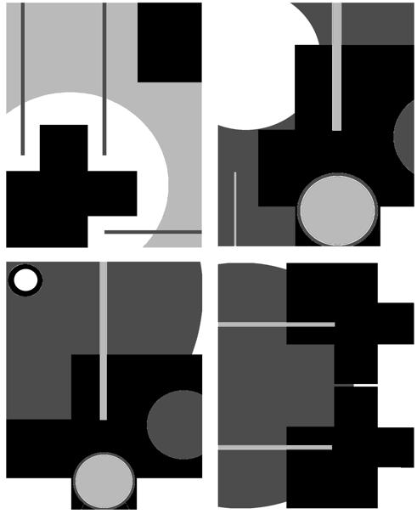Any component can be multiplied as needed. For example, you could have 2 squares, 2 circles, and two straight lines in one of your studies. However, do not exceed a total of 6 positive shapes.
* Any component can be enlarged or reduced as needed.

There are two equally effective approaches to this assignment.

1. Develop at least 20 ideas via thumbnail sketches, choose the best 8, then finalize, using Illustrator.

2. Invent your basic component (the 2 shapes and the line), then move directly to Illustrator to begin organization. Rough out at least 20 ideas on the computer, then refine the best 8

**Notes:** Buckminster Fuller, one of the most influential of American designers, described design as “the character of the organization of relationships.” Thus defined, individual components are less important that the interdependent means by which they are organized.

This assignment gives you experience with the design process as well as a design product. The seemingly intractable limitations can actually be used to stimulate creative thinking, as you seek to “break out” of the box.

**Projected Timetable:** 2 weeks

**Lectures**: The Nature of Digital Imaging **Demo**: Vector Basics: Introduction to Illustrator

Example B: TEXT/IMAGE SYMBIOSIS

**Problem:**

Step 1: Using images provided by instructor, complete three 8x10” images, exploring proportional relationships between a single figure and line of text or a sequence of numbers.

Step 2: Expand on the above, adding a second image, to provide a setting. Experiment with focus, contrast, and illusion of space

Step 3: As homework, do an expanded version of the assignment, using your own images.

**Objectives:**

* To demonstrate the effect of proportion and juxtaposition on communication.
* To introduce the basics of Photoshop, including scaling, cut/paste, degrees of definition.

**Result:** Final studies will be done digitally, using Adobe Photoshop.

**Strategy:**

1. Choose a dramatic photograph and a line of text or sequence of numbers. If you wish, the text and numbers may have a direct relationship to the photograph.

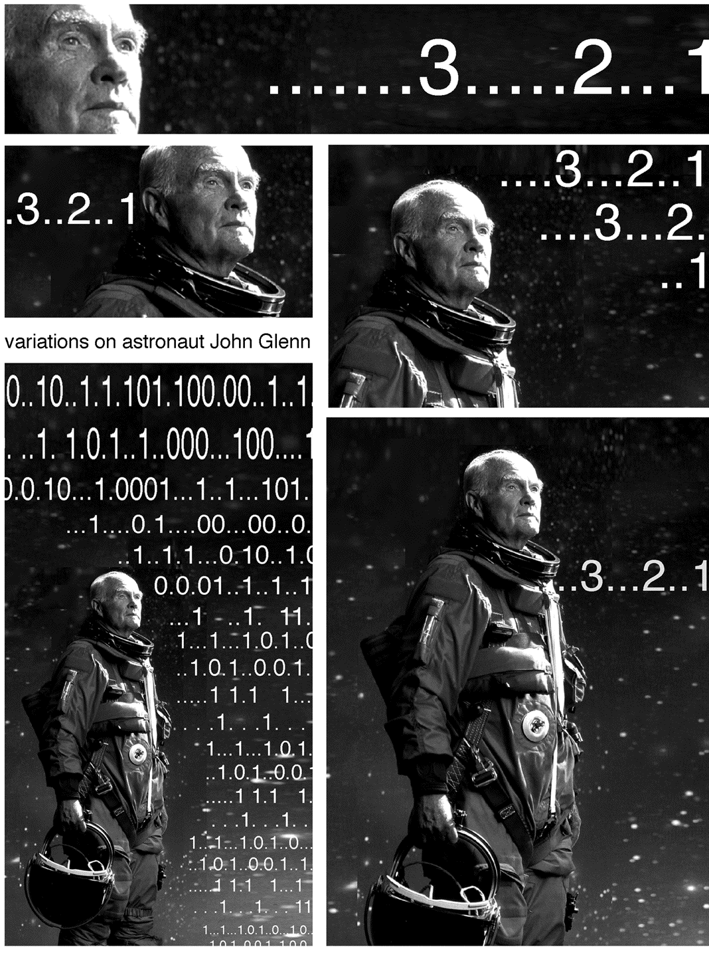2. Generate a wide range of variations. Try working with a very large figure and very small numbers; try using large numbers and a small figure; try overlapping the figure and the numbers. What happens when an extreme close up of a man’s ear is combined with 14-point type? What happens when a tiny figure is shown in silhouette surrounded by the same sequence of numbers in 48-point type? Repeat the text or numbers as necessary to create the most intriguing results.

3. Complete at least 6 rough variations, then finalize the 3 best and print them on good paper.

4. Enlarge one or two of the designs to 11x17" to demonstrate the effect of scale on communication.

**Notes:** Limiting the variables to a single figure and a single phrase or sequence of numbers helps to demonstrate the direct impact proportion has on communication. Enlarging or reducing a design can demonstrate the impact of scale. Encourage students to choose their texts carefully. Brevity is a virtue!

**Timetable:** 2 weeks

**Lecture**: Basic Raster Techniques

**Demo**: Scanning

Assignment #2: COLOR AND COMMUNICATION

Focus: Use of digital variations to explore a range of color harmonies and uses.

**Example A: POSTAGE STAMP FOR AN INVENTED COUNTRY**

**Problem:** Using Illustrator, design 4 postage stamps for a country you invent. Include the country name and a price within the stamps.

**Objectives**:

* Master basic methods of research;
* Demonstrate understanding of the role of the boundary in design;
* Expand ideas through variations on a theme.
* Learn color vocabulary and use various forms of harmony and disharmony effectively.

**Strategy:**

1. Invent your country. Using actual countries as a point of departure, make a list of its characteristics: location, climate, chief export, topography, political system, cuisine, national sport, major literary figures, etc. Your “country” can also be a virtual community or an interest group, such as chess players. Give your country an appropriate name.

2. Given these characteristics, what type of stamp is right for your country? Experiment with circular, triangular, and square formats as well as the more familiar rectangle.

3. When you have the basic designs down, experiment with traditional forms of color harmony, including monochromatic, analogous, complementary, and triadic schemes, and with disharmony. What is most effective?

**Reading**: Chapters 2, 6 and 8. Launching the Imagination **Timetable**: 2.5 weeks

**Example B: AMERICAN DREAMS: LOST, FOUND, AND RE-WRITTEN**

**Problem:** Create an 11x17” color poster commenting on some aspect of American society

**Objectives**:

1. See and effectively use visual metaphor
2. Learn the role of visual research
3. Acquire critical thinking skills and express these skills both visually and verbally
4. Relate text to image both aesthetically and conceptually
5. Learn about design process. Use a sketchbook or loose-leaf notebook to keep a record of your ideas and research.

**Process**

1. Brainstorm 3 critical issues. What do you see in the world around you that is not the way it should be? Avoid overworked national issues, instead open your viewers eyes to some peculiarity that they may not have thought about before; they will be more receptive to your message if they haven’t already developed an opinion about it. Consider:

* What’s amiss in American society?
* What do people think about America that isn’t true? What is all too true about America?
* What do I see that should be, but isn’t?

2. Group brainstorming for issue selection. Select the most promising issue by asking yourself: does it ring true? (or all too true), is it unique? what ideas are really thought-provoking?

3. Do visual research to determine the visual metaphors associated with your issue.

4. Match your concept with one or more principles of design. What compositional strategies are suggested by the concept?

5. Using the principles of design that you selected, develop sketches. What combination of images would convey your concept most effectively? The image should effectively communicate the concept... no headline yet.

6. Take or find two images that can be combined to convey your message. Look in children’s books, or the library. We aren’t going to publish this poster, so copyright won’t be an issue. Your images must be sizable to 300 dpi. You cannot effectively add dots to an image, so they must be there from the beginning. Some online images will work. You may have to join or pay something for the image, but if it’s a good image, it may be worth it. Your online image must be at least 1000 dots on a side, so do only large image searches. Good sources: iStockPhoto.com, FreeFoto.com, Corbis.

7. Bring the images into Photoshop by scanning or using digital images. The poster will be

11 x 17, so you must begin working at that size; adjust image quality if necessary. Cut and combine the images to create an image that communicates your concept visually.

8. Look at the image, considering what is unsaid. What quip would let the audience in on the visual incongruity you have created? This will take the form of commentary on the issue rather than a restatement of the message on the poster.

9. Identify the grid in the image, and place the text so that it is compatible with the image.

10. Experiment with various color palettes and choose the most effective for the incongruous situation you are creating.

11. Flatten your image for printing, save as a TIFF, but save the original layered PSD as a separate file. Allow enough time to make adjustments if print quality or color isn’t satisfactory.

Assignment #3: LINEAR NARRATIVE

Focus: Use of digital variations to explore story-telling

**Example A: PIVOT POINTS**: **THE EXTRACTED NARRATIVE**

**Problem**; Starting with Poe’s *Tell-Tale Heart*, Bierce’s *Occurrence at Old Creek Bridge, Severed*, *Theseus and the Minotaur,* or other highly dramatic short story, song, or play create a stop-motion animation between one and three minutes long, responding to the emotions evoked as well as the action depicted. Final result may be descriptive, metaphorical, or highly abstracted. Projects will be done by teams of 3 to 4 participants.

**Objectives**:

* Introduce the basics of narrative structure;
* Identify pivot points. What are the absolute essentials, both for plot and for emotional impact?
* Explore storyboarding as a means of idea development
* Practice effective team-work.

**Reading**: Chapters 14 and 13, Launching the Imagination **Timetable**: 3 weeks

**Lectures**: The Classic Narrative **Demos**: IStopMotion, Quicktime, IMovie

**Example B: CONFLICT RESOLUTION**

**Problem**: Create a dialog or some form of conflict between two opposing forces. What sets the conflict in motion? How is it resolved?

**Objectives**:

* To explore dialectical thinking;
* To expand definition of “forces”--could be between two characters; between two colors, two shapes, etc; between words and music, between light and dark, between artist and audience, etc.
* To expand discussion of temporal construction

Assignment #4: JUXTAPOSITION AND ASSOCIATION

Focus: Create meaning through juxtaposition—of images, texts, and sound

**Example A: WORDPLAY**

PROBLEM: Working in teams of 2 or 3, choose one word for temporal visualization. Explore the definitions, emotions and implications of your word. Using stopmotion and video editing, create the most compelling movie possible, up to 4 minutes in length.

Sample subject words: bridge, barrier, mind, game, blue, karate. silence.

Sample thematic words: identity, loss, community

OBJECTIVES:

* To build basic technical, compositional and conceptual skills;
* To experiment with at least two idea generation strategies;
* To explore the basics of associative editing.

STRATEGY:

1: IMovie basics. Using “stock footage” provided, master IMovie basic tools.

2: IMovie basics. Expand first draft, using sound. Complete at least 2 versions that are substantially different, based on the effects of sound and pacing.

3: Wordplay problem presentation, followed by mind map and emotion expansion brainstorming sessions--see *Launching the Imagination*, C5, for examples. Stopmotion basics presented.

4. Choose your word, begin visual and verbal research, rough out an idea, play with Stopmotion. (Each team will need 2 hours at a Stopmotion station)

5. Discuss results in team meetings; plan and complete final shooting.

6: Edit in IMovie; refine audio.

7: Final draft due. Class critique followed by written self-assessment.

For self-assessment, answer the following questions:

* What is the most compelling aspect of your final piece? What makes it compelling?
* What is the least compelling? What is wrong with it, and how can it be changed?
* Is there anything you would like to add, subtract, and expand in your movie?
* What technical, compositional and conceptual skills do you most need to acquire?
* How do you plan to acquire these skills?

Example B: SOUNDSTAGE

* + - * + **Problem**: Maximum movie length is 3 minutes. Half of the time the screen will be blank: no image. How can sound create a bridge between periods of image and no image? what else can sound do? Work will be done in teams of two or three.
        + **Objectives**:
* To explore types and effects of sound
* To create compelling relationships between visual and audio
* To be relentlessly creative, witty. I am boxing you in: push the limitations set!
  + - * + **Strategy**:
        + Session 1: Lecture/demo on sound; show examples of effective uses. HW: Develop ideas.
        + Session 2: Video basics, including hands-on experiments. HW: Shoot videos.
        + Session 3: Edit and insert audio, with each team-member creating a different “take” on the idea.
        + HW: Complete first draft.
        + Session 4: Critique of work in progress. HW: Complete final draft.

**Assignment #5: Capstone**

Focus: A grand finale to the course

**Example A: DIGITAL PORTFOLIO**

**Problem**: In preparation for an “Early Decision” BFA review, create a digital portfolio consisting of 15-18 static images (from 2D Foundations, Drawing, 3D, your own studio work, etc.) and 3 moving images from this class, plus a one-page resume and a one-page artist’s statement.

**Example B: INFINITE ZOOM COLLABORATIVE ANIMATION**

**Problem:** Create a seamless experimental animation using large-group collaborative methods for generating a time-based artwork.

You will get to collaborate with all the students in the class to create a keyframed animation using the novel technique called "infinite zoom". A conceptual theme should be agreed upon by all participants. The project will include a soundtrack and a credits list for all content included.

**Objectives:**

To create connections, relationships and dialogue among components of the animation;

To create a compelling artwork that is both unified and marvelously varied;

To heighten critique skills, focusing on how each contribution reacts or interacts with each other;

To expand creativity. Just how many variations can be developed within the chosen theme?

**Strategy:**

*Project Phase 1:*

**Establish the theme and soundtrack.**

Since a soundtrack will underlie the animation, students will bring in sample soundtracks (mp3s, etc.) that they think may be interesting to use for the animation. Each student will play excerpts from these and discuss possible themes or stylistic considerations for the project.

After hearing all the participants’ thematic ideas, students should debate and vote to determine the unifying theme and soundtrack. ( special consideration should be give to students who can generate their own soundtracks.)

*Project Phase 2:*

**Rough out concepts and determine linear order among students.**

Students will show thumbnail sketches showing possible visuals following the determined theme. Students should discuss the various conceptual relationships and insights amongst the thumbnails and ideas relating to the theme. Students should ORDER THEMSELVES in a linear fashion, according to possible sequences amongst all the ideas discussed. Each student should discuss ideas and connections between their components of the animation with the students before and after them in the sequence.

Project Phase 3: **Make the artwork.**

Each student generates a Photoshop image 1440x972 pixels in size. This is the students image to create their portion of the animation. Using the fixed rectangular selection tool, designate a 720x486 area within the image where the student **after you** will place their image. Determine and record the CENTER COORDINATE of this inset rectangle. Create a new layer and execute your imagery.

Project Phase 4: **Unify imagery and fix seams between images.**

-Give a copy of your image to the student **before you**.

-Take a copy of the image belonging to the student **after you**.

-Resize their image to 720x480 and place it on a Photoshop layer under your imagery, positioned at the inset coordinates (this is a temp. version only to help you refine your own imagery.)

-Refine the boundaries between the images, extending imagery across the boundaries to obfuscate their harsh rectangular nature. Only work on YOUR layer.

-Delete the reduced size inset layer, so that a transparent hole frames the inset location.

-Collapse your Photoshop file, so only one floating layer contains your imagery. (don't completely flatten!)

Project Phase 5: **Assemble the final animation from the components.**

-Collect all the student's imagery, and compile the sequence of images using FCP, AE, Flash or other video editing software.

-Compile the images according to student order and use the position coordinates from *Project Phase 3* to help determine the zooming keyframes and coordinates.

-Create keyframes, zooming through each layer, and use fades or blurring to help blend any remaining seams between the sequence.

-Adjust transition speeds and durations to best flow with the soundtrack.

-Add credits, titles, etc. and export this animation for final video playback.

**Examples and Links:**

Powers of Ten.wmv (1977 Charles and Ray Eames)

ZoomQuilt IIProject.swf (2007 collaborative project)

http://zoomquilt2.madmindworx.com/

Sito Collaborative Art Organization (http://sito.org)

check out their **gridcosm**:

http://www.sito.org/synergy/gridcosm/gridcosmviewer.swf

**ADDITIONAL DIGITAL FOUNDATIONS AND PHOTO ASSIGNMENTS**

TIME OBSERVED

Inspired by an assignment created by Gail Hoffman, Syracuse University

**Problem:** Sitting quietly for fifteen minutes, fully observe and record your thoughts and notice all of the activity in the world around you. Then, repeat the same process, now walking across campus for fifteen minutes, then returning to the classroom to write down the results.

**Objective:** To heighten awareness of time and space.

**Materials:** Writing pen and paper

**Strategy:** When sitting, it is important to be fully aware of each passing moment. Pay attention to everything—your breathing, the movement of your pen across the paper, the surrounding sounds and any thoughts that you have and any activity that you see. Imagine that this fifteen minutes of time has been deliberately staged for you. Apply the same awareness to your walking mediation but wait until you return to the classroom to write down the results.

**Reading:** Pages 287 to 291 and Zen Mind, Beginner’s Mind- Shunryu Suzuki

**Instructor’s Notes:** Because it is so elusive and pervasive, we tend to take time for granted. This exercise can heighten awareness of time and act as a springboard for an extended group discussion of the aspects and implications of time. In the group discussion it is wise to note the apparent compression or expansion of time based on our awareness of an event, the importance of memory, the effects of anticipation, the importance of deadlines, and so forth.

The meditative process in this assignment has some similarities to Zen practice, which has greatly influenced many artists for the past fifty years, including Bill Viola, Naum June Paik, and Robert Irwin. A slide show of works by these artists can help expand the conceptual possibilities.

**Timetable:** 60-90 minutes of writing and discussion

SEQUENTIAL RELATIONSHIPS

**Problem:** Using stock images provided by the Instructor, create four designs, each containing four to six separate images. Demonstrate your understanding of graphic, spatial, temporal, and rhythmic relationships in these four designs. For this exercise, don’t combine the images to make a collage. Leave a separation between the images to reinforce the idea of sequencing.

**Objective:** To strengthen the composition of multiple image structures through awareness   
of basic visual relationships.

**Materials:** Twenty photocopies (supplied by the Instructor), at least six 4"x18" strips of black construction paper, and adhesive

**Strategy:** First, be sure you understand the four basic relationships under discussion.   
They are described and illustrated on pages 10-3 and 10-4 of the textbook.

Next lay out all of the photocopies and consider ways they can be used to solve the problem. For many people, the graphic relationship is the simplest. For example, an image of a globe, a full moon, the round face of a clock, and the round face of a child are all essentially circles. Don’t glue anything down until you have considered solutions for all four compositions.

For extra credit, try combining categories (such as a spatial and a rhythmic relationship), or invent more complex possibilities of you own.

**Reading:** Pages 291 and 294

**Instructor’s Notes:** This problem goes very quickly if you bring in stacks of photocopies of stock images you have chosen. My set of images includes a variety of circular objects (such as the clock, moon and globe described above), a crying child, a laughing child, a smiling man, a woman looking out a window, and various room interiors. Enlargements and reductions of each basic photograph greatly expand the possibilities.

If the strips of black paper are folded back and forth to create strips of six 3"x4" panels, students will immediately think in frames rather than simply making one continuous collage. This is essential: to create a sequence, you must have some degree of separation. And, when organized in this way, the resulting design can free-stand, creating a simple accordion book.

**Timetable:** 3 hours in class; can be expanded with additional homework

### TEMPO

Inspired by the *Hand Drawn Film* created by Gail Hoffman at Syracuse University

**Problem:** Make a ten-second film demonstrating one or more of the basic relationships explored in the *Sequential Relationships* assignment. Dramatically vary the tempo to increase interest while retaining simplicity

**Objective:** To see connections between story boarding and the traditional time arts, such as film and video.

**Materials:** Clear 16mm leader, fine point Staedtler felt pens, splicing tape

**Special equipment:** At least two 16 mm projectors and at least 4 simple splicers

**Strategy:** Using the template provided, create a storyboard for a hand-drawn film. In this storyboard, each box represents six film frames, or 1/4 of a second. Space has been provided for you to plan two versions of the film. At twenty-four frames per second, you will have 240 frames to draw, so use simple shapes inventively. Do not try to compete with Disney, Pixar, or other big animation studios, and please do not use any text.

Instead, experiment with tempo, the rate at which change occurs. If a circle is drawn the same way twenty-four times, it will be visible for one second. If it is drawn twice, the viewer will not really see it at all. A lot of movement can be created even with very simple shapes. For example, gradually enlarging the circle will make it appear to advance in space.

Then, draw directly on the leader, roughing out at least three feet of film. Since you are drawing on such a small format, registration is important to reduce the amount your images jump around on the screen. Here is a simple registration technique:

1. On white paper, trace the outside edges and sprocket holes of an 8” length of leader

2. Remove the film, and using a ruler, draw two vertical lines down the inside edges of the sprocket holes.

3. Again using the ruler, draw horizontal lines connecting the opposite sprockets and then draw two diagonal lines from the four corners of each frame to create an “X.”

To improve registration, place your leader over this chart as you draw and then move the film successively up onto the chart as the work continues. Experiment with various types of movement, including:

• A dot that moves into a line that connects to create a shape.

• A shape that advances or recedes in space.

• A shape that emerges into the frame or goes off the edge.

• A change in background color.

Remember to leave at least one foot of blank film at the beginning and end for feeding it through the projector. Run it through the projector to see the results. Continue this process until you have all 240 frames roughed out, then fine tune the drawings and add more color. If a section of the film is really terrible, remove it, splice in a new section of clear leader, and re-draw that part.

**Reading:** Pages 287 to 297 and The Animation BookCrown Publishers 1979.

**Instructor’s Notes:** Consistently, I have found that students are fascinated by this low-tech (and seemingly simple) assignment. With minimal instruction, they figure out how to use the projectors, and often take a very playful approach to the problem. By splicing all of the films together and showing the result brings the project to an exuberant conclusion. Vigorous, rhythmic music is a great addition.

**Timetable:** 5-6 hours

CHRONOLOGY

**Problem:** You will receive six starter images:

• A close-up of a hand opening a safe,

• Men in suits, running down a street,

• A man cautiously looking out a window,

• A man running down a flight of stairs,

• A woman watching the evening news, and

• An explosion.

Create four different stories by changing the order in which the images occur. At least four of the starter images must appear in each study, and any image can be repeated if necessary.

**Objective:** To explore the impact of chronology on meaning.

**Materials:** The Instructor will provide starter images.

**Reading:** Pages 306 to 308, and Structure of the Visual Book, by Keith Smith

**Instructor’s Notes:** Chronology refers to the order in which events occur. A change in chronology can enhance communication or change the story altogether.

**Timetable:** 1 hour



### INTENSITY

**Problem:**

Option 1: Working with video, drawing, or photographic images of a single performer, create three versions of an event, gradually increasing the intensity.

Option 2: Working with your own voice quality, timing, and one prop, deliver four different readings of a brief text, varying the intensity.

**Objective:** Often overlooked, intensity is actually one of the most complex and important aspects of time design. A wide range of solutions to the same problem, from a very low-intensity performance to a very high-intensity performance, helps to demonstrate the significance of this critical aspect of time.

**Materials:** Video footage, drawings, or photographs as needed

**Strategy:**

Option 1: Choose a dramatic event requiring an outstanding performance by a single person, such as an ice skater at the Olympics, a timid employee confronting an abusive boss, or a pianist in a competition. Collect or draw at least twenty images of the performance and present them chronologically. Then, increase the intensity of the event using close-ups, contrast, and editing.

Option 2: Choose a very brief but very compelling text. The New York Trilogy by Paul Auster and many stories by Italo Calvino are packed with great material. Memorize it and consider how variations in delivery can strengthen or weaken its intensity. Using a single, simple prop (such as a chair, an item of clothing, or a candle), present four variations to the class.

**Reading:** Pages 297 to 298

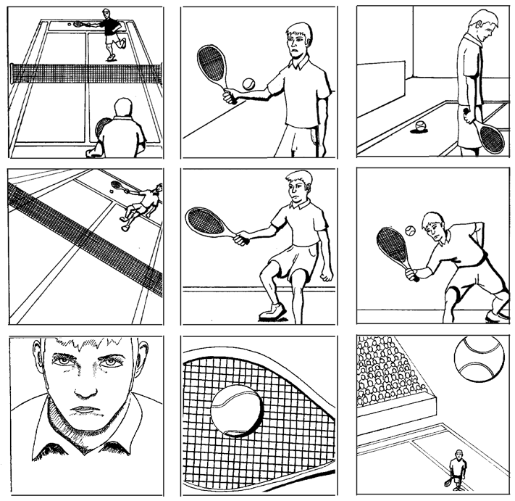**Instructor’s Notes:** Intensity refers to the level of energy in a performance or the quality of observation of an event. You can demonstrate intensity through variations in voice or through a very “flat” performance of a repetitive action (such as a karate kata) compared to a highly charged performance of the same action. Encourage students to use intensity to manipulate meaning and demonstrate how contrast, volume, and lighting can increase or decrease intensity. **Timetable:** 3 to 12 hours, depending on the approach taken.

Low intensity

Medium intensity

High intensity

COUNTDOWN

### Based on an assignment by Patrick Fitzgerald, North Carolina State University

**Problem:** Organize a minimum of ten images, objects, or actions to create a countdown (from ten to one) or count up (from one to ten).

**Objective:** In this assignment we will explore ways to compress or expand time. In a countdown, a sequence of preliminary moments is used to heighten awareness of a culminating moment.

**Strategy:** Start by brainstorming, listing every conceivable situation in which a sequence of moments culminates in a definitive event. A rocket ship blasting off is perhaps the most obvious. Consider the countdown from pregnancy to birth, the countdown to graduation, or the countdown to the beginning of a foot race. Explore personal implications, (such as the countdown to that last cigarette before you finally quit smoking) as well as global implications, (such as the events preceding a nuclear war). Consider ways in which a countdown can expand time as well as ways in which a countdown can compress time: both have expressive potential.

Then, begin turning your ideas into thumbnail sketches. Which of your ideas can be visualized most effectively? Is every moment in the sequence equally charged with energy, or does the tension noticeably rise as the end nears? Try to avoid jumping between high and low intensity. A gradual and accelerating rate change is generally more effective for this problem.

Finally, develop your ideas into a refined artwork. It is a good idea to start with too many images, then edit, finally creating the most powerful result.

**Reading:** Chapter 12.

**Instructor’s Notes:** This assignment can be as concise or as complex as you see fit. The brainstorming stage can take a week or it can be completed in an hour. The ideas can be expressed through simple drawings or through complex actions or sculptural objects.

**Timetable:** 6-12 hours

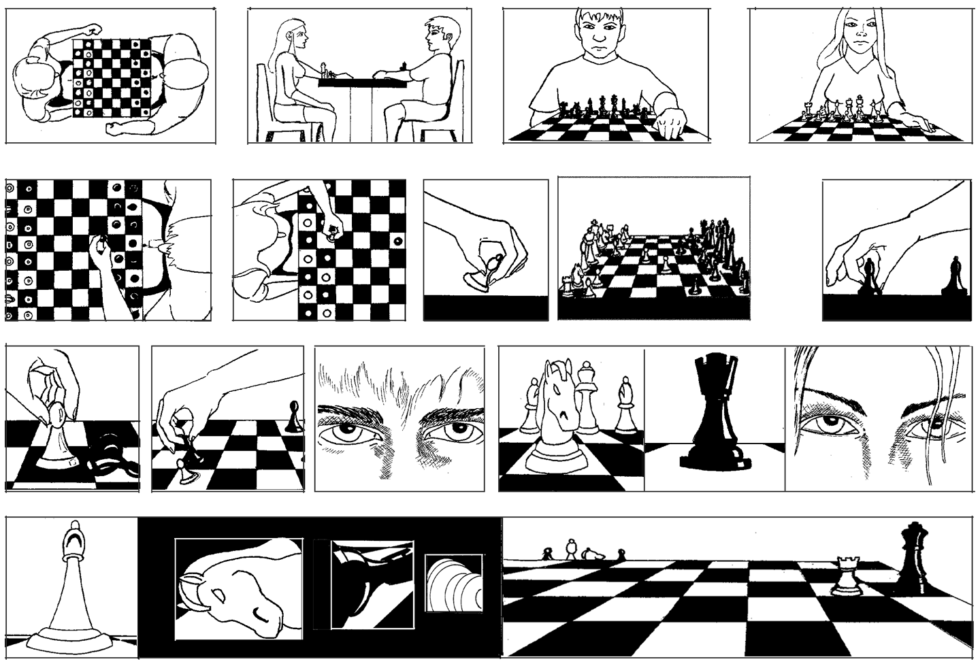

**CHANGING THE SCENE CHANGES THE STORY**

**Problem:** Draw or find photographs of one or two human figures. They may be sitting on a bench talking, walking hand and hand, engaged in physical combat, etc. Then, place your characters in four different settings. How does the setting affect the ideas or emotions being expressed?

**Objective:** To demonstrate the importance of setting.

**Materials:** Drawing materials or photographs. This assignment can also be done digitally.

**Strategy:** Begin by considering the characters and their relationship. What happens when they are two twenty-year old women? Does the interaction change if a twenty-year old and an eighty-year old women are used? How about a twenty-year old man and a twenty-year old woman? Experiment with various positions and gestures. The figures can be physically connected (holding hands, perhaps), or can be physically separated.

Then, photocopy, scan or draw images of at least ten different, settings, such as a circus, a cemetery, a grocery store, an dark alley, a locker room, and so on.

Finally, place your character(s) in the settings which most dramatically change the story. You must use the same characters throughout, but can enlarge, reduce or distort the figure(s) as necessary.

**Reading:** Pages 301 to 304. **Timetable:** 3 hours

SCOPE

**Problem:** Create a panoramic silhouette of a large site, such as a public beach, a track meet, or a circus. Then, add at least four windows to that design, showing specific simultaneous events within the site.

**Objective:** To heighten awareness of scope and compositional complexity.

**Materials:** Two-dimensional materials of your choice

**Strategy:**

1. Make a list of at least twenty settings in which multiple events occur—grocery store, expressway interchange, political rally, football game, etc.

2. Then consider how many events can occur in that setting at one time. For example, you might develop a panoramic design of a horse race, then add close-ups of a gambler placing a bet, a stable hand grooming a horse, an trainer talking to a jockey, a racing fan studying the program.

3. Finally, create an elegant silhouette showing the site as a whole, then add images of at least four events occurring at the site.

**Reading:** Pages 298 to 300; and Tuesday, a children’s book by David Wiesner.

**Instructor’s Notes:** In time design, scope refers to the range of action that occurs within a given moment. Stories that are narrow in scope often gain intensity and have great immediacy. Broad scope is often used for stories that are more complex or are universal   
in nature.

**Timetable:** 12 to 15 hours

**STRATA**

Based on *Breakdown*, created by Janet Ballweg, Bowling Green State University

**Problem:** Choose a complex interior or exterior setting in which multiple objects are positioned at various distances in space. Transform the objects into three silhouettes, describing the foreground, middle ground, and background. When combined, these silhouettes should create distinct layers of space, or strata.

**Objective:** To heighten awareness of the spatial location of objects and provide another approach to abstraction.

**Materials:** Colored paper or colored pencils or paint on illustration board. The colors can also be added digitally.

**Strategy:**

1. Look for an interesting site. A cityscape, architectural setting, landscape, automobile showroom, or large greenhouse are all suitable sites.

2. Draw the shapes you see, fusing all of the foreground information into a single silhouette, then continuing this process as you create the middle ground and background silhouettes.

3. Fill in the silhouettes using paint or colored pencils or use cut paper to define the various layers.

**Reading:** Pages 95 to 101

**Instructor’s Notes:** The flat shapes commonly used in 2D design classes are a mixed blessing. On one hand, they help to clarify compositional relationships. On the other hand, they can result in spatially flat images, with every piece of information jammed into the foreground. In this composition, students combine the simplicity of flat shapes with the complexity of spatial layering.

*Note:* The resulting design can also be used in the Scope Assignment described in the Time Design section.

**Timetable:** 6 to 9 hours

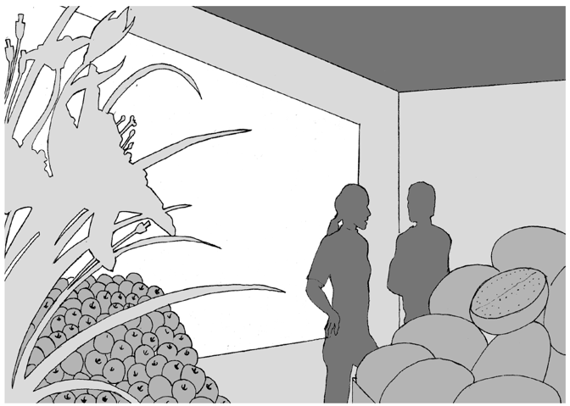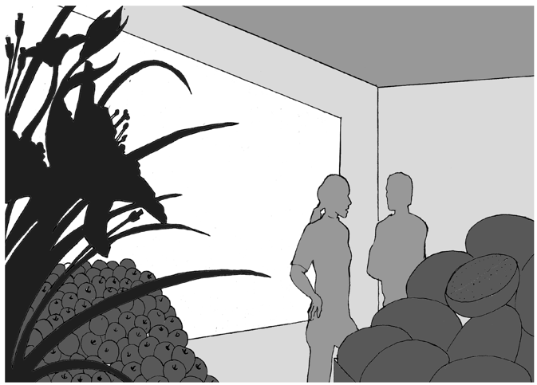

**ARRESTED TIME**

By Mathew R. Kelly, Whitman College

**Problem:** Create a dynamic sculpture from a captured moment in time.

**Objective:** To imply motion or potential motion using a static material.

**Materials:**  A 6"x6"x9" block of urethane foam for each student, files or rasps, handsaws, small dowels and or toothpicks, lightweight wire.

**Strategy:** You may work subtractively by carving the piece out of the block of foam or additively by cutting up the block and assembling the piece.

Think of the block as your supply of material and consider how you can get the most mileage out of it. Consider relationships between organic and geometric forms, and the implications of physical forces, such as torsion, tension, compression and expansion. Can a hard-edged geometric form begin to flow? Billow? Twist? Take the piece beyond the obvious.

1. Generate a list: Think of something flowing, billowing, exploding, imploding, collapsing, tumbling, melting, swirling, splashing etc. Write down at least 20 examples, and consider how to communicate your ideas sculpturally. Making several thumbnail sketches of each idea will greatly expand your brainstorming process.

2. Focus: Determine which option has the most potential. Which solution best expresses the idea of arrested time? How can this solution be made into a compelling sculpture?

3. Create a working sketch or maquette: Make a detailed drawing or maquette of your proposed sculpture.

4. Finalize the piece: Start sculpting with the urethane foam but keep yourself open to changes that might present themselves along the way.

**Reading:** Review Part 3: Three-Dimensional Design

**Instructor’s Notes:**  Many of arrested time can be found in various media, including:

• Photographer Henri Cartier-Bresson’s “Behind the Gare St. Lazare, Paris, 1932” in which he captured a man in mid-stride, just before his foot hits a puddle of water.

• Many photographs by Harold Edgerton, who used the strobe light to capture moments in time, such as a bullet hitting an apple.

• Isamu Noguchi’s “Cube”, which balances precariously on its corner rather than safely on its side. The perceived potential of this cube to tip over is what creates tension in this piece, increasing its dynamism. If limitations in time and equipment make it impossible to do this sculptural assignment, have students explore the idea photographically instead.

**Timetable:** 4 hours in class, 4 hours outside of class.

### TIME PIECE

Assignment created by Mat Kelly

**Problem:** Take the ordinary mechanism of a clock and expand upon it to communicate a time-related theme of your creation.

**Objective:** To combine function with a conceptual interpretation exploring ways to integrate the needs of both without one being subservient to the other.

**Materials:** A battery powered clock mechanism, (found at craft stores) cardboard or mat board for the maquette and a variety of drawing tools and materials such as wood, mat board, foam core, plastic, etc. for the final piece.

**Strategy:**

1. Time and the marking of time play a major role in our lives. We are slaves to our own invention. How many people do you know who don’t have a watch? Think of all the different ways we mark time from the obvious such as a watch or calendar to the indirect like birthdays, biological clocks, and circadian rhythms (sleeping habits). Think about different kinds of time such as “daytime,” “nighttime,” “geological time,” and “dinner time.” Think of phrases like “time is running out” or “time is money.” Most of all think about the way time affects *your* life.

2. Make at least three preparatory sketches of three different ideas about the way time is affecting you. Avoid conventional ways of displaying a clock where the time-telling function is the main concern. Include in these sketches the working clock. How can you make the clock an integral part of your sculpture and not have it look like it was just stuck on as an afterthought?

3. Once you have decided upon a solution that communicates a theme, start building a maquette or small-scale model of your idea out of cardboard or mat board. Keep an open mind and continue to experiment. Remember that the basic elements and principles of design still apply.

4. When the maquette is complete you may start building the actual sculpture. You have some construction issues to think about. The clock mechanism itself is quite light, yet with the battery it becomes a bit heavier, this will help determine what kind of material you are going to use for the clock face. The shaft that turns the hands of the clock is of a specific length, which cannot be adjusted, whatever kind of clock face you create is going to have to accommodate that specific length. You need to also consider that the hands of the clock are slowly turning so there shouldn’t be anything in their way or the functional aspect of this piece fails. Even at this stage you should still remain flexible with your idea. You will find certain materials do not behave the way you would like them to so that will help determine the kind of things you actually use.

5. Write a statement, no longer than a single page, discussing the theme you have chosen, why it is significant to you, and why you chose it for this project.

**Reading:** Chapter 5, sections on problem solving, brainstorming, conceptual expansion, pages 5-4 through 5-14. Additional reading: *Longitude* by Dava Sobel (Walker Publishing Company, Inc, 1995) and the Royal Observatory at Greenwich website: http://www.rog.nmm.ac.uk/.

**Instructor’s Notes:** This project has left quite a bit of freedom within materials and concepts and often times students will think of the function of the piece as being the most important part of the project. This has the potential to get out of hand with elaborate designs so, depending on the dynamics of the class and availability of equipment, you may want to consider adding a few more restrictions in order to help focus your students.

**Timetable:** 4 to 6 hours in class, 4 to 6 hours outside of class

Before and After

Inspired by *Clue Diptych*, Mary Frisbee Johnson in Visual Workouts, Prentice Hall, 1983

**Problem:** Imagine a dramatic event. Then, invent two images, one showing the scene before the event occurred, the second showing the aftermath. Do not show the event itself. Instead, use objects and lighting to provide the clues the viewer needs to create his or her own story.

**Objective:** To demonstrate the importance of setting.

**Materials:** Two-dimensional materials of your choice

**Strategy:**

1. Start by making lists of dramatic events, environments, and objects. For example:

*• Events*: explosion in a toy factory, new home run record set, etc.

*• Environments*: circus, airport, chemistry lab, racetrack, cathedral, dentist’s office

*• Objects*: address book, stopwatch, telephone, elevator, escalator, ladder, car keys

2. Consider the stories each may conjure.

3. Add characters. They may be human, animal, robots, etc.—use your imagination! Consider any objects (props), which might be associated with each character.

4. Begin designing images. Experiment with lighting, camera angle, close-ups, etc. to get the most powerful effect. Pay attention to details: the news program on a TV set in the background may provide an essential clue.

5. Experiment with various mediums, such as graphite, computer graphics, and watercolor. Choose a medium which is appropriate to the subject matter and easy to use.

6. Consider:

• What role does the setting play? How can interiors, objects, and lighting contribute to the sense of anticipation and mystery; how can the setting heighten emotion?

• How much conceptual and/or narrative information need you provide to the viewer? You don’t want to be obscure, but over-explaining defeats the mystery.

• How much perceptual information is needed? To what degree need the objects and interiors be defined? When is suggestion more powerful than description?

• What is the observer’s position? Detached? Involved?

• How much time has elapsed between image #1 and #2? An hour? A day? Fifty years?

**Reading:** Pages 301 to 308, Chapter 13

**Instructor’s Notes:** This is a complex assignment and most students are confused initially. It is helpful to provide several specific examples, followed by relentless coaching.

A familiar and dramatic example works best. Consider the Oklahoma City bombing. It was a spring morning, shortly after the Murrah Federal Building had opened. Parents were dropping off their children at a day care center. In this story, the 8:03 am explosion of a fertilizer bomb is the event itself.

What occurred before the explosion and how can it be shown? Timothy McVeigh buying fertilizer? McVeigh watching news reports on the fire at the Branch Dravidian compound in Waco? The children walking into the federal building? A combination of these images? What occurred after the explosion and how can it be shown? Injured people and wreckage? The trial of McVeigh? Children playing in a park now being built at the site of the bombing?

**Timetable:** 18-24 hours, in and out of class

**THE WORLD IS A STAGE: The Transformative Effects of Value**

**Problem:** Using lighting, transform the everyday world into a world of magic, murder or mystery. Shoot 36 photographic prints, get them processed; bring the twelve best and six worst to the critique.

**Objectives:**

* To increase our awareness of light.
* To demonstrate the emotional impact of light.
* To practice cropping images through a camera lens.

**Materials:** Camera and good quality printer paper.

**Strategy:** Use natural or artificial light. Time of day, angle and direction of light, and the effects of shadows are essential aspects of natural lighting. Artificial lights (such as clamp-on floods) provide great opportunities for back, side, and fill lighting. A single light source tends to be emphatic and dramatic, while multiple sources can be used to create more complex effects. Experiment!

Search out extraordinary images in an ordinary world. How can a simple glass of wine become a shimmering source of light and shadow? Can a pile of wood at a construction site or a simple stone wall become a beautiful composition? Compose each image carefully, framing the moment as well as the shapes in the design.

**Reading:** Pages 1-20 to 1-23

**Instructor’s Notes:** One of the great benefits of photography is its relative speed. While students may spend hours identifying subject matter and adjusting lighting, the actual recording process is relatively fast. Disposable cameras and commercial film processing can make this assignment accessible to anyone. And, the ease with which images can be produced encourages experimentation.

Lighting can increase or decrease the illusion of space, emphasize an object or an action, and strongly influence our emotional response. When working photographically we actually draw with light. When critiquing the results, consider the basic composition of each photograph as well as the lighting. Consider:

• How was the image selected? What made it stand out? Why was it worth recording?

• How was it cropped? Why shoot this particular fragment of reality and not another?

• Is it spatially shallow or spatially deep? What does spatial depth contribute to a composition?

• Is the image balanced? If so, how? If not, is the absence of balance an advantage?

• What creates variety? Is the balance between unity and variety appropriate to the subject?

• What is truly essential? Could anything be deleted from this image?

**Timetable:** 4-6 hours

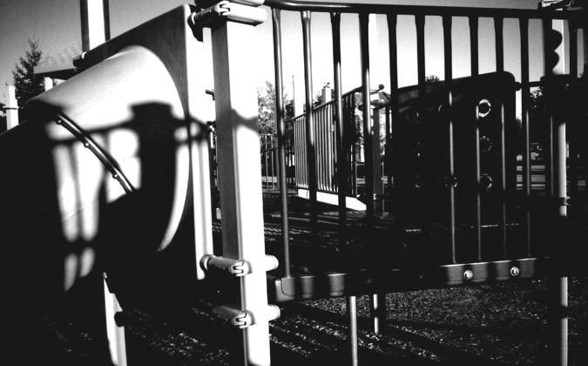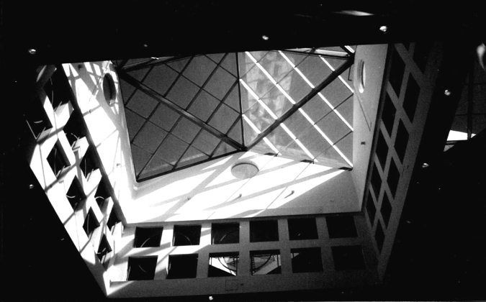

**MODULAR DESIGN: Exploring Pattern**

Assignment created by Frank Kulesa, Northern Illinois University

**Problem:**

Using the modular (grid) system of working similar (but not limited) to the shown examples, produce two compositions; one with only black and white values, and one with black, white, and shaded values.

**Objective:**

This project deals with the theory of modular design composition. Modular design is used within the fine art, design, textile, and architectural fields. Primary examples range from modular dwelling construction, floor/wall design, textile patterns, modular Op/Abstract painting/printmaking, and commercial design layouts.

A modular design may seem limited in its scope to produce dynamic imagery, but with just a small number of operations one can easily create interesting compositions. To make an interesting modular composition, you need to start with an interesting module. One needs to experiment with numerous modules before choosing one as the key design.

**Strategy:**

1. The size and type (square, polygonal) of module is optional. Execute the project with the computer, ink, paint, magic marker, etc. The medium is up to the student, but keep in mind the grade will be influenced by the craftsmanship of the finished project. Be careful that your shapes are consistent in value through out the composition and that the shapes have sharp and clean edges.

2. Do not make the final composition so small it is hard to see or so large that you run out of time to meet the project deadline.

3. Present the two individual key modules separately for identification.

**Instructor’s Notes:**

The actual space in which the module exists will influence certain potential design key points. For example; a square modular space could contain eight evenly spaced key points (see picture below) one in each of the corners and one as the bisection of each side. Using these key points when designing a module will invite greater interaction between the positive and negative shapes. This method makes is easy to join shapes into a seamless composition.

*Operations of the Module*

* Identity/Translation - repeat without rotation or reflection or inversion.
* Rotation - turning the module (degree of rotation depends upon modular space and shape.
* Inversion - 180 degree rotation.
* Reflection - mirrored image.
* Subtraction - the removal of some positive area.

Using one or more of the above operations in different sequences can dramatically effect the look of your composition.

**Pattern and Symmetry**

This project also introduces the design principle of *pattern* and *symmetry*. Pattern is created through the repetition of one or more visual elements within a composition. Using a constant grid structure as in this project will create a design that has symmetry. Using pattern and symmetry generally is associated with static design, but with interesting modular shapes and using the above mentioned operations, very interesting and dynamic designs can be created.

**TIME PORTRAIT: Symmetrical Balance**

Assignment created by Frank Kulesa, Northern Illinois University

**Problem:**

Using the concept of time, show a chronological sequence of figures and other images that represent your development from a youth to now or the future.

**Objective:**

Use a variety of figures and other images to create a composition that goes beyond a simple illustration of past and present images. Give the viewer a strong sense of *who you are*.

**Strategy:**

The final composition can flow from left to right or from bottom to top.

The final composition has to be larger than the 8.5 X 11-inch print out from the lab printer. So a stiff backing board is required for mounting you printed images together. Test prints should be printed before the mounting step. Check for good readability and contrast of the images. Since the printout will be from the lab printer, it might be better to work in grayscale mode versus color.

1. Collect and scan pictures of yourself, family, friends, interests, etc. Images of your environment and own artwork are a rich source of content to work with. Gather as many images as you can. It is better to have more than not enough images to work with. Scan all the images at the same resolution.

* Type out a paragraph listing the theme of the composition and what is significant to you.
* Develop several rough sketches with the main images to represent your idea.
* Put the scanned images into different sequences, juxtapositions, layers, values, etc.

2. All your images should be scanned and your major ideas for the background/s and foreground/s chosen.

* Clean up and enhance the scanned images for contrast, lighting, readability, and details.
* The main locations and the main images should be positioned.
* Print test prints and loosely position the printouts and view the composition at full scale.
* Study your timeline and project theme. Are they communicated well?

3. Fine-tune both the visual composition, time flow, and message of your theme.

* Does you composition flow cleanly and smoothly from the beginning to the end.
* Printout the composition in sections and neatly mount the sections together onto stiff mounting board.

This project is an excellent way to explore the many effects of paint application software and design/artistic techniques: layering, overlapping, transparency, blending, blurring/sharpness, cut and paste, scale, value, contrast, juxtaposition, distortion, rhythm, etc.

NOTE: as a reminder, do not flatten your layers as you are working on the project. Keep your layers, and save the project as a PhotoShop file. Later you can flatten the layers and print as a JPG or TIF file. The better you become familiar with a variety of PhotoShop effects, the better your composition will be.

**Instructor’s Notes:** Think about: Your history, Your goals, Your interest, Light and shadow, Your desires, Sequential experiences, Changes in light due to time, Chronology and tempo.

This project has a lot of freedom in what you want to say. The theme can be complex with more than one message or it can be simple as having a goal to graduate from college or have a career as an artist or designer.

**Notes to the Beginning Teacher:**

**The Perils and Possibilities of Concepts and Creativity Assignments**

Students become highly motivated when they are conceptually engaged and are often more willing to explore compositional variations as they seek the most effective way to communicate their ideas. Separate Foundation courses in Concept Development are being developed at some schools. In a more traditional curriculum, concept development can enrich any studio course. The following strategies can help students get started.

Start small. A concept may be defined as a well-developed thought. Any thought can serve as a beginning point. Using the skills described in Chapter 5, even the most modest thought can be enhanced and expanded.

Think big. Encourage students to explore their ideas fully, even when the results may be technically or financially impossible to implement. Many freshmen have never been encouraged to dream big dreams, and the opportunity to do so is exhilarating and enlightening. A big idea can always be distilled down to create a more feasible solution, whereas a truncated idea is just a tragedy. By distilling big ideas down to their essential meaning, students can often strengthen their intentions and heighten communication.

Try anything. The best way to have good ideas is to have a lot of ideas. Dismissing a seemingly weak idea prematurely discourages risk-taking and re-enforces self-criticism. Have students invent at least twenty rough solutions to a problem, then ask them to choose the three best for further development.

Connect the conceptual cart to the compositional horse. Developing a great idea is just the beginning. To reach an audience, the idea must be communicated visually, through composition and construction. Thumbnail sketches and model making can be used to connect concepts to composition from the very start. While they are often initially resistant to such preliminary work, students quickly adopt this approach when they realize its value.

**Assignments**

* *Limited /Unlimited:* pushing beyond apparent limitations
* *Microcosmos / Macrocosmos:* connecting simple & complex forms
* *Poster Design:* integrating words and images and the importance of research
* *Collaboratvie Compositions:* digitally creating a collaborative collage
* *Expanding Escher:* an exercise in collaborative creativity
* *WordIimage Synergy*:Exploring juxtaposition
* *Build a Concept Generator*: a basic cube turns into a conceptual toy
* *Capstone Assignment:* expanding creativity through in-depth exploration

LIMITED/UNLIMITED

Inspired by the *Nine Dot* assignment by Bob Urso, Western Washington University

**Problem:** Two-, three- or four-dimensional versions of this problem can be done in any order.

• Invent 24 ways to connect nine dots on a two-dimensional surface.

• Invent at least 12 ways to connect the 27 dots that define a three-dimensional matrix.

• Invent at least 12 ways to connect 9 temporal points. Use your sketchbook to describe and draw each possibility. Implement the best (and most feasible) idea, using music, sound effects, light, speech, movement, film, or other temporal form.

Then, expand and refine the best solution from the 72 ideas generated, and present the completed work for the critique.

**Objective:** To push past apparent limitations and explore similarities and differences between two-, three- and four-dimensional design.

**Materials:** Open

**Strategy:**

*2D approach:* Using the template provided, complete one page of 12 studies using straight lines. First see how many ideas you can generate just using vertical and horizontal lines of various width. Then explore the possibilities using diagonal lines. On a second page, create 12 more solutions, using curves, solid shapes, broken lines and continuous lines. Invent ways to break out of the box!

*3D approach*: Working with wire, balsa wood, chipboard or other materials, invent 12 ways to connect the twenty-seven dots which define a matrix. Determine the best size for your work based on the materials used. In general, a four to six inch cube is an appropriate size for these studies. Experiment with lines of various width, length, and orientation.

*4D approach*: Further expand the possibilities, using objects in space, actors, events, and so forth. What happens when nine alarm clocks, placed at nine points in the classroom, ring in a carefully designed sequence? What happens when the same nine clocks ring simultaneously then sequentially shut off leaving only a single clock ringing? Experiment!

Finally, develop the best solution for the critique. What are the advantages of 2D design, of 3D design, and of 4D Design? How did you choose the study you finalized for the critique?

**Reading:** Chapter 4

**Instructor’s Notes:** Every artwork is created within various limitations. When working on a poster, a designer generally works within a 22"x17" format, must include all of the text specified by the client, and if the budget is tight, create a great design using a single color. A sculptor must work within the structural limitations of each material and must make gravity an ally rather than an adversary. A choreographer must work within the limitations of the performance space, accept and embrace the skills each dancer brings, and use rehearsal time to the best advantage.

Creative people use such limitations as a springboard. For an inventive person, a limitation, which first appears as a barrier, can instead create a bridge. A willingness to experiment is essential. The best way to have a good idea is by having a lot of ideas, so try anything!

**Timetable:** 10 to 20 hours

**MICROCOSMOS/MACROCOSMOS**

Assignment by Mat Kelly, Whitman College

**Problem:** Create a unified composition out of a minimum of 25 smaller images all related to a single motif.

**Objective:** To enhance visual awareness and discover the simple shapes within complex forms.

**Materials:** A computer with Photoshop, digital camera, and printer.

**Strategy:**

1. Choose a simple theme from the following menu:

* Circles, cycles, and spheres,
* Squares, rectangles and cubes,
* Triads, triangles, trios and tetrahedrons,
* Bridges

2. Collect the images. Using a digital camera take a minimum of 20 pictures of objects, pieces of objects, or negative spaces that fit your basic theme. Forget about what the objects are and focus on the shapes they create.

3. Bring them together. In an 8"x10" format arrange the images into a unified composition comprised of 20 two-inch squares. Pay particular attention to figure/ground relationships, proximity, balance, and boundaries.

4. Turn up the heat: Take the color composition, copy it, and change it to a gray scale image.  How does the lack of color change the dynamics within the composition? Combine the color and gray scale images to create additional possibilities. Finally, combine words and images to create a poster sized composition expressing your simple theme as fully and eloquently as possible.

**Reading:** Chapter3, and pages 132 to 135 and 152 to 157

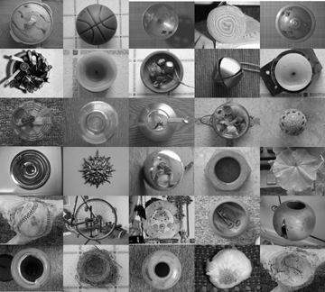

**Instructor’s Notes:**

This assignment really occurs in three stages: transcribing, translating, and transforming. In step one, encourage your students to search for similarities among the most improbable objects. In step two, give them time to explore a wide range of compositional possibilities. In the final design, the students can transform the basic information into a compelling visual essay on perception and cognition.

**Timetable:** 18 to 24 hours

POSTER DESIGN

Inspired by an assignment created by Max Hein, Santa Rosa Junior College

**Problem:** Design an 11"x17" black-and-white poster.

**Objective:** To provide experience with applied design and explore word/image connections.

**Materials:** Photocopies or computer prints, Bristol paper and black felt markers. This assignment can be done digitally

**Strategy:**

1. First, find out as much as possible about the event the poster will publicize. Talk to your client, read up on the event, and for a concert, listen to the music.

2. Next, develop at least ten 4"x6 1/2" thumbnail sketches exploring compositional alternatives. Carefully consider the relationship between words and images.

3. Develop an 11"x17" rough, refining and expanding earlier ideas.

4. Finally, complete the black-and-white poster that is camera-ready. Provide a 1/2" border around the image to improve print quality. Black areas must be solid and any stray marks must be removed from the white areas. Tonal areas can be created through cross-hatching.

**Reading:** pages 132 to 141, Chapter 3 and look at posters in Graphis Design and Print.

**Instructor’s Notes:**

Poster design is a difficult problem for most freshmen. Appearing in context with other visual notices, a poster must aggressively compete for the viewer’s attention. An effective poster requires integration of text and images, clarity of communication, and visual invention. The following checklist can help students stay on track.

1. Posters are basically pictorial statements. Visual communication precedes verbal communication. You should allow about 70% of the total area for pictorial imagery and 30% for the verbal text.

2. The content must be communicated quickly. Eliminate all non-essential information.

3. Consider the context in which it will be shown. Including a border in the design helps make a poster stand out on a cluttered wall.

4. A vertical format is preferable. It is more familiar and makes good use of display space.

5. A poster should have a focus and impact. Let one element or idea dominate.

6. Strong contrast (light/dark) is essential for readability and can increase impact.

7. All elements should be carefully selected to reflect the nature of the event.

8. Photographs must often be changed if they are to be effective in a poster. A poster is a graphic statement—not reality.

9. Distinctive or exotic type styles are best used for the main heading. Neutral type styles, such as Helvetica, Palatino, or Garamond are usually used for most of the copy. Limiting students to two typestyles can be helpful.

10. The verbal information must be carefully integrated into the overall design. It shouldn’t look like an afterthought.

11. Copy should be organized and sized according to importance. The usual ranking is: 1. Name, 2. Date, 3. Place, 4. Time, 5. Admission.

12. A simpler, more neutral style of type is preferred for copy of lesser importance. Lower case letters are easier to read than all capitals.

14. Economy is a virtue.

15. A bad design can ruin a good idea. Poor craft can ruin a good design.

**Timetable:** 16 to 20 hours

**COLLABORATIVE COMPOSITION**

Assignment by Mat Kelly, Whitman College

**Problem:** Using the computer, work collaboratively with three others to develop a complex piece on a main theme. Integrate a small design from another student into a larger composition of your own, and then give a small portion of your own design to someone else to be used in the same way. Then, as a group, decide how to best integrate the four designs into one cohesive unit.

**Objectives:**

* + To introduce basic steps of scanning material and digitally manipulating an image.
  + To explore the advantages and disadvantages of working collaboratively.
  + To develop increasingly complex compositions.

**Materials:** A computer with Photoshop, a scanner, a printer, and a portable storage device.

**Strategy:** You will be assigned to a team with three other students. Your team will have a folder on the computer, and within that folder will be a folder for you and each member of your team. Your team will share designs, as detailed below, in order to create a larger composition on a main theme.

1. Decide on the theme. Is there a common experience or interest that everyone in your group shares?  Are you all involved with theater? Sports? Art?  What is the common thread that will conceptually unify your collaborative project?

2. Collect and scan the material. You will need to collect a set of images related to the agreed upon theme. Gather photographs, actual objects small enough to place on the scanner, and create hand-drawn images. The more images you have the easier it will be later in the project.  Scan everything at the same resolution and in the same kind of file format, preferably JPEG or TIF.

3. Create your composition.  Use a 6"x9" format.  Your composition should be made up of a minimum of one hand-drawn image, a photograph and a scanned three-dimensional object. Experiment with your images but don’t forget about the basic elements and principles of design. Your individual images should be strong by themselves.

4. Share part of your composition. When your composition is done, select a small portion that is roughly no larger than 9" in area (e.g., a 3"x3" square, a 1"x9" rectangle, a 3" diameter circle, etc.) Title the selection and put it in the folder of one team member, as instructed.

5. Incorporate a team member’s selection into your composition. Open your folder and find your collaborator’s work-a selection from his/her composition. You must incorporate that selection into your own complete composition.

6. Put the pieces together.  When everyone is finished incorporating his/her collaborator’s work, the team will have four compositions.  As a group, decide how to put the four compositions together to form a single coherent work.  You could line them up, stack them, arrange them in a grid, etc.  Together you may also further manipulate the combined image.  When the team is satisfied with the image, print it out and all sign it.

**Reading:** Pages 128 to 139

**Instructor’s Notes:** Do not flatten the images until the final piece is done. Save files as JPEG or TIF.

**Timetable:** 6 to 8 hours in class, 6 to 8 hours outside of class.

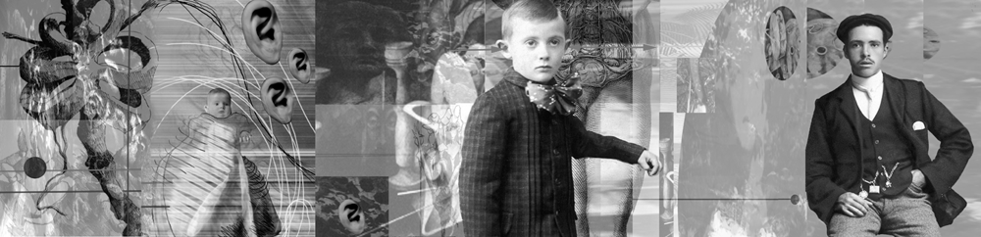

Collaborative Compositions

EXPANDING ESCHER

**Problem:** Using two fragments of M.C. Escher’s Metamorphose as a starting point, design the most inventive way possible to bridge the gap between the two existing images. Then, in collaboration with other members of your class, connect each of the individual pieces together to make a continuous design.

**Objective:** To encourage collaboration and creative problem solving.

**Materials:** Escher starter images (supplied by the teacher), felt pen and pencil.

**Strategy:**

1. Look carefully at the starter image you have been given. What are the most interesting characteristics of each fragment? What similarities and differences do you see? How many strategies can you invent to create a bridge between the two sides?

2. Make at least four photocopies of the starter image. Sketch various ideas on each copy.

3. Refine the best idea. For best results, re-draw the Escher fragment, so that the final result is crisp, clean and continuous. Modify the final image as necessary to match the designs made by the students next to you and to create an image that fits into the banner as a whole.

**Reading:** Chapter 5

**Instructor’s Notes:** This assignment can be given on the first day of class, to break the ice and get students talking!

**Timetable:** 6 hour

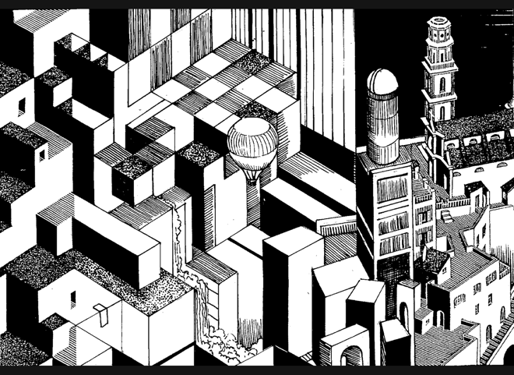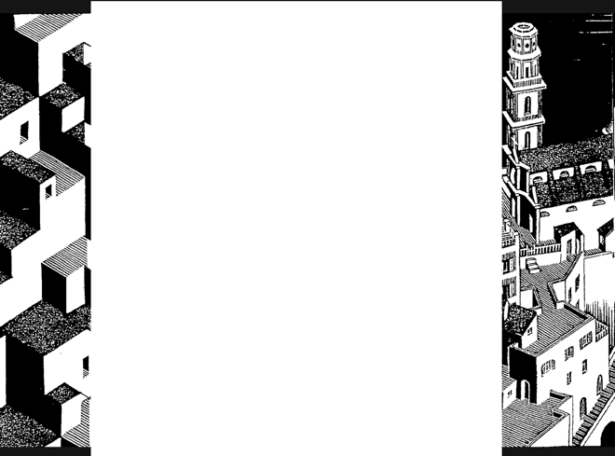

**Word/Image Synergy**

**Problem:** Using Photoshop or photocopies, combine one or more images with a single word to create an unexpected message. Create at least ten 7”x11” black and white studies, then print out the best two in the 10.5”x 16.5” size.

**Objectives:**

* To explore the implications of visual and verbal communication
* To introduce metaphor
* To increase awareness of typography
* To introduce ten additional Photoshop tools.

**Materials:** Computer and portable storage device.

**Strategy:**

1. Scan at least 6 thought-provoking images from books on photography in the library and bring at least 10 of your favorite words. Examples: paradox, independence, trap, toxic, cryptic, kindness, cruelty, discovery, foundation, extravagant.

2. Using your own photographs plus a dozen we will supply, create an intriguing image.

3. Insert one word. Experiment with typestyle and size to create the best effect. When combined, the word and image should have a stronger and more complex meaning than either would have had by itself. What happens when "cruelty" is combined with a photograph of children in a beauty pagent? Or "independence" is combined with a photograph of physicist Stephen Hawking, who is confined to a wheelchair?

Consider:

• Why was each image selected? What made it stand out?

• What part of each image most effectively supports your message?

• What happens when some parts of the design are out of focus?

• What is the advantage of a multiple-image solution verses a single image solution?

• How big should the word be? Where should it be located? Should it be very prominent, or is a more subtle treatment more effective?

• What is essential? Are all visual elements adding to the message you want to convey?

**Reading:** Pages 92 to 95 and 124 to 135

**Instructor’s Notes:** This assignment is deceptively complex. Any image can be used; any word can be used. Nouns are very powerful in this context, but words like “don’t” or “to sing” can also be used. Cropping, degrees of definition, and selection of typestyle can substantially change meaning.

**Timetable:** 2 hours for library work; 10 hours for computer work and critique.

**BUILD A CONCEPT GENERATOR**

**Problem:** Create a three-dimensional puzzle or toy. When manipulated, this object should help the user generate a rich and varied response to the subject matter.

**Objective:** To expand library research and explore non-linear narrative.

**Materials:** Two-and four-ply chipboard, photocopies, double-sided tape and glue, acetate

**Strategy:** Begin by researching a word, idea, or phrase using mapping, list making, and a library or Internet key word search.

*Part* #1: Find and photocopy at least twelve images from library sources. Organize six of the images on the six exterior surfaces of a four-inch cube, with one image per side. When the cube is turned, the images should serve as a conceptual stimulus for the viewer, helping him/her think about the subject matter.

*Part #2*: Using a second four-inch cube, organize up to twelve photocopies to create a more fluid design. Images can wrap around edges to create compositional and conceptual flow.

*Part #3*: Using a third four-inch cube, organize photocopies and up to twelve words to activate both the interior and exterior surfaces. Those who are more ambitious can expand the problem using multiple cubes or cubes within cubes.

*Part #4*: Invent your own conceptual toy, designed to generate the greatest number of concepts or evoke the most powerful emotions when manipulated. Invent boxes, puzzles games etc.

*Part #5*: Expand the Concept Generator toy to create a collaborative installation

**Reading:** Chapter 7, Chapter 5, and Art in Boxes, by Mogelon.

**Instructor’s Notes:** Linear narrative was a primary concern in the *True Lies* assignment. Using a traditional codex book structure, we worked sequentially, using images on each page to develop a story with a deliberate beginning, middle, and end. By contrast, this assignment gives students experience with non-linear thinking. On a cube, the order in which the images will be seen is unpredictable, and any direction the viewer travels must offer rich possibilities and powerful implications. No longer telling a story, the *Concept Generator* serves as a stimulus for the thoughts the viewer develops him or herself.

The most inventive students will be able to create a great project using any word. Less confident students should be encouraged to start with an especially meaningful word. A Roget’s International Thesaurus (the kind that is not alphabetical) can help students identify words with great potential.

Discuss the importance of archetypes and the recurrence of certain images across many cultures: why are circles so powerful and used so widely? How many images and meanings can be derived from the word “water?” or “hidden?” or “parallel?” Can a Concept Generator evoke irrational dream-images, rather than remaining in the rational world? This assignment offers endless possibilities: encourage students to play with all sorts of ideas!

Extensive library research can greatly expand the possibilities. Try to find a librarian to serve as a collaborator. As the project evolves, the source images can be substantially transformed using enlargements, reductions, collage, drawing and so forth, to produce work which is conceptually inventive and visually compelling.

**Timetable:** 18 hours for Parts 1 to 4, 12 -18 more hours for Part 5 (optional)

**BASIC BIBLIOGRAPHY**

**Visual Literacy**

Rudolph Arnheim. Art and Visual Perception: A Psychology of the Creative Eye. Berkeley, CA, University of California Press, 1974.

Arthur Asa Berger, Seeing is Believing: An Introduction to Visual Communication, 2nd edition. Mountain View, CA, Mayfield Publishing Company, 1998.

John Berger, Ways of Seeing. London, British Broadcasting Corporation, 1987.

Donis Dondis, A Primer of Visual Literacy. Cambridge, MA, MIT Press, 1973.

**Two-Dimensional Design**

Roy R. Behrens, Design in the Visual Arts. Englewood Cliffs, NJ, Prentice-Hall, Inc. 1984

Frank Cheathan, Jane Hart Cheathan, Sheryl A. Haler, Design Concepts and Applications. Englewood Cliffs, NJ, Prentice-Hall, Inc., 1983

Jonathan Block and Gisele Atterberry. Design Essentials, Englewood Cliffs, Prentice Hall, 1999.

Donald W. Graham. Composing Pictures. New York, NY Van Nostrand Reinhold, 1970.

Gyorgy Kepes. Language of Vision. Chicago, IL, Paul Theobald, 1944.

David A. Lauer and Stephan Pentak. Design Basics, 6th edition. Fort Worth, TX, Thomson

Jack Fredrick Myers, The Language of Visual Art: Perception as a Basis for Design. Orlando, FL, Holt Rinehart and Winston, Inc. 1989.

**Color Theory**

Josef Albers, Interaction of Color. New Haven, CT, Yale University Press, 1963.

Farber Birren. Light, Color and Environment. New York, NY, Van Nostrand Reinhold,1982.

Frans Gerritsen, Theory and Practice of Color. New York, Van Nostrand Reinhold, 1975.

David Hornung, Color: A Workshop Approach. New York, McGraw-Hill, 2004.

Johannes Itten, The Art of Color. New York, Van Nostrand Reinhold, 1974.

Albert H. Munsell. A Grammar of Color: A Basic Treatise on the Color System of Albert H. Munsell. New York, NY Van Nostrand Reinhold, 1969.

Rosemany and W. Kilmer. Designing Interiors. NY, NY, Harcourt, Brace & Jovanovich, 1992.

Harald Kuppers, Color: Origin, Systems, Uses. New York, Van Nostrand Reinhold, 1972.

Harold Linton, Color Model Environments. New York, Van Nostrand Reinhold, 1985.

Albert Munsell, A Color Notation. Munsell Color, 1981.

Richard B. Norman, Electronic Color. New York, Van Nostrand Reinhold, 1990.

**Creativity**

Mihaly Csikszentmihalyi, Creativity: Flow and the Psychology of Discovery and Invention.

New York, HarperCollins Publishers,1996.

John Briggs, Fire in the Crucible: Understanding the Process of Creative Genius. Phanes Press, 2000.

David Bohm, On Creativity. New York, Routledge, 2000.

John Dewey. Art As Experience. New York, NY, Capricorn Books, 1958.

Howard Gardner, Creating Minds: An Anatomy of Creativity Seen Through the Lives of Freud, Einstein, Picasso, Stravinsky, Eliot, Grapham, and Gandhi, New York, Basic Books, Inc., Publishers,1993.

Howard Gardner, Frames of Mind: Theory of Multiple Intelligences, New York, Basic Books,

Anne Lamott, Bird by Bird: Some Instructions on Writing and Life. New York, Anchor 1998.

Michael Le Boeuf, Imagineering. New York, McGraw-Hill, 1980.

George Prince. "Creativity and Learning As Skills, Not Talents." The Philips Exeter Bulletin, 1980.

Denise Shekerjian, Uncommon Genius: How Great Ideas Are Born. New York, NY,   
Penguin Books, 1991.

Doris B. Wallace and Howard E. Gruber, editors, Creative People at Work. New York,   
Oxford University Press, 1989.

**Concept Development**

James L. Adams,Conceptual Blockbusting. Reading, MA, Addison-Wesley Publishing Company, Inc.,1986.

Edward de Bono, Lateral Thinking. London, England, Ward Educational Limited, 1970.

Malcolm Grear. Inside/Outside: From the Basics to the Practice of Design. New York, Van Nostrand Reinhold, 1993.

Mary Frisbee Johnson. Visual Workouts: A Collection of Art-Making Problems. Englewood Cliffs, NJ, Prentice Hall, 1983.

George Lakoff and Mark Johnson. Metaphors We Live By. Chicago, Il, University of Chicago, 1981.

Ben Shahn. The Shape of Content. Cambridge MA, Harvard University Press, 1957.

Roger Von Oech, A Kick in the Seat of the Pants. New York, Harper and Row, 1963.

Roger Von Oech, A Whack on the Side of the Head. New York, Harper and Row,1986.

**Critical Thinking**

Sylvan Barnet, A Short Guide to Writing about Art, 6th edition, Addison, Wesley, Longman, 2000.

Terry Barrett, Criticizing Photographs: An Introduction to Understanding Images, 2nd edition. Mountain View, CA, Mayfield Publishing Company,1996

Henry M. Sayre, Writing About Art, 3rd edition. Upper Saddle River, NJ, Prentice-Hall, Inc., 1999.

Howard Smagula, editor. Re-visions: New Perspectives of Art Criticism. Englewood Cliffs, NY,   
Prentice Hall, 1991

Amy Tucker, Visual Literacy: Writing About Art. McGraw-Hill, Burr Ridge, IL 2002.

**Three-Dimensional Design**Oliver Andrews, Living Materials: A Sculptor's Handbook, Berkely, CA, University of California Press, 1988.

Gaston Bachelard, The Poetics of Space, trans. Maria Jolas, Boston, MA. Beacon Press, 1969.

Frank Ching, Architeccture: Form, Space, and Order, 2nd Edition. New York: Van Norstrand Reinhold, 1996.

Peter Dormer and Ralph Turner. The New Jewelry: Trends and Traditions. London, England, Thames and Hudson, Ltd., 1985.

Suzanne Frantz. Contemporary Glass: A World Survey from the Corning Museum of Glass. Abrams, NY 1989

Peter Lane, Ceramic Form: Design and Decoration, revised edition. New York: Rizzoli International Publications, Inc. 1998.

Susan Grant Lewin, One of a Kind: American Art Jewelry Today. New York: Harry N. Abrams, Inc., Publishers, 1994.

John Lidstone, Building with Wire. New York: Van Nostrand Reinhold, 1972.

Martha Dreyer Lynn, Clay Today: Contemporary Ceramists and Their Work. Los Angeles: Los Angeles County Museum of Art and San Francisco: Chronicle Books, 1990.

Ezio Manzini. The Material of Invention: Materials and Design. Cambridge, MA, MIT Press, 1989.

Bonnie J. Miller. Out of the Fire: Contemporary Glass Artists.. San Francisco, Chronicle Books, 1991.

Nicholas Penny, The Materials of Sculpture. New Haven: Yale University Press, 1993.

Arthur Williams, Sculpture: Technique, Form, Content. Worcester, MA, Davis Pub., Inc. 1993

Wucius Wong, Principles of Form and Design. New York, NY, Van Nostrand Reinhold, 1993.

Charles Wallschlaeger and Cynthia Busic-Snyder. Basic Visual Concepts and Principles for Artists, Architects and Designers. Dubuque: William C. Brown, Publishers, 1992.

**Sculpture History:**

John Beardsley, Earthworks and Beyond: Contemporary Art in the Landscape. New York:   
Abbeville Press, 1998.

Jack Burnham, Beyond Modern Sculpture: The Effects of Science and Technology on the Sculpture of This Century. New York: George Braziller, Inc. 1968.

Howard Hibbard. Masterpieces of Western Sculpture from Medieval to Modern. Harper and Row, Publishers, 1980.

Janet Koplos. Contemporary Japanese Sculpture. New York, NY, Abbeville Press, 1991.

Nicolas de Oliveria, Nicola Oxley, Michael Petry, Installation Art. Washington,DC: Smithsonian Institution Press, 1994.

Jeremy Schmidt and Laine Thorn. In the Spirit of Mother Earth: Nature in Native American Art. San Francisco, CA, Chronicle Books, 1994.

Peter Howard Selz. Barbara Chase-Riboud, Sculptor. New York, NY, Hearry N. Abrams, Inc., Publishers. 1999.

Diane Waldman. Transformations in Modern Sculpture: Four Decades of American and European Art. New York, NY, The Solomon R. Guggenheim Foundation, 1985.

Virginia Watson-Jones. Contemporary American Women Sculptors. Phoenix, Oryx Press, 1986.

Gary Wyatt, Spirit Faces: Contemporary Native American Masks from the Northwest. San Francisco, CA, Chronicle Books, 1994.

Sculpture Inside, Outside. Various authors. Rizzoli International Publications, Inc. 1988

**4D Design/Visual Narrative**

Huntley Baldwin, How to Create Effective TV Commercials, 2nd edition. Lincolnwood, IL, NTC Business Books, 1989.

David Bordwell and Kristin Thompson, Film Art: An Introduction New York, McGraw-Hill, 2009.

Roselee Goldberg, Performance: Live Art Since 1960. New York: Harry N. Abrams,1998.

Stephen F. Gordon. Making Picture-Books: a Method of Learning Graphic Sequence. New York, NY, Van Nostrand Reinhold, 1970.

Lincoln F. Johnson, Film: Space, Time, Light and Sound.Holt, Rinehart & Winston, Inc. 1974.

Stephen D. Katz. Film Directing, Shot by Shot: Visualizing from Concept to Screen. Studio City, CA, Michael Wiese Productions, 1991.

Scott McCloud, Understanding Comics. New York, HarperPerennial, 1994.

Robert McKee, Story: Substance, Structure, Style and the Principles of Screen Writing. New York, HarperCollins, 1997.

Steve Riordan, editor. Clio Awards: A Tribute to 30 Years of Advertising Excellence, 1960-1989. Glen Cove, New York, PBC International, 1989.

David Ross, Bill Viola.. New York: Whitney Museum of American Art, 1998.

Herbert Zettl. Sight, Sound, Motion: Applied Media Aesthetics, 3rd edition. Belmont, CA,

Wadsworth Publishing Company, 2008.

Story and Discourse: Narrative Structure in Fiction and Film Seymour Benjamin Chatman, Cornell University Press, 1980.

The Cinema Effect, Kerry Brougher (Author), Anne Ellegood (Author), Kelly Gordon (Author), Kristen Hileman (Author), Tony Oursler (Author) Hirshhorn Museum/D Giles Limited, 2008.

Video: The Reflexive Medium**,** Yvonne Spielmann, The MIT Press

The Emergence of Cinematic Time: Modernity, Contingency, the Archive**,** Mary Ann Doane, Harvard University Press, 2002

Reading Images. The Grammar of Visual Design**.** Kress, & Theo Van Leeuwen, Routledge, 1996

Looking Awry**,** Slavoj Žižek, The MIT Press, 1992

Half-Real: Video Games between Real Rules and Fictional Worlds**,** Jesper Jul, The MIT Press, 2003

First Person: New Media as Story, Performance, & Game**,** Noah Wardrip-Fruin, The MIT Press, 2006

**Book Arts**

Johanna Drucker, The Century of Artists' Books, New York, NY, Granary Books, 1995.

Shereen La Plantz. Cover to Cover. Asheville, NC, Lark Books, 1995.

Joan Lyons. Artists' Books: A Critical Anthology and Sourcebook. Rochester, NY, 1985.

Keith A. Smith, Structure of the Visual Book. Fairport, NY: The Sigma Foundation, Inc. 1992.

Keith A. Smith, Text in the Book Format. Fairport, NY: The Sigma Foundation, Inc. 1991.

Christopher Vogler. The Writer's Journey: Mythic Structure for Storytellers and Screenwriters. Studio City, CA, Michael Wiese Productions, 1991.

**A FINAL WORD: TOP TEN THINGS EVERY GTA NEEDS** By Anthony Fontana

Every GTA is engaged in a complex juggling act. Teaching must be fit into a rigorous schedule of precious studio time, intense critique, heavy reading and study. For some GTAs it has been a mere four to five years since they themselves were sitting in the class they are now instructing. What questions and concerns do GTAs bring to their first teaching appointment?

1. **Clear job definition**. Every GTA needs to understand the role s/he plays in the big picture of a Foundations Program and the bigger picture in the department. A GTA must know the significance of his or her job and have a clear sense of the responsibilities.

2. **Knowledge of the program**. Many first time instructors begin teaching using the same methods with which they were taught. This can add helpful variety and new ideas to a program. But often the ideals of the program from which the GTA received their own Foundations training don’t match the Foundation Program in which they will teach. Clear guidelines are essential.

3. **Mentoring**. Every GTA needs a Foundations Coordinator or appointed faculty member to provide support, instruction, and guidance. Simple questions arise from time to time and the GTA needs someone they can trust to turn to. This Mentor also serves as the superior to their position, holding the GTA accountable for their responsibilities.

4. **A good role model**. A smart mentor doesn't have to do all the work nor be the only model-teacher for the GTA to follow. Introducing newer GTAs to successful adjunct faculty or upper level GTA's presents them with positive influences. It is with this kind of synergy that GTAs realize they are not alone and camaraderie can be established.

5. **The support of faculty**. It is extremely important that the hard work of every GTA be recognized and supported and that upper division faculty “buys into” the Foundations mission. Mixed messages undermine both the Foundations program and the GTA, who is trying his or her best to teach the curriculum.

6. **Guidance systems**. Sample syllabi, lesson plans, books, and rubrics should all be ready for a GTA teaching a new course. A GTA without these tools is on a crash course to learn things the hard way.

7. **Assessment**. A GTA can be reviewed by: their students, their mentor, by efforts in class or out, by their lesson plans, or by their students' work. Every GTA needs to be rewarded for what they do well. Each GTA also needs to understand his or her shortcomings. These shortcomings can then be transformed into goals that the GTA can aim to achieve.

8. **Goals**. Every semester, as each GTA grows, they should set goals for themselves that will better their effort and focus their energy inside a classroom. These goals aren't meant to overburden the already pressured GTA, but instead be simple, insightful motivations for the student to succeed.

9. **Methodology**. It is important for GTAs to try different critiquing, lecturing, and demonstration styles to determine which ones work best for them. Starting with one method of instruction and always sticking to it is no way to improve your ability to educate.

10. **Confidence**. A graduate student is a highly motivated self-starter. Given the tools, knowledge, and resources to begin their career as an instructor, GTAs will do all they can to succeed!