Foundations Program
INSTRUCTOR’S MANUAL

Florida State University Department of Art

Developed by Mary Stewart, with extensive input from colleagues from around the country

SECOND EDITION: 2009-2010

TABLE OF CONTENTS

THE FSU FOUNDATIONS PROGRAM pg. 3

Higher Education basics pg. 5
- From Mission to Outcome
- Critique Strategies
- Communication 101
- Syllabus Basics
Essential Vocabulary pg. 15

ART 1000: Success Strategies in Art and Design pg. 19

ART 1300: Drawing Foundations pg. 22
- Notes to the beginning teacher
- Sample syllabus
- Assignment details

ART 2330: Figure Drawing Foundations pg. 35
- Notes to the beginning teacher
- Sample syllabus

ART 1203: Two-Dimensional Foundations pg. 39
- Notes to the beginning teacher
- Sample syllabus
  - Assignment details

ART 2004: Color Theory Foundations pg. 58
- Notes to the beginning teacher
- Sample syllabus

ART 1203: Three-Dimensional Foundations pg. 66
- Notes to the beginning teacher
- Sample syllabus
- Assignment details

ART 1602: Digital imaging Foundations pg. 94
- Notes to the beginning teacher
- Sample syllabus
- Assignment details

Extra Information #1: Concepts and creativity assignments pg. 116
- Notes to the beginning teacher
  - Assignment details

Foundation Bibliography and PowerPoints pg. 126

THE FSU FOUNDATIONS PROGRAM: AN INTRODUCTION
___________________________________________________________________________

MISSION:
The Florida State University Art Foundations Program will provide beginning art students with the fundamental skills, knowledge, and experiences essential to their further development as visual arts professionals.

Philosophy:
In the Foundations Program, students will be encouraged to expand their technical skills, develop their critical judgment, explore interdisciplinary connections, refine their personal goals, and increase their understanding of contemporary art and design. Inventive concepts will be used to fuel development of compelling composition and constructions. The curriculum will provide the basis on which the BA and BFA programs can be built in the Department of Art and will also provide fundamental coursework for the BS in Art Education.

OUTCOMES:
Upon successful completion of the Art Foundations Program, students will have achieved:
- An ability to develop and solve visual problems using a variety of ideation strategies;

- An ability to translate ideas into art images and objects using a wide range of art materials, methods, and processes;

- Understanding of the basic elements and principles of design;

- A capacity to think critically, and write and speak clearly about the visual arts;

- Knowledge of contemporary visual experience in art, design, and kinetic arts;

- A work ethic that reflects integrity, teamwork, dedication to professional growth, social responsibility and the confidence to take risks.

SAMPLE ASSIGNMENTS AND SYLLABI

Sample assignments and syllabi for Foundations Drawing, Figure Drawing Foundations, Two-Dimensional Foundations and Three-Dimensional Foundations follow. Time Design and Concept Development sections expand on these basics.
- First-time teachers usually follow the recommended assignment sequence closely, making adjustments in timing and emphasis based on student response.
- Experienced teachers should write up and provide a brief description of a personal plan for the semester. Any strategy is fine, as long as it fulfills the course objectives.
Every group of students has its own dynamics. Be attentive to the needs of your class, and speed up, slow down or increase complexity as needed.

NEW ART DEPARTMENT FOUNDATIONS CURRICULUM
____________________________________________________________________________
ART 1300: Drawing Foundations (3) Creative expression and communication using a variety of black and white mediums.
This is a combination of straightforward observational drawing with basic composition and concept development, especially using inventive homework assignments. Ideally, to become a co-requisite with ART 1203 for Art majors.
____________________________________________________________________________
ART 1203: Three-Dimensional Foundations (3). Experience in designing and constructing expressive three-dimensional forms using a variety of materials and methods.
This course offers a solid introduction to 3D composition and construction using a modest range of materials, including wood, wire and paperboard. Ideally, to become a co-requisite with ART 1300 for Art majors.
____________________________________________________________________________
ART 1201: Two-Dimensional Foundations (3). Experience in conceptualizing, creating, and critiquing two-dimensional compositions using the elements and principles of design.
Three aspects of visual thinking are emphasized in this course: concept development, composition, and critique. Ideally, to become a co-requisite with ART 1602 for Art majors.
____________________________________________________________________________
ART 1602: Digital Imaging Foundations (3). Introduction to digital processes and the basics of time-based art and design. (Fulfills computer competency requirement for art majors.)
This course is designed to provide students with the fundamental digital understanding required professional success in contemporary art and design. It will build on and expand the skills, knowledge and experience students gain from each of the other Foundations courses.
____________________________________________________________________________
ART 2330: Figure Drawing Foundations (3) Exploration of the anatomical and conceptual complexities of the human form.
The updated course description better fulfills the overall Foundations mission, presents well-balanced course material, and helps a variety of teachers (including adjuncts and graduate students) teach this course more effectively.
____________________________________________________________________________
ART 2XXX (new course, being added) Color Theory Foundations (3). Experiments in color perception combined with uses of color in visual communication and visual expression.
Offered as an alternative to Figure Drawing Foundations. By this means, we will be able to expand the total Foundations menu, while at the same time providing student with a degree of choice. Some concentrations within the Art Department will require BOTH courses, others will require either Figure Drawing or Color. ____________________________________________________________________________
ART 1000: Success Strategies in Art and Design (1). Orientation course designed to increase first-year student success, introduce departmental concentrations and explore career possibilities.
Success Strategies will show how students navigate through an increasingly demanding program, help them prepare for the BFA review, and provide an overview of possible careers.
____________________________________________________________________________
ART 2003: Contemporary Art Survey (3) Lectures and visual presentations exploring the myriad forms and expressive content of contemporary visual culture.
This course provides a visual and conceptual barrage: contemporary ideas and images of all kinds: a real eye- and mind-opener! A Gordon Rule course, it requires at least 3000 words in written work.

HIGHER EDUCATION BASICS

Why Read This Manual?
Freshmen have a lot to learn—about art and design, about the university, about the visual arts professions, and about themselves. As the matrix on which all majors are built, Foundations must provide a broad base of essential knowledge. To create effective assignments, Foundations teachers must:
- deeply understand the subject being taught,
- invent projects that are compelling and comprehensible to beginners,
- communicate effectively, and grade honestly,
- coach, cajole, and challenge first-time college students.
This manual is designed to help you rapidly build the skills you need for Foundations teaching.

Recommended Methods of Instruction
- Break down complex concepts and processes into comprehensible bits.
- Encourage students by continually cruising the classroom and talking one to one.
- Focus on basic skill development (“eating spinach”) during class. Expand on classwork by using inventive homework assignments and sketchbook projects.
- Present inspiring visual examples of professional and student works.
- Give students ownership of their own learning progress through engaging critiques.
- Encourage students to become active members of the art community by attending gallery openings, lectures and performances.
- When appropriate, share your experiences as an artist. Show your work. Model how art history, the liberal arts, science, etc. can be integrated into the experience of art making.

Making the course compelling
- Establish that you are knowledgeable, capable and committed. Arrive early and bring visual examples to every class. Whenever possible, do a new assignment yourself a day or two before presenting it, then bring the resulting artwork in as an example.
- Convince your students that what you have to teach is worth learning. Connecting fundamental skills learned in class to more creative homework projects helps.
- Be mindful of the delicate balance between your dual roles as taskmaster and as cheerleader. Set high standards, then do all you can to promote student success.
- In critiques, remember to be instructive rather than punitive. Beginners are generally stunned by criticism and tend to accentuate the negative. Start with positive comments.
- Have faith in your students and in yourself. Drawing, especially, is an accumulative process--a lot of practice is needed. The first efforts by a complete beginner can be astonishingly bad. Don’t give up: hard work pays off, and the work will get better.

When Things Go Wrong
Despite your best efforts, some students will behave foolishly, especially in the first and last month of the term. Class clown behavior can even rear its ugly head. Simply taking the student aside and telling him/her that such behavior is unacceptable in college can help a lot.
When students complain about their grades, first talk to them one-to-one, describing more fully your rationale for the grade given and suggesting specific ways to improve either the current project or subsequent work. Where appropriate, give students the opportunity to re-do the project. (By the way, if no student complains about grades, you are grading too high!)
If this doesn't solve the problem, send the student to me, with a complete description of the assignment and all of the work done, including preliminary sketches. I may be able to provide another perspective on the problem and re-direct student energy.
FROM MISSION TO OUTCOME: A Concise Guide to Curriculum Construction

In this section, we will explore relationships between a departmental Mission Statement, Curriculum Chart, Course Objectives, and Assignment Objectives.

Step 1: Developing a Mission: What, When, How and Why

What IS a Mission Statement, and when should one be written? A departmental Mission provides a concise statement of purpose. In it, members of an academic unit determine what they want to achieve, why these goals are important, and what effect they hope to have on students. Since the Mission Statement provides essential targets, it should be written as soon as a distinct academic unit is created. And, it should be revised whenever a substantial shift in direction is undertaken.

Why is a clear Mission Statement important? Without a shared sense of mission, members of the unit tend to work at cross-purposes, squandering time and effort. The Mission Statement provides focus, and a realistic Mission increases credibility.

How can the Mission Statement be written most effectively? A small committee, representing major constituencies within the department or school, can do the initial work. And, reviewing examples from comparable programs can provide a springboard for more discussion. Typically, a Foundations Program Mission consists of three parts:
- A one-or two- sentence statement of purpose;
- A brief philosophical discussion that describes the context or unique values of the program;
- A list of essential targets, generally described as “outcomes.”

Step 2: Charting your Curriculum
OUTCOMES | Drawing 1 | 3D Design | Success Strategies | 2D Design
Ability to develop and solve visual problems using various ideation strategies | expansion of in-class projects through inventive homework assignments | work with at least 3 ideation strategies, such as idea maps, distillation, and collaboration | lectures will include discussion of ideation strategies used by artists and designers | work with at least 3 ideation strategies, such as convergent, divergent, and metaphorical thinking
An ability to creatively translate ideas into art images and objects using a wide range of art materials, methods, and processes | work with graphite, charcoal, conte and ink, rendering of basic forms, work with one- and two-point perspective | work with additive and subtractive processes using wire, board, wood, and plaster,  effective use of band saw, drill press, sanders, lathe, and basic hand tools | lectures will include discussion of materials, methods, and processes used by artists and designers | work with markers, collage, acrylics and other materials
Creating a simple graph can help you see connections among the various courses in your curriculum. Outcomes are listed in a column on the right, while the courses taught are lined up along the top. Then, simply fill in the resulting boxes. In what courses and by what means are the outcomes being presented? If you wind up with an overload of information in one area and an absence of information in another, there is a mis-match between your Mission and your curriculum. In that case, either the Mission or curriculum needs to be revised. Example:
Step 3: Constructing Each Course
Most Foundations Programs are taught by a large number of faculty members, often with widely ranging levels of experience. A clear and reasonable list of baseline objectives for each course can help provide essential structure while retaining a reasonable level of independent initiative. Too much structure results in bored and frustrated teachers; too little structure can be an introduction to chaos theory. The most experienced and inventive members of the program can expand well beyond the baseline targets. A sample list of course objectives follows.

THREE-DIMENSIONAL FOUNDATIONS

Course Description: Experience in designing and constructing expressive three-dimensional forms using a variety of materials and methods.
Course Objectives: Upon course completion, all students should be able to:
- Define and effectively manipulate the elements and principles of 3D design to create non-objective, abstract, and representational compositions;
- Use a wide variety of idea generation strategies confidently;
- Create projects that are structurally sound, using wire, board, wood, and clay;
- Use a band saw, drill press, sanders, lathe, and basic hand tools effectively;
- Speak and write critically about personal and peer artworks and propose alternatives
- Design and complete an ambitious personal Capstone Project.

Step 4: Constructing an Assignment

For the emerging educator, turning personal studio experience into inventive assignments for freshmen can be a daunting task. The actions and compositional choices we take for granted may be totally foreign to beginners. A sense of purpose is essential: each assignment should advance the overall learning experience in a substantial way. The following checklist can help an emerging educator organize assignments and strengthen communication.

- Title: An inventive or memorable title immediately attracts attention.

- Author. Give your name, institution, and contact information.

- Premise or Springboard: What is the intellectual or aesthetic context for the assignment? What concepts will the students address?

- Problem: What will the students do? Describe the assignment in one or two sentences. Stick with essentials: details on why and how will follow in sections on objectives and strategy.

- Objectives/Assessment Targets: What new knowledge will students gain through this assignment? Three to five objectives are ideal. Consider including a variety of learning experiences, from technical and perceptual experiences to critical and conceptual thinking. This helps students gain multiple skills simultaneously. Objectives that lead to tangible results help with the assessment process: if there is no visual evidence of progress, it is hard to know what students actually accomplished. Thumbnail sketches, maquettes, and rough drafts expand creativity and provide evidence of ideation, so encourage their use.

- Materials: List the tools, equipment and supplies needed.

- Strategy: How will the work be accomplished? When appropriate, identify the thinking processes, organizational methods, and in-progress deadlines. When an ambitious assignment unfolds through a series of steps, more ideas and variables can be addressed effectively.

- Examples: List 6-12 artists whose work is related to the assignment, or list recommended readings. Since freshmen generally know little or nothing about contemporary art, it is important to include recent as well as historical references.

- Key Questions: To expand critical thinking and increase personal responsibility, list three or four practical questions students need to ask themselves as they complete the assignment. Examples:
  - Experiment with wire, bristol board, and plaster gauze. Which material will best communicate your idea?
- How can lighting enhance mood or expand meaning in your drawing?
  - What are the metaphorical implications of the objects you have included in your assemblage?

- Critiquing Strategy: Determine the type of critique best suited to the problem and work out the logistics. Using a variety of techniques throughout the term can increase student involvement.

- Timetable: As appropriate, determine due dates for various stages in the problem as well as the final deadline.
Use this structure as an organizational framework. If more interesting alternatives develop as the assignment unfolds, modify your plan. Use your intuition as well as your intellect!

Step 5: Assessing the Results
A simple rubric can speed up the grading process and give students a clear sense of the areas of strength and areas needing more development.

SAMPLE ASSIGNMENT RUBRIC
Rating: 5 = highest

CRITERIA | 1 | 2 | 3 | 4 | 5 | COMMENTS
Range of colors created

Richness and inventiveness in color relationships

Craft

Eloquent translation
of object into image

Conceptual invention
In final design

GRADE:

SAMPLE ASSIGNMENT SHEET: LINE DYNAMICS

Problem: Develop three dynamic, non-objective designs, using line, shape and texture.

Objectives/Assessment Criteria:
- To fully engage the edges of each composition
- To create an illusion of space using overlap, size, location, and degree of definition
- To experiment with forms of balance
- To effectively engage in a visual critique process.

Materials: Black felt markers and six or eight sheets of 18" x 24" drawing paper

Strategy: Use thumbnail sketches to rough draft at least ten ideas.
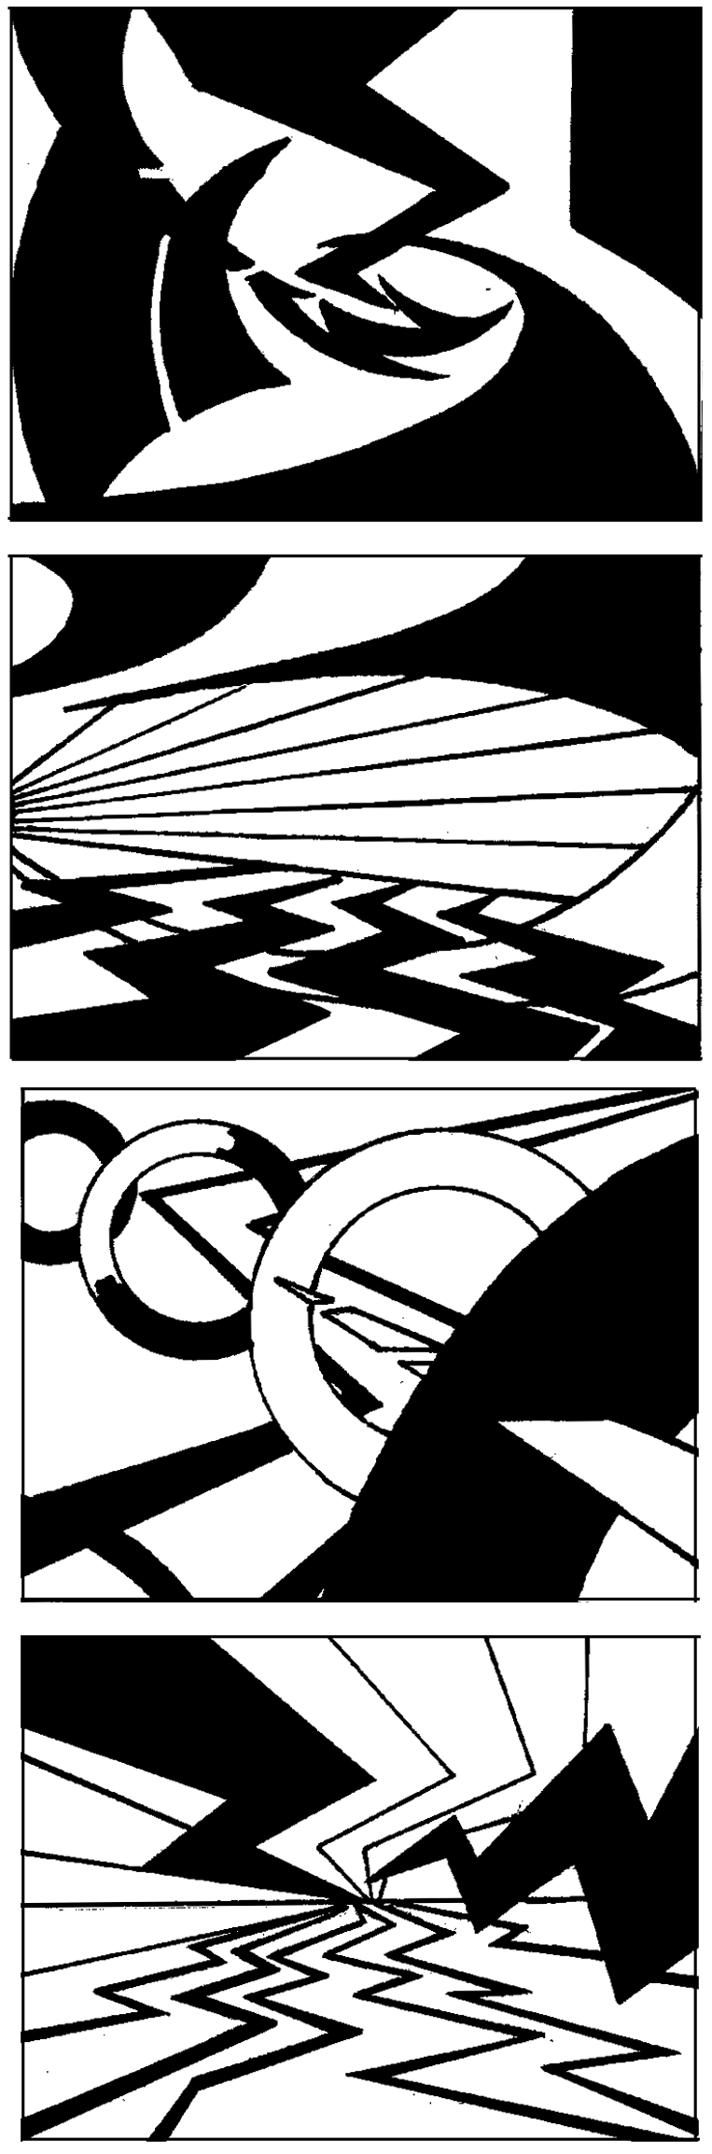
- Pay special attention to the edge of the composition. When a line or shape intersects this edge, the composition can extend beyond the page and into the viewer’s world.
- Overlap, variations in size, location, and degrees of definition can be used to increase the illusion of space. The illusion of space gives more room for movement, increasing the overall energy in the design.
- Experiment with forms and degrees of balance. Symmetrical balance is often used when stability is needed; asymmetrical balance is generally more dynamic.

Examples: Chapters 1 and 3, LTI.

Key Questions:
- How does spatial depth contribute to visual dynamism?
- Is there a dominant movement in the composition?
- If so, how was this movement created?
- What would happen if this movement was enhanced?

Critique Strategy: Visual critique will be used. Student A will select a study by Student B, then re-design it, making it 50% stronger. Student A then gets to talk about the choices he or she made, This provides a form of critique without putting either Student A or B in a negative position!

Instructor’s Notes: Working in larger scale, students can more fully explore the inherent dynamism of line. Dynamic designs are generally dominated by diagonals and curves, which tend to suggest movement and imply change. When lines are connected, shapes can be formed, adding variety and complexity to the design.
This seemingly simple assignment can actually provide an overview of the elements and principles of design. To create a dynamic design, students must understand balance and use it effectively. By creating the illusion of space, they can suggest movement from foreground to background. And, a focal point can provide a dramatic pivot point for the entire composition.

Timetable: 15-40 minutes per design, 15-40 minutes per discussion. Continually alternating between drawing and discussion works well.
A Well-Designed Course
All courses must meet the basic objectives listed on the sample syllabi in this manual. HOW you meet these objectives is your choice: be inventive! These following strategies can increase the focus, clarity and substance of your course.
- A sequential structure can help students gain momentum and continually expand ideas. Starting at a basic level, each assignment builds on the preceding problem and anticipates the subsequent problem. Using this approach, complex concepts can be mastered through a series of comprehensible steps.
- Variations in timing, presentation, conceptual objectives, problem-solving processes, and critique strategy can add substance and increase interest in your course.
- A balanced approach increases breadth and adds interest. Vary the pace and assignment content, including quick experiments as well as extended investigation.
- Bottomless assignments can provide variations in the degree of difficulty. Whenever possible, create assignments you find interesting--assignments that can apply to beginning or more advanced study. Use simple, single-solution problems sparingly. Rigid, one-answer questions rarely challenge the more ambitious students.
- Honor the individual. Each student is unique, possessing his/her own values, experiences, temperament and vision. Help each student find and express his/her own truth, rather than simply imposing your own truth. Developing a personal voice is of vital importance to freshmen and a source of great energy and motivation.

Critique Strategies
- To determine the success of compositional decisions relative to their aesthetic intentions, students must receive a thoughtful, thorough, and honest response.
- By playing an active role in the critiquing process itself, students develop their vocabulary while increasing their visual awareness.
- As students develop their critical thinking, they become more independent and self-directed, increasingly able to pose questions as well as solve problems.

Match the critique to the assignment, using dialogs, team meetings, and written formats as appropriate. Students learn more when they are active participants. Bring several specific questions to each critique, and try a variety of approaches, such as:
- Description. The first step is to look carefully and report clearly. Without making value judgments or telling stories, each student writes two or three paragraphs careful describing the facts of visual organization in another student's work.
- Cause and Effect. In this critique, students identify the compositional cause that creates a conceptual effect.
- Compare/Contrast. A compare/contrast approach works best with an assignment that has clear, definite criteria, yet allows a wide range of interpretations. When the solutions are presented, have each student choose the piece most similar to his/her own and the piece most dissimilar.
- Greatest Strength/Unrealized Potential. By mid-term, students have more confidence
in themselves and more trust in others. This is a good time to introduce an in-progress critique designed to help students expand and refine ideas.
- Turn Up the Heat. How can the drawing be made 50% stronger?

A critique helps us determine which drawings and designs are the most effective, and why. Whether they are giving or receiving advice, students need to come with their minds open, rather than arriving with their fists closed. A critique is neither a combat zone nor a mutual admiration society. Chapter 6 in LTI, and Interpreting Art by Terry Barrett are good resources.
Communication 101
- Arrive at least fifteen minutes early. Collect your thoughts and organize the room.
- Write assignment info and due dates on the board, and insist students write them down.
- Create silence before you begin to speak.
- Be succinct. Clearly, simply, and directly, just say what needs to be said.
- Develop and use a variety of critique strategies. Rearrange furniture in the room as necessary, so that the work can be easily seen and the speakers can be heard.
- Periodically work with small groups in order to analyze a project more fully. Discussing weaknesses in a more personal setting generally reduces defensiveness.
- Start and end class decisively. Provide overview in the first 10 minutes; review the day’s work in the last 10 minutes.
- At the end of each class, clean up and re-organization the room.

If you are making an earnest effort and clearly know the material, freshmen will readily forgive minor mistakes such as a jammed slide projector, a botched demonstration, or forgetting someone's name. We're all human; such things happen.
Students are much less forgiving when they feel that course policies are being applied unevenly or believe that they are being neglected while a few "stars" get all the attention. Abide by the policies established on the first day of class, and refer back to the syllabus as necessary.

Portfolio Reviews: Frequency and Focus
It is best to have a clear purpose for each review. Students need to know what projects will be included in the review, and what skills they must demonstrate. An example follows:
Review #1: Diagnostic Portfolio. Schedule individual appointments after a month of class. Assess all of the work done up to that point. This approach can reveal recurrent strengths and weaknesses and provides an opportunity for direct conversation and advice.
Review #2: Midterm Portfolio. This review should provide evidence of the student’s exploration of content as well as his/her understanding of form and technique.
Review #3: Final Portfolio. Exam week. Students must present a comprehensive portfolio of at least 12 two-dimensional pieces, demonstrating their mastery of course objectives. Establish requirements for signing, fixing, matting, and submitting work. Schedule individual appointments, at least twenty minutes in length.
Projects for 2D and 3D FOUNDATIONS often must be graded on completion, due to limited storage space. It is still valuable to schedule individual appointments at midterm and during exam week, to provide direct input and advice.

Start strong; End strong
By starting class decisively you establish your credibility and justify the students’ faith in your commitment and knowledge. This is especially important during the first month of the term. The pattern set during the first two weeks of class tends to become the pattern for the term.
Ending strong is equally important. Be sure your last assignment for the term is both challenging and engaging. A “Capstone Assignment,” through which the student demonstrates knowledge gained throughout the term is one good option. Or, to avoid the “end-of the-term-crunch,” you might complete your Capstone project two weeks early, then end the term with a shorter assignment. Individual appointments during exam week are highly recommended.

SPOTS Reports
Students evaluate the course using SPOTS reports. Pick them up in the Art Office. Have a responsible student oversee their completion while you step outside. The student returns the completed forms to the office; you get the results at term’s end. Note that SPOTS reports are just one indication of your achievement. To me, student work quality is much more revealing.
Syllabus Basics
In the syllabus, you lay out policies for the entire term. Be sure that your syllabus includes:
- The catalog description of this course.
- Clear course objectives--what can the student expect to accomplish.
- Assessment criteria.
- Description of grades.
- Attendance policy.
- Required books and supplies. Students rarely buy “recommended texts.”
- Your contact info (such as office hours, or if you have no office, email contact)
- The FSU Honor Code. Use specific wording provided by University.
- ADA accommodation. Use specific wording provided by University.
- As necessary, health and safety information.

Foundations Attendance Policy and Grades
A program-wide standard for attendance and grades reduces student complaints. Please include the following text in your syllabus, or write something comparable.
Arrange an individual appointment with a student as soon as a pattern of absences or other poor performance becomes clear. Learn more about the problem, and seek a solution. In extreme cases, withdrawal from the course is the student’s best option.

Attendance: Attendance is required. Your grade will drop by one letter for every unexcused absence beyond three. It is impossible to fully “make up” missed demonstrations or critiques, and getting the information second-hand is inadequate. Arriving late also derails learning. If you miss more than 8 hours of class for any reason, you are likely to receive a final grade of C- or below. For details on University approved excused absences, go to: http://www.fsu.edu/~fasenate/attendance.html.

Grades will be defined as follows:
A = Outstanding competence. Expansive investigation of ideas; excellent composition and/or construction. All assignments completed on time, with at least one extra credit project done well. Insightful contributions to critiques. Goes well beyond minimum requirements.
B = Above average competence: Substantial investigation of ideas, very good composition and/or construction. All assignments completed on time, good contributions to critiques.
C = Average competence. Assignments done competently and completed on time.
D= Marginal work, due to two or more late projects, limited investigation of ideas, poor craft, incoherent compositions, minimal contribution to critiques. May have more than 3 absences.
F = Unsatisfactory work. Course failure due to minimal idea development, poor craft, disjointed compositions, lack of participation, late assignments. May have over 6 absences.
Note: One project will be accepted one day late without penalty. One additional late project will be accepted with a one letter-grade penalty for each day it is late.

A Final Note
Of all students, freshmen can be the most fun to teach. They are gutsy, exuberant, funny, imaginative and, (honestly), sometimes exasperating. In my experience, they are generally far more capable than many teachers realize. Take them seriously, challenge them with interesting projects, give them substantial feedback, and support them on their journey.

HELPING STUDENTS TRANSITION FROM HIGH SCHOOL TO ART SCHOOL

There are distinct differences between high school and art school. The sooner first-year students recognize these differences and adjust to the pace and level of responsibility required, the greater their prospects for success. The following points can be used as a springboard. Don’t preach (they hate that!), but do discuss as necessary.

AS A STUDENT, YOU MUST:
1. Be receptive. You will learn what you choose to learn. A radio must be turned on to receive music; a student must be turned on to receive information. Listen carefully. College teachers tend to say more and repeat less than high school teachers. Take notes!

2. Be prepared. Bring required supplies to every class. Bumming materials off other students will annoy your friends. Using class time for shopping will annoy your teacher. You control your bank balance and daily schedule; you are responsible for supplies.

3. Do your homework. Most classes require at least four hours of homework each week.
Pace yourself, so that you can complete assignments and avoid all-nighters. Bring all pertinent information to class, including preliminary studies.

4. Arrive on time. Each session is packed with information, and we will start right on time.

5. Attend class regularly. You must be present physically and mentally in order to learn the material. If you are feeling ill, try to attend the first hour of class, so that you can at least get a description of the current assignment. Stay home or go to the Health Center when you have strep, flu, severe bronchitis, or other serious illness. Bring cough drops and tissues if you are infectious and explosive!

6. Get involved. If you are shy, sit near the front of the room. Ask questions. The foundation year is the basis for you entire college education: this is not a rehearsal.

7. Make mistakes--it’s the fastest way to learn. Build on your previous experience rather than repeating past successes--you don't want to make high school the high point of your career. Clinging to a narrowly defined personal style can really limit learning. Take risks.

8. Value your individuality. What are your unique strengths? How can those strengths be expanded? Is your visual voice best expressed though a soliloquy, a narrative, a song, or a whisper? Use your sketchbook as a record of your creative thinking throughout the term.

9. Never give up. Some assignments will seem impossible at first, others just seem impossible to complete. Just keep at it, getting help as needed. The more work you do the more you will learn. In my experience as an artist, writer, and teacher, "talent" is generally overrated; tenacity is generally more important. No amount of facility can replace hard work.

AS A TEACHER, YOU CANNOT AND SHOULD NOT:
1. Have all the answers. Students learn by “living in the question.” You should have answers to technical questions and provide demonstrations. You should have a clear sense of your objectives for each assignment. If, however, you "have all the answers" to a problem, it is probably conceptually limited. Let students experience a bit of stress: have you made progress as an artist by playing it safe or avoiding challenges? When students complain of frustration, try to determine the cause, then ask questions to help re-focus thinking.
2. Have all the questions. The nature of the question posed determines the nature of the answer given. Even your most carefully posed questions inevitably reflect your interests. To broaden the conceptual base while increasing independence. create critiquing situations in which students pose questions and give students more freedom via a self-designed Capstone assignment.

3. Be an entertainer. Do make each assignment as interesting and engaging as possible--a little humor can go a very long way. Do not load your course with entertaining yet insubstantial assignments. Students seeking entertainment should go to a movie!

4. Become a parent. Many aspects of freshman teaching can become almost parental. It is tempting to adopt them all, to nurture like a parent, to become the sounding board for all their fears and frustrations. To a degree, this sort of love for students can distinguish the great teacher from the competent teacher. However, you must realize your own limitations in time, energy and resources, and find a reasonable balance between nurturing and smothering. And, avoid the role of psychotherapist. If students perform brilliantly in your course, but flounder helplessly in subsequent courses, their success was probably too dependent on you.

AS A TEACHER, YOU MUST:
1. Listen. Listen to all your students, not just the talkers. Some of the best students are quiet and introspective; many have experienced substantial trauma; they may have a damned good reason for withholding trust. Work from the assumption that all are potential Michelangelos. Listen to their emotions as well as their words. Sometimes all they need is reassurance that the risks they are taking or ideas they are pursuing are valid.

2. Never give up. Immaturity and fear of failure can cause some curious behavior, especially
in the first semester. It is easy to write off a seemingly hopeless student after a month of class. While some students really don't belong in art and soon change majors, the majority can and do succeed eventually. Be flexible. Re-explain, using different words and providing analogies. For best communication, talk privately.

3. Set high standards. If you expect hard work, innovative thinking and serious engagement, you will generally get it. If you accept frequent absences, lame excuses, poor preparation and endless clichés, poor performance is inevitable. Establishing ground rules during the first month of class is critical. The initial pattern tends to become the set pattern. Set reasonable expectations then insist on competent realization. Incompetent solutions must be re-done.

4. Value the individual. Some students have strengths as teachers, and offer great insights in critiques. Others struggle with idea development, yet realize even modest ideas beautifully. Some struggle with technique, have difficulty generating ideas, clam up in critiques--and, are tenacious as bulldogs. Each of the qualities is essential to an artist: value them all.

5. Be optimistic. Positive reinforcement is essential. The more one develops confidence, the more one takes risks.

All students desperately want to succeed, and your enthusiasm can provide crucial support. I'm not sure that anyone can really teach art, however, I do know that your attitude as well as your assignments can create an environment conducive to learning.

BASIC VOCABULARY: ELEMENTS AND PRINCIPLES

LINE: a point in motion, 2. a series of adjacent points, 3. a connection between points, 4. an implied connection between points. Lines can divide, connect and define a composition.
-calligraphic line: derived from the Greek words for beautiful and writing; an expressive line, highly personal line. Calligraphic lines are often produced with brush and ink and generally vary in thickness.
outline: a line that simply defines the outer edges of a form. no suggestion of three-dimensionality.
-contour line: a line that defines the inner and outer edges of a form and suggests three-dimensionally.
-cross contour: multiple, curving, parallel lines running over the surface of an object horizontally and/or vertically which describe its surface topographically. A cross-contour drawing is much like wire framing in three-dimensional computer modeling.
-crosshatching: a technique used in drawing and printmaking to shade an object using two or more networks of parallel lines. Darker values are created as the number of linear networks increases.

SHAPE: a flat, enclosed area created when 1. a line connects to enclose an area, 2. an area of color or texture is defined by a clear boundary, 3. an area is surrounded by other shapes.
-definition: 1. the degree to a shape is distinguished from both the ground area and from other shapes within the design. Clearly defined shapes tend to advance while blurred shapes tend to recede. 2. the degree of resolution or focus of an entire image.
-figure: the primary or positive shape in a design; a shape which is noticeably separated from the surrounding ground or negative shape. The figure is the dominant, advancing shape in a figure-ground relationship.
-figure/ground reversal: an arrangement in which positive and negative shapes alternatively command attention. Also known as positive and negative interchange.
-geometric shape: a shape derived from or suggestive of mathematics. Geometric shapes are characterized by crisp, precise edges and mathematically consistent curves.
-negative shape: 1. any clearly defined area around a positive shape. 2. the receding shape in a figure-ground relationship. 3. a shape created through the absence of an object rather than through the presence of an object.
-non-objective shapes: circles, squares and other shapes which are not based on a specific perceptual source.
-organic shape: a shape based on forms from the natural world or suggestive of living organisms. also know as biomorphic shape.
-positive shape: the principal or foreground shape in a design and the dominant shape or figure in a figure-ground relationship
-rectilinear shape: a shape whose edges are created by straight lines and angular corners.

TEXTURE: the surface quality of a two dimensional shape or a three dimensional volume. \-characteristic texture: the inherent or familiar texture of a material, such as the gritty texture of sand versus the bumpy texture of burlap.
-contradictory texture: the unfamiliar use of a texture or the addition of an unusual texture to the surface of an object.
-actual texture: texture that can be felt physically
-visual texture: 1. a surface treatment that simulates an actual physical texture, 2. any covering of a surface with multiple marks.

COLOR:
-accent color: a color that stands out from its surroundings. Often used to attract attention to a specific part of a design.
-additive color: color created by combining projected beams of chromatic light. The additive color primaries are red, green and blue and the secondarys are cyan, magenta, and yellow.
-afterimage: a ghostly image that continues to linger after the actual image has been removed. Often used to demonstrate various aspects of color theory.
-analogous color: a color scheme based on hues that are adjacent on a color wheel, such as red, red-orange, orange and yellow-orange.
-chroma: the purity, intensity, or saturation of a color.
-chromatic gray: a gray made from a mixture of colors rather than using black and white.
chromatic value - every color in itself has a value. Pure yellow is very light in value, while pure purple is dark in value. Mixing white, black, gray, or other colors to create a new value can create further values. Value and color are related.
-complementary colors: Hues that oppose one another on a color wheel. When juxtaposed, complementary colors create contrast; when mixed, they neutralize each other.
-color key: a color that dominates an image and provides an overall visual or emotional effect.
-hue: the name of a color, such as red or yellow, that distinguishes it from others and assigns it a position in the visual spectrum and on the color wheel.
-intensity: the purity, saturation, or chroma of a color. For example, fire engine red is a high intensity color, while brick red is a low intensity version of the same hue.
-monochromatic color system:: a color system based on variations in a single hue. For example, a light, pastel blue, a medium navy blue and a dark blue-black may be used in a monochromatic color scheme.
-primary colors: the additive primaries (colors created directly using light) are red, green and blue. The subtractive (or pigment) color primaries are yellow, magenta red and cyan blue.
-secondary colors: hues mixed from adjacent primaries. In paint, the secondary colors are violet, green and orange.
-shade: a hue that has been mixed with black.
-simultaneous contrast: the optical alteration of a color by a surrounding color. For example, when a square of blue is placed on a yellow background, the blue appears dark and cool. The same blue will much lighter when it is placed on a black background.
-spatial illusion: when colors are used, high contrast values comes forward visually, whereas areas of lesser contrast generally recede into the background. Usually bright colors and warm colors will come forward in space and the dark and cool colors will recede into space.
-split complementary: a complementary color plus the two colors on either side of its complement on the color wheel.
-subtractive color: color created when light is selectively reflected off a pigmented or dyed surface. For example, when an object is painted red, the molecular makeup of the red pigment absorbs (subtracts) all of the spectral light except the red wavelength, which is reflected back to the viewer's eyes. The subtractive primaries are yellow, magenta red and cyan blue.
-symbolic color: a color that has been assigned a particular meaning by a society. Example, in the United States, a white wedding gown symbolizes purity; in Borneo, white symbolizes death.
-temperature: the physical and psychological heat generated by a color. An aspect of hue.
-tertiary color: a hue that is mixed from a primary color and an adjacent secondary color.
-tint: a hue that has been mixed with white
-tone: a hue that has been mixed with black and white
-triadic harmony: a color scheme using three colors which are equidistant on a color wheel.
-value: 1. the lightness or darkness of a color, 2. the relative lightness or darkness of a surface.
EXPANDED DISCUSSION OF VALUE:
-gradation: any gradual transition from one color to another or from one shape or volume to another. In drawing, shading created through the gradation of grays can be used to suggest three-dimensional form.
-lighting: the deliberate manipulation of light to increase emotional or visual impact through value.
-shading: in drawing, a continuous series a grays which are used to suggest three-dimensionality and to create the illusion of light.
-value scale: a range of grays which are presented in a consistent sequence.
-value contrast: the relationship between areas of light and dark. General contrast values between joined areas are termed "low-value", "mid-value", and "high-value". Theoretically, between white and black there could be an almost unlimited number of values. When value contrast is minimized, the range of values creates a subtle effect. When the value contrast is high, the effect is more "high-contrast" or dynamic.
- value pattern: this is the arrangement and the amount of variation in light and dark areas. By adjusting the number of values, contrasts, and patterns, will affect the emotional feel of a painting or design.

PRINCIPLES OF DESIGN:
BALANCE: equilibrium among interacting and/or opposing forces in a visual composition.
-asymmetrical balance: equilibrium among visual elements which differ in size, number, weight, color, or texture. Asymmetrical balance is generally dramatic and dynamic.
-module: a standardized unit or compositional component
-system: a group of interrelated elements of parts forming a collective entity. The system is the way you place your modules next to each other. One may start in a corner and work across and down, or one may start in the center and work in a growing spiral outward.
-symmetrical balance: a form of balance that is created when shapes are mirrored on either side of an axis, as in a composition that is vertically divided down the center.
-radial symmetry: a form of balance that is created when shapes or volumes are mirrored both vertically and horizontally, with the center of the composition acting as a focal point.
-visual weight: 1. the inclination of shapes to float or sink based on their solidity and compositional location. 2. the relative importance of a visual element within a design.

EMPHASIS: special attention given to some aspect of a composition, which gives it prominence.
-accent: a line, shape, or color that has been emphasized. Using an accent, a designer can bring attention to a specific part of a composition, shift visual balance, and increase the rhythmic variety within a pattern.
-anomaly: an obvious break from norm in a design. Often used to create an accent or to emphasize an idea.
-contrast: the degree of difference between compositional parts or between one image and another. High contrast tends to be eye catching, and is often used to create dynamic, highly readable images.

ILLUSION OF SPACE:
-amplified perspective: the exaggerated use of linear perspective to achieve a dramatic and engaging presentation of the subject. Amplified perspective is often created using a unusual viewing position, such as a bird's eye view, an accelerated convergence, or some form of distortion.
-atmospheric perspective: a visual phenomenon in which the atmospheric density progressively increases, hazing over the perceived world as distance increases. Overall definition lessens, details fade, contrasts become muted and in a landscape, an blue mist descends.
-one-point perspective: a form of linear perspective in which the lines receding into space converge at a single vanishing point of the eye line (also called the horizon line).
-two-point perspective: a form of linear perspective in which the lines receding into space converge at a two vanishing points of the eye line (or horizon line), on to the left of the object being drawn and one to the right of the object being drawn. Used when the object being drawn is placed at an angle to the picture plane.
-three-point perspective: a form of linear perspective in which the lines receding into space converge at a two vanishing points of the eye line (one to the left of the object being drawn and one to the right of the object being drawn) plus a third vanishing point above or below the eye line. Used when the picture plane must be tilted to encompass an object placed above or below the eye line.

SCALE AND PROPORTION
-scale: a size relationship between two separate objects, such as the relationship between the size of the Statue of Liberty and a human visitor to the monument.
-proportion: a comparative relationship between the parts to a whole. For example, in figure drawing, the model's head is often compared to the overall height of the body.

UNITY AND VARIETY:
gestalt: a complete configuration which we perceive through psychological closure. This configuration is often different from and more complete than the sum of its parts. In a gestalt, all elements operate in relation to the whole.
-unity: the oneness or wholeness in a design which occurs when all parts work together to create a cohesive whole.
-variety: the differences which give a design visual and conceptual interest; notably, use of contrast, emphasis, differences in size, and so forth.
Basic ways to increase unity: containment, proximity, containment. similarity, pattern, closure.

CONCEPT DEVELOPMENT:
analogy: a similarity or connection between things which are apparently separate and dissimilar. Analogies are often used to explain a difficult concept or unfamiliar skill. For example, when a teacher describes wet plaster as having the "consistency of cream," she is using an analogy.

convergent thinking: a problem-solving strategy in which a pre-determined goal is pursued in a linear progression using a highly focused problem-solving process. Six steps are commonly used:1. define the problem, 2. do research, 3. determine your objective, 4. devise a strategy, 5. execute the strategy, 6. evaluate the results.

divergent thinking: an open-ended problem solving strategy. Starting with a broad theme, the designer explores in all directions, expanding ideas in all directions.

metaphor: a figure of speech in which one thing is directly linked to another dissimilar thing. Through this connection, the original word is given the qualities of the linked word. For example, when we say, "she's a diamond in the rough" we attribute to a woman the brilliance and value of an unpolished gem.

ART 1000: SUCCESS STRATEGIES IN ART AND DESIGN. Section 01
FALL 08, Monday 4:00-5:20, FAB 332
Prof. Mary Stewart mstewart3@fsu.edu Office Hours: Monday 3:00-3:45pm

Course Description: Orientation course designed to increase first-year student success, introduce departmental concentrations and explore career possibilities.

Course Objectives: Upon course completion, students will be able to:
- Effectively critique peer and professional artworks and design projects;
- Use local exhibition venues to expand their understanding of art and design;
- Develop a rough draft plan for completion of a BA or BFA within four years;
- Begin to plan career and long-term goals.

Books: Students are required to purchase a date book or planner. Part 2 in Launching the Imagination, and Success Strategies in Art and Design are strongly recommended, and Art and Fear, by Bayles and Orland, and The Practice of Creativity by Kelley are excellent additional resources. Other readings will be provided in digital form.
Assessment Criteria: Class participation, including contributions to class discussions, will count for 49% of your grade. Five 2-page writing assignments will count for the other 51%. Plan on 2 hours a week for papers, museum visits, and other homework.
Attendance: Any absence will reduce your learning experience. Since the class meets only once a week, more than 2 unexcused absences will result in course failure. For details on University approved excused absences, go to http://www.fsu.edu/~fasenate/attendance.html. You can make up a one missed class by writing a 3-page paper on a topic related to the subject you missed.
The bottom line: regardless of the reason, you are just as gone whenever you are absent. This class will present an exuberant mix of ideas and images using lectures by professional artists and designers. It will be fast-paced and intensive. Turn off that cellphone and buckle your seatbelt!

PROJECTED SCHEDULE
1. AUGUST 25: ENTERING THE DOMAIN
Focus: Visual overview, presenting departmental faculty and student work in particular, and introducing Foundations curriculum rationale and structure.
Speakers: Joe Sanders and Mary Stewart

2. SEPTEMBER 1: LABOR DAY: NO CLASS Send your bio by email by 11am.

3. SEPTEMBER 8: YOU CALL THAT ART??
Focus: Criteria for judgment, characteristics of critical writing, critique. Speaker: Allys P-Craig

4. SEPTEMBER 15: THE COMPELLING CONCEPT
Focus: Where does an idea start and how does it develop? What is discarded and why?
Speaker: Joelle Dietrick

5. SEPTEMBER 22: YOU CALL THAT GOOD DESIGN??
Focus: Design objectives; traditional characteristics of good and bad design.
Speaker: Tony Archer, from Lorem Epsum

6. SEPTEMBER 29: CRITIQUES AND CREATIVITY
Focus: Relationship between idea expansion and idea selection. Speaker: Mary Stewart
7. OCTOBER 6: THE THIRD DIMENSION
Focus: Introduction to ceramics and sculpture. Speakers: Koven, Raulerson, Wegman

8. OCTOBER 13: PICKING YOUR PATH: BA or BFA
Focus: Curricular options. Speakers: Meredith McMacklin and BFA Director Anne Stagg

9. OCTOBER 20: MOVING IMAGES
Focus: Animation and Video. Speakers: Keith Roberson

10: OCTOBER 27: DISCIPLINARY and INTERDISCIPLINARY
Speakers: Denise Bookwalter and Judy Rushin or Meg Mitchell

11. NOVEMBER 3: A JOB WELL DONE
Focus: Site Visit to Master Craftsman program, Ira Hill as guide

12: NOVEMBER 10: PHOTOCENTRIC
Focus: Various approaches to photography. Speakers: Photo Program faculty

13. NOVEMBER 17, 24: Small Group meetings with Prof. Stewart

14: DECEMBER 1: Self-reflection: Greatest accomplishments for term, plans for future.

15. DECEMBER 8: Showcase. Attend Foundations Showcase, Museum of Fine Arts.

ASSIGNMENT #1: BIOGRAPHICAL STATEMENT DUE BY EMAIL, SEPTEMBER 1
The purpose of this assignment is to provide me with some background on your work and to give you practice writing about your ideas. Write anything you want, one to three typed pages, double-spaced, 12-point type. Please proofread, and use spell-check!
Consider: How long and for what reason have you made art? What are the sources of your ideas? Under what conditions do you learn the most? What is your definition of success as an artist or designer? Really give this assignment some thought—it is the basis on which I will begin to build the intensity level of this course. Concise sample:

BIOGRAPHICAL STATEMENT: ART 1000, Monday, 4:00pm Jane Doe
"Every child is an artist. The problem is how to remain an artist once he/she grows up” Picasso
When I was about six years old, I drew a Christmas card with a stable, the star, sheep, Mary and the baby Jesus. I was very proud of this card, and when I showed it to my mother, she photocopied it and sent it to relatives.
In fact, if my parents hadn't been so supportive of my creativity, I doubt that I would have pursued art beyond making cut outs and mud pies. I have worked hard to get to this point in my life. I've had to teach myself many things and have used instinct on the rest. All along the way, the gentle critiquing and positive reinforcement my parents offered helped me gain confidence.
I do not know why I have always drawn. As a child, I knew that it was something that set me apart from my friends. Even though being able to draw gave me a certain prestige, it also scared away some of the kids, who were interested in sports or music. I kept drawing, though, constantly trying to make things look more realistic.
As I entered middle school, I was labeled as the weird artist type. I hated middle school. High school was a big improvement. I found so many ways to express myself and got involved in everything from drama to soccer. Unfortunately, my happiness was short lived when I realized that my school's art department was extremely weak.
Instead of giving up, I looked elsewhere for guidance and experience. I took painting lessons with a local artist, learning a lot about color in the process. I was also able to take a series of workshops at a junior college, studying ceramics and watercolor. I even took a clown class!
I have many sources of inspiration. That, however, doesn't make it easy for me to create things. On the contrary, I'm the kind of artist that has to get things just right or not at all. I always see the flaws in my work and want to start over. As a result, it is hard for me to finish things. I hope that this class will help me get past this perfectionism so that I can enjoy all aspects of the creative process.

IMPORTANT DATES:
- Aug. 25, 2008 | - Classes Begin.
- Aug. 25–Aug. 28, 2008 | - Late Registration ($100.00 late registration fee.)
- Aug. 28, 2008 | - Last day to Drop/Add and have fees adjusted.
- Aug. 29, 2008 | - Fifth Day of Classes.  - Last day to cancel enrollment and have fees removed.
- Sept. 1, 2008 | - Labor Day. No Classes.
- Oct. 10, 2008 | - End of seventh week of semester.  - Last day to submit form requesting S/U grading or to change S/U option back to a regular grade.  - Last day to reduce course load without the permission of academic dean  - Last day to drop a course without receiving a grade.  - Last day to withdraw without receiving a grade.
- Nov. 11, 2008 | - Veterans’ Day Holiday. No Classes.
- Nov. 14, 2008 | - End of 12th week of semester.  - Deadline for late drop with dean’s permission.
- TBA | - Homecoming: No classes after 1:10 p.m.
- Nov. 27–28, 2008 | - Thanksgiving Day Holiday. No classes.
- Dec. 8–12 | Final Exam Week.
- Dec. 12 | - Semester Ends.
- Dec. 17 | - Grades available online.

ACADEMIC HONOR POLICY: The Florida State University Academic Honor Policy outlines the University’s expectations for the integrity of students’ academic work, the procedures for resolving alleged violations of those expectations, and the rights and responsibilities of students and faculty members throughout the process. Students are responsible for reading the Academic Honor Policy and for living up to their pledge to
“.. . be honest and truthful and . . . [to] strive for personal and institutional integrity at Florida State University.” (Florida State University Academic Honor Policy, found at http://dof.fsu.edu/honorpolicy.htm.)
AMERICANS WITH DISABILITIES ACT: Students with disabilities needing academic accommodation should: (1) register with and provide documentation to the Student Disability Resource Center; and (2) bring a letter to the instructor indicating the need for accommodation and what type. This should be done during the first week of class.
This syllabus and other class materials are available in alternative format upon request. For more information about services available to FSU students with disabilities, contact the: Student Disability Resource Center 874 Traditions Way, 108 Student Services Building, Florida State University, Tallahassee, FL 32306-4167 (850)644-9566, (voice) (850)644-8504 (TDD) sdrc@admin.fsu.edu http://www.disabilitycenter.fsu.edu/

WHO’S TEACHING THIS COURSE SECTION
The primary teacher is Mary Stewart, Foundations Program Director for the Art Department and author of Launching the Imagination: A Comprehensive Guide to Basic Design. Additional presentations will be given by various members of the faculty and by visiting artists. See www.marystewart.info

Notes to the Beginning Teacher:
The Perils and Possibilities of DRAWING FoundationS

Each foundation course offers distinct challenges and opportunities.
Two-Dimensional Foundations tends to focus on developing and composing visual ideas. Three-Dimensional Foundations presents technical and conceptual challenges. Drawing focuses on heightening perception and providing various means of notation.
For many students, drawing is the most difficult. There is a relentless honesty to drawing. There is no place to hide when the proportions are off or the perspective is skewed. Students and teachers must bring an endless supply of patience, persistence, and optimism to each and every class meeting.
As you begin teaching, it may be useful to collaborate with your students in making a “Top 10 List” of characteristics of great drawing. This can be used as a reference as the course unfolds. My own list includes the following. Quotes from Edward Hill can add pizzazz!
1. Vitality. Drawing is about immediacy, energy and insight. Gesture can be an end in itself or it can provide the underlying framework on which a more extended drawing can be built.
“Drawing turns the creative mind to expose its workings. Drawing discloses the heart of visual thought, coalesces spirit and perception, conjures imagination; drawing is an act of meditation, an exorcism of disorder, a courting of artistic ideas; above all it is the lean instrument of visual formulation and the vortex of artistic sensibility.” Pg. 1, Edward Hill, Language of Drawing
2. Subtlety. Drawing is also about intimacy and thoughtful observation. Every edge, volume and shadow is carefully observed and sensitively rendered.
3. Sensitivity to materials. Brush and ink, graphite, charcoal, and pastel are as different as Chinese, German, English, and Spanish. In the best drawings, the artist is eloquent in the material chosen.
“A provisional definition: “Drawing” is the act of making a mark, line, or incision on a surface; and in the larger sense, a participation in the Language of Drawing.” Pg 8, Hill, Language of Drawing
4. Appropriate rendering of three-dimensional form. Some drawings gain strength from the bold use of flat shapes. Others gain strength from confident manipulation of illusionistic space. Either can be used to create a great drawing.
5. Design for the Page. The best drawings are authoritatively positioned on the page. Every square inch contributes to the feeling and/or concept.
“One must be cautious of accepting another artist’s method of form-making and wary of instruction directing one How to Draw.To accept another’s technique is to accept also his way of seeing. The methods must grow from one’s own vision—style is a manifestation of an individual spirit.” Pg 29, Hill, Language of Drawing
Taught well, Drawing. Foundations can heighten perception, develop a variety of technical and compositional skills, and expand the definition of drawing. Go for it!
SAMPLE DRAWING FOUNDATIONS SYLLABUS

ART 1300: Section 10, FALL 07 Monday/Wednesday 9:05-11:35, FAB 330
Professor Jane Doe jdoe@fsu.edu Office Hours: Monday/Wednesday 11:45-12:30

Course Description:
Creative expression and communication using a variety of black and white media.

Objectives: Upon successful completion of this course, you will be able to:
- Identify and map the underlying structure in a single object or a complex still life;
- Render cubes, cylinders, spheres and composite forms convincingly;
- Create a convincing illusion of space through one- and two-point perspective;
- Use graphite, charcoal, conte and ink effectively;
- Effectively critique personal and peer artworks and propose alternative solutions;
- Develop and complete an extended Final Project.

Assessment Criteria: Grades will be based on three major factors.
- Skill acquisition and application. In a “realistic” drawing, is the illusion of space convincing? Is the composition deliberate and effective? (40%)
- Idea Development. How effectively have you used thumbnail sketches and other idea generation strategies? How wide a range of possibilities did you explore? (40%)
- Learning Process. Do you come to class prepared? Do you take risks? How substantial and consistent are your contributions to class discussions? (20%)

Attendance: Attendance is required. Your grade will drop by one letter for every unexcused absence beyond three. It is impossible to fully “make up” missed demonstrations or critiques, and getting the information second-hand is inadequate. Arriving late also derails learning. If you miss more than 8 hours of class for any reason, you are likely to receive a final grade of C- or below. For details on University approved excused absences, go to: http://www.fsu.edu/~fasenate/attendance.html.

Grades will be defined as follows:
A = Outstanding competence. Expansive investigation of ideas; excellent composition and/or construction. All assignments completed on time, with at least one extra credit project done well. Insightful contributions to critiques. Goes well beyond minimum requirements.
B = Above average competence: Substantial investigation of ideas, very good composition and/or construction. All assignments completed on time, good contributions to critiques.
C = Average competence. Assignments done competently and completed on time.
D= Marginal work, due to two or more late projects, limited investigation of ideas, poor craft, incoherent compositions, minimal contribution to critiques. May have more than 3 absences.
F = Unsatisfactory work. Course failure due to minimal idea development, poor craft, disjointed compositions, lack of participation, late assignments. May have over 6 absences.

Incompletes: A grade of Incomplete can only be assigned to students with an otherwise passing grade who are unable to complete the course due to some serious illness or personal tragedy. Incompletes are not given lightly.

Recommended Text: Drawing: Space, Form and Expression, Enstice & Peters

Other Readings: Figure Drawing - Goldstein The Art of Responsive Drawing - Goldstein
Drawing: A Contemporary Approach - Betti & Sale Drawing from Observation - Curtis
Mendelowitz's Guide To Drawing – Wakeham & Faber The Craft of Drawing - Wood
Drawing from Life - Brown & McLean Perspective Drawing - O'Connor

Basic Supplies:
3 ebony pencils and 2 graphite sticks: 3B Pad of 18 x 24” Strathmore 400
3 soft charcoal pencils Spiral-bound sketchbook, 9x12”
Black and white Conte crayon: soft 4 sheets gray charcoal paper, 19x25”
Utility box, Drawing board and clips Spray fixative
plastic and kneaded eraser; chamois Artist’s tape or Masking tape

Final portfolio will consist of at least twelve pieces, including:
1. 1-point perspective drawing of architectural interior or exterior;
2. 2-point perspective drawing of architectural interior or exterior;
3. Ellipse study, showing multiple views of a cylindrical object in various orientations;
4. Cross contour or planar analysis of drapery, exploring surface variation;
5. Two figurative studies, such as planar analysis of skull or contour drawing of hands;
6. One example of idea generation, such as visual journal;
7. Four examples of extended work with value.
8. Final Self Portrait project.

TYPICAL ASSIGNMENT SEQUENCE
WEEK 1: Discussion of the nature, purposes, and types of drawing. Mapping and measuring.

WEEK 2: Creating a Composition: The Negative/Positive Dialog.

WEEKS 3 and 4: Perspective: Theory and Practice. One- and two-point perspective.
PORTFOLIO REVIEW #1

WEEKS 5 and 6: Structural Basics: Studies of cubes, cylinders and composite forms.

WEEK 7: Linear Networks. Contour and cross contour.

WEEK 8: Form and Value: Drapery. Planar analysis and introduction to value.
PORTFOLIO REVIEW #2

WEEKS 9 and 10: Form and Value: Geometric objects in animated sequences.

WEEKS 11 and 12: Structure, Value, and Action: Structural studies of skulls

WEEKS 13-15: Final Project: Self portrait

FINALS WEEK: Individual Appointments

Honor Code. Students are expected to uphold the Academic Honor Code published in The Florida State University Bulletin and the Student Handbook. The Academic Honor System of The Florida State University is based on the premise that each student has the responsibility (1) to uphold the highest standards of academic integrity in the student's own work, (2) to refuse to tolerate violations of academic integrity in the university community, and (3) to foster a high sense of integrity and social responsibility on the part of the university community. Please see the following web site for a complete explanation of the Academic Honor Code. http://www.fsu.edu/Books/Student-Handbook/codes/honor.html
AMERICANS WITH DISABILITIES ACT (ADA): IF THERE IS ANYONE WHO NEEDS AN ACCOMODATION DUE TO A DISABILITY, PLEASE BRING IT TO MY ATTENTION.

Students with disabilities needing academic accommodation should:
- register with and provide documentation to the student Disability Resource Center;
2. bring a letter to the instructor indicating the need for accommodation and what type. This should be done during the first week of class.
For more information about services available to FSU students with disabilities contact the
Student Disability Resource Center, 97 Woodward Avenue, South, Florida State University, Tallahassee, FL 32306-4167 (850) 644-9566 (voice) (850) 644-8504 (TDD) sdrc@admin.fsu.edu http://www.fsu.edu/staffair/dean/StudentDisability/

HOMEWORK #1: BIOGRAPHICAL STATEMENT
The purpose of this assignment is to provide me with some background on your work and to give you practice writing about your ideas. Write anything you want, one to three typed pages, double-spaced. Please proofread, and use spell-check!
Consider: How long and for what reason have you made art? What are the sources of your ideas? Under what conditions do you learn the most? Really give this assignment some thought—it is the basis on which I will begin to build the intensity level of the course.

Example:
BIOGRAPHY, by Allison Delano DRAWING FOUNDATIONS, section 5

"Every child is an artist. The problem is how to remain an artist once he/she grows up” Picasso

When I was about six years old, I drew a Christmas card with a stable, the star, sheep, Mary and the baby Jesus. I was very proud of this card, and when I showed it to my mother, she photocopied it and sent it to relatives.
In fact, if my parents hadn't been so supportive of my creativity, I doubt that I would have pursued art beyond making cut outs and mud pies. I have worked hard to get to this point in my life. I've had to teach myself many things and have used instinct on the rest. All along the way, the gentle critiquing and positive reinforcement my parents offered helped me gain confidence.
I do not know why I have always drawn. As a child, I knew that it was something that set me apart from my friends. Even though being able to draw gave me a certain prestige, it also scared away some of the kids, who were interested in sports or music. I kept drawing, though, constantly trying to make things look more realistic.
As I entered middle school, I was labeled as the weird artist type. I hated middle school. High school was a big improvement. I found so many ways to express myself and got involved in everything from drama to soccer. Unfortunately, my happiness was short lived when I realized that my school's art department was extremely weak.
Instead of giving up, I looked elsewhere for guidance and experience. I took painting lessons with a local artist, learning a lot about color in the process. I was also able to take a series of workshops at a junior college, studying ceramics and watercolor. I even took a clown class!
I have many sources of inspiration. That, however, doesn't make it easy for me to create things. On the contrary, I'm the kind of artist that has to get things just right or not at all. I always see the flaws in my work and want to start over. As a result, it is hard for me to finish things. I hope that this class will help me get past this perfectionism so that I can enjoy all aspects of the creative process

SAMPLE ASSIGNMENT DETAILS: ART 1300: DRAWING FOUNDATIONS
Unless otherwise noted, drawings are on 18x24” Strathmore or equivalent, using graphite.

BE SURE TO SUPPLEMENT IN-CLASS ASSIGNMENTS WITH INVENTIVE HOMEWORK PROBLEMS, REQUIRING AROUND 5 HOURS OF OUTSIDE WORK PER WEEK.

WEEK 1: INTRODUCTION

Session 1: Introduction and Benchmark

Plan: Using slides, syllabus, and hands-on work, provide a verbal, visual and technical introduction to beginning drawing.

Objectives:
- To define course content and expectations clearly;
- To develop a dialog with students, creating a community of learners;
- To establish a benchmark on which to build;
- To provide an introduction to contemporary Drawing.

You need to bring: copies of syllabus, at least 15 examples of terrific student drawings and 25 slides of master drawings, textbook, grade book, class list, sample materials, and start-up supplies (ebony pencils, graphite sticks, charcoal, erasers, and white drawing paper).

Strategy:
- Using an approach you find appropriate, introduce yourself to the students and get
the students talking a bit. (I quiz them on “difference between drawing and reality,”
and make a checklist on the blackboard: reality is big, drawing is small; reality is 3D, drawing is 2D, etc. Since this course emphasizes representation, this checklist helps us determine the skills needed for “realistic” drawing.)
- Orient students to the facility, including use of easels and drawing boards, location of bathrooms, and vending machines, lockers, etc.
- Discuss the syllabus and materials needed, showing examples.
- Distribute the “start-up” supplies and ask students to draw a still-life object—their choice.
any way they can, for the purpose of determining their familiarity with the materials. Collect the drawings as baseline data, but it is best that you NOT grade this initial work.
- End class with a discussion of the types and purposes of drawing. This is a good time to show slides, which can be used to foreshadow the skills and concepts that will be presented in class.

Suggested Homework Defining Drawing
Scan through the images in various books on drawing. Find three drawings that you like and drawings that you dislike. Photocopy and insert in your sketchbook. Start a “Top 10 List” of characteristics of great drawings and a “Top 10 List” of drawing pathologies.

Readings:
Enstice & Peters: Introduction (Pp. 1- 19), Glossary of Media (Pp. 354-365)
Betti & Sale: Chapter 1 (Pp. 3-30), and Guide A: Materials (Pp. 316-321)

Session 2 : Gesture and Organizational Line

Plan: Use ebony or graphite stick. Starting with simple gestural masses, gradually “map” the picture plane by analyzing the north, south, east and west location of objects within a loose grid. (Think Giacometti!) A still life composed of four to six large objects works well.

Objectives:
- To practice working from the general to the specific;
- To use gesture and mapping to establish relative size and location of objects;
- To give students a feel for the 18x24” format.

Strategy:
Start with very generalized blobs, quickly and lightly drawn. Then, begin mapping, extending vertical lines off of corners and edges of objects to create the grid. Demonstrate use of pencil as a plumb line and as a proportion-measuring device. Stay with the same drawing for at least an hour (and longer, if necessary). Just keep erasing and adjusting until objects and spaces are mapped convincingly. Advanced students can turn grid into a matrix.

Readings:
Enstice & Peters: Chapter 1 and 3 Betti & Sale: pages 31-54

WEEK 2: LINEAR NETWORKS

Session 1: Contour
Plan: Complete one blind and several contour drawings of a skull in various orientations.

Objectives:
- To heighten awareness of edges;
- To explore use of line weight as a way to suggest space and create emphasis;
- To introduce foreshortening;
- To increase concentration.

Strategy: First do a very slow blind contour drawing, following each edge with excruciating attentiveness. Then, do a series of observed contours, varying the skull’s orientation. As students become more familiar with the process, encourage them to vary line weight and challenge themselves with more difficult foreshortening.

Session 2: Cross Contour
Option 1: Create an 18x24” cross-contour drawing to create a “wire-frame” drawing of skull. This study can be combined wth 3D class to create wire assignment.

Option 2: In sketchbook do four gestural studies of a hand-held object that has emphatic, repeated lines. Examples are corn, bananas, pine cones. Establish the dominant direction of the object, playing with its spatial relationship to the picture plane. Compose the final 18x24” drawing using 3 views of the object. Emphasize selected areas using darker contours. Complete as homework.

Objectives:
- To create depth of field through line variation
- To suggest movement through position, direction and scale
- To suggest emotion through object depiction
WEEKS 3 and 4: PERSPECTIVE BASICS: INTERIORS

Plan: Complete an extended one or two-point perspective drawing

Objectives:
- To understand the theory of perspective;
- To identify differences between one-, two-, and three-point perspective;
- To highlight the relationship between objects and the edges of the picture plane;
- By the end of the assignment, to create a resolved perspective drawing.

Supplies: 18 x 24" paper, ebony pencils, wide tip black marker, eraser

Strategy: Using slides and your own drawings, demonstrate the basic principles of perspective. (If you are rusty on this, see Perspective Drawing, by O'Connor and read Illusion of Space in LTI.) Then, have students practice drawing interiors, with special attention to eye level and vanishing points, building from the back of the room and moving forward.

PORTFOLIO REVIEW #1: Collect examples of work to date, grade, using rubric.

WEEK 5: CREATING A COMPOSITON

Session 1: Negative and Positive
Plan: Complete two simple negative space drawings by focusing on the space between objects. Ideal subject: spatially rich set-up, using ladders, chairs, etc.

Objectives:
- To practice shifting attention from positive to negative;
- To demonstrate connections between drawing and design;
- To explore the push-pull relationship created by edge variation
- To introduce value mediums.

Supplies: 18x24" paper, blue highlighter, black Sharpie.

Strategy:
- Start with a light gestural sketch, representing the negative shapes in the set up.
- Use angling to correct the relationships of objects to picture plane
- Fill these in the shapes in black, using scribble line gesture, to make a bold design.

Reading: Enstice & Peters: Chapter 2

Session 2: Layers of Space

Plan: Create a more complex drawing, now assigning one or more middle values to "mediate" between the negative and positive shapes. Add compositional interest using focal point.

Objectives:
- To expand discussion of composition
- To use of edges and value range to create push-pull effect
- To introduce a reductive method.

Supplies: 18x24" paper, black NuPastel, chamois, eraser.

Strategy:
- Lay in an even ground, using NuPastel. It won’t erase easily, so a light ground is essential!
- Using eraser, create a light gestural sketch, representing the negative shapes in the set up.
- Use angling to correct the relationships of objects to picture plane.
- Develop values based on spatial position, such as black foreground, grey middle, white background or the reverse.

For More Advanced Students
Plan: Create more complex drawing, now assigning more middle values. Add compositional interest using push-pull, dissolving edges, eye movement around composition, etc.
Strategy:
See above. Expand use of soft and crisp edges to strengthen composition and spatial position.

Suggested Homework: Night Drawing. Complete 18x24” drawing at night, of night, using value.

WEEK 6: STRUCTURAL BASICS: CYLINDERS AND COMPOSITE FORMS

Sessions 1: Cylinders and Ellipses

Plan: Structural still life drawing, focusing on cylindrical objects.

Objectives:
- To create a convincing illusion of space using more complex volumes;
- To heighten awareness of the continuity of form: there IS a connection between the top and the bottom of a cylinder!
- To use space as a way to activate composition

Strategy: Thoroughly describe ellipses and demonstrate drawing of simple cylindrical forms in perspective. Use a set-up comprised of simple cylindrical objects and coach students relentlessly. Drawing an imaginary core line greatly helps beginners connect the top and bottom of the form.

Homework: Distribute transparent plastic cups with a shishkabob skewer inserted to create the “core line.” By drawing the cup at least 8 times in various sizes and orientations, students will get lots of practice with ellipses. Encourage them to think as animators—make the cup tumble and fall through space. This assignment is harder than you think: most students will have to do it at least twice.

Readings: Basic Principles of Design, V. 1, by Manfred Maier
Enstice & Peters, Chapter 4; also review chapter 3, p.62

Session 2: Composite Forms

Plan: Make a series of “transparent” drawings of composite forms, such as plastic milk jugs, watering cans, teapots, musical instruments, etc. Transparency helps demonstrate the continuity of form.

Objective:
- To heighten awareness of the continuity of form

Supplies: Ebony pencil on 18 x 24" tinted paper, black and white conte, eraser
Strategy: Focus on form, then selectively use black and white conte to heighten edges or accentuate negative space, a la Degas.

Readings: Basic Principles of Design, volume 1, by Manfred Maier provides great examples of “transparent” drawing.

WEEK 7: DO IT AGAIN

Repeat an earlier assignment or expand on week 6 assignment. Beginners need lots of practice!

PORTFOLIO REVIEW #2: Up to ten works recommended, including homework and classwork, all signed on back and spray fixed. Students will appreciate meeting with you one to one, twenty minutes each.

WEEKS 8 AND 9, OPTION 1: STILL LIFE AS STAGE

Session 1:
Plan: Create linear drawing of boxes and chessboards in various eye levels and orientations.

Objectives:
- To expand work with perspective and proportion;
- To explore graphite as a value medium and eraser as drawing implement.

Supplies: 18 x 24" paper, graphite stick, eraser

Strategy: As in previous sessions, start with very generalized masses, quickly and lightly drawn. Then, begin mapping, extending vertical lines off of corners and edges of objects to create a loose grid. Emphasize use of pencil as a plumb line and proportion measuring device.
Vigorously lay in dark shapes using graphite stick

Session 2:
Plan: Create a more complex line AND shape drawing of boxes and chess boards.

Objectives: As above, expanded.

Supplies: 18 x 24" paper, woodless pencil, eraser

Strategy: Expand on previous work, creating a more complex dialog between line and shape. Challenge students to use overlap, size, angles and edges to create a kinetic sense of form and space and enhance the illusion of space. Objects become actors on a chessboard stage.

Readings: Enstice & Peters: Chapter 3 Betti & Sale: Chapter 8

Suggested Homework: Night in the Museum. Using checkerboard and at least two objects, create dramatic set-up at home in which objects come to life.
WEEKS 8 AND 9, OPTION 2: PLACE AND SPACE PROJECT

Time permitting, expand on preceding perspective work using an inventive assignment of your own. Dream up some cool application of perspective drawing--if you can give students a compelling reason to USE perspective, their interest will increase. At this point, most students will find this work pretty dry, and using perspective to create something expressive will be most helpful. Examples follow.

#1: INDIANA JONES ESCAPES!
Assignment: Drawing an invented archeological site based on actual buildings.

#2: EMOTIONAL INTERIOR
Assignment: Use perspective and value to create an emotionally charged interior.

Strategy: Using masterworks, show how perspective can be used expressively. Works by Magritte, Disney's Mulan, and many forms of illustration provide great examples: also see American Illustration Showcase.

#3: ZOOM IN/ZOOM OUT
Assignment: Complete three drawings of the same object. Start with a long shot, move to a medium shot and conclude with a close up. Or reverse this order. How does the perceptual distance change the expressive impact? See handout on storyboarding.

Readings: Sight, Sound, Motion - Zettl, also Chapter 11, LTI

#4: LAYERS OF MEANING
Assignment: Using collage and/or drawing create a multi-layered image.

Objectives:
- To introduce other means of spatial notation;
- To explore further the expressive uses of space;
- To expand definition of drawing.

Strategy: Using slides and/or examples from books, show and discuss other spatial systems and their applications. Use overlap, superimposition, focus, size variation, etc. to create one or more spatially rich images. This is a great time to introduce collage as an aspect of drawing, and many students will enjoy exploring other mediums, such as Xerox transfer.

Readings:Enstice & Peters: Chapter 9, 13, and 14 Betti & Sale: Chapter 9

WEEK 10: FORM AND VALUE: Drapery

Session 1: Structural Anaylsis

Plan: Complete a linear structural analysis of striped fabric.

Objective: To expand understanding of form in space.

Strategy: Start with the light gesture of the drapery, noting major masses and intersections. Then, map more carefully, using pencil as a plumb line as a way to note NSEW positioning. Then, carefully define folds, primarily using cross contour lines. This will be labor intensive, so have students select and detail the most interesting third of the drawing, as if putting that section under a microscope.

Readings: Enstice & Peters: Chapter 6 Betti & Sale: Chapter 5

Session 2: Reductive Value

Plan: Complete a simple still life drawing erasing the charcoal or lifting the light in the same directional manner as the preceding cross contour drapery study.

Objectives:
- To capture six levels of value;
- To use directional marks to enhance the sense of form;
- To create compositional movement.

Supplies: !8"x24" drawing paper, charcoal, kneaded, mars plastic and Tuff Stuff retractable erasers, chamois, gray blending stumps

Subject: Striped drapery cascading over simple cubic forms. Take some time to create explicit folds and a nice compositional flow. Use strong directed light to make distinct cast shadows

Strategy: Tone the paper with charcoal to a deep mid value. Begin lifting the charcoal to block out the composition engaging the entire picture plane. Work from the general to the specific achieving a full range of value.

Reading: Enstice & Peters Chapter 7 Betti / Sale: Chapter 4

WEEKS 11 and 12: LOCAL VALUE AND BOUNCING LIGHT

Focus on the relationship between object color, value, and direction of light. Depending on the skill level of the class there are several options. Do not go faster than the students can successfully grasp.

Plan: Depict the local tonal relationship between objects within a complex still life.

Objectives:
- Develop full value range
- Edit, and select an interesting point of view
- Visually describe light variation from local color and texture

OPTION 1: One to two day reductive charcoal drawing

Supplies: 18"x24" drawing paper, charcoal and assorted erasers, chamois, spray fix

Strategy: Set up a still life with various objects of differing local value. Do place some forms with highly reflective surfaces and use some drapery. Keep it fairly simple with strong directed light. Working reductively block out the major areas working from general to specific.

OPTION 2: Two to three day reductive and additive charcoal drawing

Supplies: 18"x24" drawing paper, charcoal and assorted erasers, chamois, spray fix

Strategy: Layering and weaving draped, patterned fabric, which is pinned to the wall, creates a challenging study using reductive and additive value. Use several direct lights to enhance visual movement in the set up and create a dramatic effect. Lay down three levels of tone with charcoal; quarter tone, half tone and three quarter tone, then work both additively punching out with black and reductively lifting the light.

OPTION 3: Extended reductive and additive charcoal drawing

Supplies: 22"x32" drawing paper, charcoal, assorted erasers, chamois, spray fix

Strategy: Large complex thematic still life with deep inner spaces multiple objects with different textures. Suggestions: "Bones, Books and Bottles" or "Investigate the Plumbing" find interesting pipe and wire configurations, add a contradictory object such as a shiny bow.

OPTION 4 Two to three days, reductive and additive conte.

Supplies: 18"x24" tinted paper, conte black, white, assorted erasers, chamois, spray fix

Strategy: Set up groupings of clear glass bottles filled to varying heights with water on a white flat plane. Use several direct lights to shine through the bottles creating light onto the ground as well as the reflections bouncing off the glass. Lightly tone the paper then lift the three quarter tones to highlights. Push the blacks, then add white conte to create a full value range.

WEEK 13: STRUCTURAL ANALYSIS: HEADS
Gesture, volume summary, planar analysis

Session 1: Volume Summary #1

(See Goldstein’s Art of Responsive Drawing or Figure Drawing for detailed description)

Plan: Defining the head using basic volumes, complete one drawing with model looking down, and one with model looking to the side. You can hire a model or have students alternate posing.

Objectives:
- To provide a preliminary introduction to anatomy;
- To explore the “volume summary’ technique;
- To provide students with a more interesting and more challenging subject.

Strategy: Describe basic divisions of head and point out major volumes, such as the wedge-shaped nose or boxy chin. Emphasize changes in all orientations as model looks up, down, or to the side. With students sitting at horses facing each other, trade off modeling, with one posing for twenty minutes (have them read a book), then the other.

Reading: Enstice/Peters: Chapter 7 Betti & Sale: Chapter 3

Session 2: Volume Summary #2

Plan: Complete one volume summary drawing of the head, with model looking up, and one with model looking to the side. You can hire a model or have students alternate posing.
Objectives: same as above

Strategy: Describe basic divisions of head and point out major volumes, such as the wedge-shaped nose or boxy chin. Emphasize changes in all orientations as model looks up, down, or to the side. With students sitting at horses facing each other, trade off modeling, with one posing for twenty minutes (have them read a book), then the other.

Reading: Enstice/Peters: Chapter 11 Betti & Sale: Chapter 3

WEEK 14: PLANAR ANALYSIS: HEAD

Plan: Complete one carefully observed planar analysis drawing, as if head had been constructed from sheet metal.

Objectives:
- To heighten awareness of spatial structure in a curved mass;
- To demonstrate the exaggerations necessary to make a drawing work;
- To provide a bridge into 2000 level Figure Drawing.

Strategy: Start as before, with a light gesture, noting major masses and intersections. Then transform your model into the tin man.

WEEK 12: VALUE DRAWING: HEADS

Plan: Expand on work from Week 11, now using value. Reading: Enstice/ Peters: Chapter 7

WEEKS 13, 14, 15 : EXPRESSIVE VALUE
Expand on the preceding value work with an inventive assignment of your own. Examples:

# 1: VANITAS: Use objects to create a personal self portrait and meditation on mortality.

#2: PORTRAITURE: Skull studies, expression through process, symbolism, addition of one color

#3: FILM NOIR: SETTING THE STAGE: Use silhouettes, evocative objects, shadows and focus to create an expressive interior. (See Film Art, by Bordwell &Thompson; Sight, Sound, Motion by Zettl)

FINAL PORTFOLIO: PREPARATION and REVIEW

If your students need time to re-work previous assignments or otherwise prepare their final portfolios, you can use the last week of regular classes for this purpose. Teach them how to mat their work and discuss with them the criteria on which their final portfolio will be reviewed. Individual appointments during exam week are an excellent way to conclude the course.

Notes to the Beginning Teacher:
The Perils and Possibilities of figure DRAWING FoundationS

Figure Drawing Foundations is one of the most exciting courses to teach—and one of the most challenging. A rigorous introduction to anatomy must be balanced by understanding of the emotional implications of the body.

As with Drawing Foundations, it may be useful to start the course by making a “Top 10 List” of characteristics of great figure drawing. This can be used as a reference as the course unfolds. My own list includes the following. Quotes from Edward Hill can add pizzazz!
1. Vitality. Figure drawing is about animation and insight. A “dead” figure is never compelling, no matter how skillfully it has been rendered. Gesture can be an end in itself or it can provide the underlying framework on which a more extended drawing can be built.
“Drawing from Life refers not only to the time-honored tradition of drawing from the life model but also to the larger experiences of life, with all its shifting meanings and nuances.” Pg.2, Brown, McLean, Drawing from Life
2. Subtlety. Figure drawing is also about empathy and attentive observation. Every edge, volume and shadow is carefully observed and sensitively rendered.
“One of the truisms of art is that you must first learn to see before you can learn to draw.” Pg.9, Brown, McLean, Drawing from Life
3. Understanding of anatomy. In addition to mastery of the structure and function of bones, joints and muscles, the best artists understand anatomical kinesthetics: how the figure moves.
“One cannot learn to draw simply by having someone describe the process or explain how it is done.” Pg.11, Brown, McLean, Drawing from Life
4. Appropriate rendering of three-dimensional form. Some drawings gain strength from the bold use of flat shapes. Others gain strength from confident manipulation of illusionistic space. Either can be used to create a great figure drawing.
“Portraits are often said to have captured not only the subject’s likeness but the essence of the individual’s personality. The very word portrait comes from the Latin portrahere, which means ‘to draw forth and reveal.’” Pg. 170 Brown, McLean, Drawing from Life
5. Design for the Page. The best figure drawings are authoritatively positioned on the page. Every square inch contributes to the feeling and/or concept.
“One of the expressive tools of artists’ drawing from their imaginations is their ability to present convincing details that imbue their drawings with all the elements of truth.” Pg. 170 Brown, McLean, Drawing from Life
Sample FIGURE Drawing Foundations Syllabus
ART 2330: Section 10, FALL 07 Monday/Wednesday 9:05-11:35, FAB 330
Professor John Doe jdoe@fsu.edu Office Hours: Monday/Wednesday 11:45-12:30

Course Description: Exploration of the anatomical, conceptual and expressive complexities of the human form.

Class Format:
Studio course, including hands-on work, critiques, demonstrations, and presentations.

Course Objectives: Upon successful completion of this course, you will be able to:
- Convey movement and action through gesture drawing;
- Using foreshortening and proportion, convincingly represent the figure in any pose;
- Demonstrate substantial knowledge of the human skeleton;
- Create a compelling illusion of volume through a variety of shading techniques;
- Convincingly incorporate the figure in an environment;
- Propose and complete an ambitious Capstone assignment

Assessment Criteria: Grades will be based on three major factors.
- Skill acquisition and application. Is the anatomy convincing? Is the composition deliberate and effective? Have various mediums been used well? (40%)
- Idea Development. How effectively have you used thumbnail sketches and other idea generation strategies? How wide a range of possibilities did you explore? (35%)
- Learning Process. Do you come to class prepared? Do you take risks? How substantial and consistent are your contributions to class discussions? (25%)

Attendance: Attendance is required. Your grade will drop by one letter for every unexcused absence beyond three. It is impossible to fully “make up” missed demonstrations or critiques, and getting the information second-hand is inadequate. Arriving late also derails learning. If you miss more than 8 hours of class for any reason, you are likely to receive a final grade of C- or below. For details on University approved excused absences, go to: http://www.fsu.edu/~fasenate/attendance.html.

Grades will be defined as follows:
A = Outstanding competence. Expansive investigation of ideas; excellent composition and/or construction. All assignments completed on time, with at least one extra credit project done well. Insightful contributions to critiques. Goes well beyond minimum requirements.
B = Above average competence: Substantial investigation of ideas, very good composition and/or construction. All assignments completed on time, good contributions to critiques.
C = Average competence. Assignments done competently and completed on time.
D= Marginal work, due to two or more late projects, limited investigation of ideas, poor craft, incoherent compositions, minimal contribution to critiques. May have more than 3 absences.
F = Unsatisfactory work. Course failure due to minimal idea development, poor craft, disjointed compositions, lack of participation, late assignments. May have over 6 absences.

Note: One project will be accepted one day late without penalty. One additional late project will be accepted with a one letter-grade penalty for each day it is late.

Incompletes: A grade of Incomplete can only be assigned to students with an otherwise passing grade who are unable to complete the course due to some serious illness or personal tragedy. Incompletes are not given lightly.
Honor Code. Students are expected to uphold the Academic Honor Code published in The Florida State University Bulletin and the Student Handbook. The Academic Honor System of The Florida State University is based on the premise that each student has the responsibility (1) to uphold the highest standards of academic integrity in the student's own work, (2) to refuse to tolerate violations of academic integrity in the university community, and (3) to foster a high sense of integrity and social responsibility on the part of the university community. Please see the following web site for a complete explanation of the Academic Honor Code. http://www.fsu.edu/Books/Student-Handbook/codes/honor.html

Basic Supplies:
3 graphite sticks 3 soft charcoal pencils Pad of 18 x 24” Strathmore 400
Spiral-bound sketchbook, 9x12” Pad of 81x24” newsprint, rough
Black and white Conte crayon: soft 4 sheets charcoal paper, 19x25”
Utility box, Drawing board and clips Spray fixative
plastic and kneaded erasers; chamois Artist’s tape or Masking tape

Recommended Readings: Drawing: Space, Form and Expression, Enstice & Peters
Drawing: A Contemporary Approach - Betti & Sale Drawing from Observation - Curtis
Figure Drawing - Goldstein The Art of Responsive Drawing - Goldstein
Mendelowitz's Guide To Drawing – Wakeham & Faber The Craft of Drawing - Wood
Drawing from Life - Brown & McLean Perspective Drawing - O'Connor

FINAL PORTFOLIO WILL CONSIST OF TWELVE DRAWINGS, INCLUDING:
- Planar analysis study
- Foreshortening study
- Multiple figure composition
- Examples of idea generation, such as extended work with variations on a theme
- Examples of extended work with value
- Anatomical studies
- Final Capstone assignment

TYPICAL ASSIGNMENT SEQUENCE
Week 1: In-class Drawing: Mass-Volume Gestures, Linear Gestures
Anatomy Homework: Basic proportions, center of gravity, and weight distribution

Week 2: In-class Drawing: Tonal Gestures, Foreshortening
Anatomy Homework: The Arm, bone and flesh (scapula/clavicle to wrist)

Week 3: In-class Drawing: Composition. Framing the body and using negative space as a drawing aid and an aesthetic device. Anatomy Homework: Hands and Feet.

Week 4-6: In-class Drawing: Tonality - white charcoal on black paper
Anatomy Homework: The Leg (ankle to hip); The Pelvis.

Week 7-9: In-class Drawing: Temperature - black and white charcoal on brown paper.
Anatomy Homework: The Torso (spine and thorax).

Week 10: In-class Drawing: Ink wash on cream paper plus white acrylic for cool values
Anatomy Homework: The Skull.

Week 11-12: Self-portrait studies. Capstone proposals due, Week 13-16: Capstone projects.

FIGURE DRAWING FOUNDATIONS CAPSTONE PROJECT GUIDELINES

Problem: Design and complete an ambitious project requiring at least 30 hours of work, in class and out, over a three week period.
Objectives: In this project, you will need to demonstrate the following:
- Extensive idea generation, resulting in numerous alternatives;
- Clear decision-making. Of the alternatives you invent, which will best convey your idea?
- Capacity to turn concepts into compositions;
- Self discipline and effective time management.
Materials: Your choice

Strategy: Assess your strengths, weaknesses, and interests. What would you most like
to explore in this final assignment? Create an assignment that is challenging and intriguing! Write up a clear, concise proposal, describing the project, suggesting questions to address, and determining how the work can best be completed.

Here is an example:
VISUALIZING THE INVISIBLE MAN Jane Doe janedoe@fsu.edu ART 1XXX

Description: I plan to complete a series of five 22x30” conte drawings based on the concept of invisibility as defined by Ralph Ellison in Invisible Man. I will interpret his idea of invisibility using the various design elements and drawing techniques I have learned this year, including forms of balance, degrees of definition, contrast, and illusion of space. The first and last images will serve as a prologue and epilogue, from the narrator’s point of view. The remaining three images will be designed to express the points of view of the three major characters in the book.
Primary Concerns:
- How many ways can I visually suggest invisibility?
- How can cropping and focus suggest invisibility on a more psychological level?
- How can I show the power plays that are so closely related to the concept of invisibility in the book?
- Should they work in any narrative way, or should each stand alone?
Time Management:
- Week One: Idea Development and Rough Drafts
- Week Two: Completion of two drawings.
- Week Three: Completion of three drawings.
- Week Four: Final Critique

AMERICANS WITH DISABILITIES ACT (ADA):IF THERE IS ANYONE WHO NEEDS AN ACCOMODATION DUE TO A DISABILITY, PLEASE BRING IT TO MY ATTENTION.
Students with disabilities needing academic accommodation should:
- register with and provide documentation to the student Disability Resource Center;
2. bring a letter to the instructor indicating the need for accommodation and what type. This should be done during the first week of class.
For more information about services available to FSU students with disabilities contact the
Student Disability Resource Center, 97 Woodward Avenue, South, Florida State University, Tallahassee, FL 32306-4167 (850) 644-9566 (voice) (850) 644-8504 (TDD) sdrc@admin.fsu.edu http://www.fsu.edu/staffair/dean/StudentDisability/
(This syllabus and other class materials are available in alternative format upon request.)

Notes to the Beginning Teacher:
The Perils and Possibilities of Two-Dimensional FoundationS

Each foundation course offers distinct challenges and opportunities.
For many students, drawing is the most difficult. There is a relentless honesty in drawing
and there is no place to hide when the proportions are off or the perspective is skewed. Students and teachers must bring an endless supply of patience, persistence, and optimism to each and every class meeting.
Three-Dimensional Foundation presents a range of technical and physical challenges. To translate ideas into three-dimensional form, students must gain a working knowledge unfamiliar materials and competence in using drills, saws, and a variety of adhesives.
Superficially, Two-Dimensional Foundation may appear to be the easiest course to teach. Students can manipulate simple shapes and construct photographic collages regardless of their drawing ability or familiarity with power tools. Furthermore, in most Foundation Programs, Two-Dimensional Foundation is the most open-ended of the studio courses. Projects can be constructed using a wide range of mediums, and various ideas and approaches can be addressed.

Several pitfalls do exist, however. As you begin to construct your course, be aware of the following hazards:
1. Putting the conceptual cart before the compositional horse. The basic elements and principles of design may seem sterile and outdated at times. Work with line, shape, texture, and color may seem less engaging than work with social commentary or other conceptual possibilities. However, moving immediately to concepts without thoroughly teaching basic compositional skills will handicap students in the long run.
2. Detaching the formalist horse from the conceptual cart. A mix of simple exercises and complex problems is offered throughout this manual. The simple exercises help students analyze and manipulate the elements and principles of design. The complex projects then give students the opportunity to use these skills in the development and communication of more personal ideas. A course that is entirely devoted to form is pretty meaningless to students.
3. Overloading. It is important to accept the fact that you will not be able to teach your students everything they need to know in one semester. Foundation courses provide the matrix on which more complex conceptual and visual structures can be built, in each major. Carefully weigh each assignment. What are the primary objectives? When connected together to create a course, do these assignments provide a balanced body of transferable knowledge? When teaching beginnings, it is much better to present ten ideas well than to present fifty ideas badly.
4. Drag racing. Challenging students with high standards and fresh ideas is exhilarating. To some extent, the more information you can pack into your course, the richer the experience will become. Careful pacing is essential, however. When beginners are bombarded with too many assignments, they retain little of the information presented. To build on the Foundation experience, students must “own” the information themselves: it cannot simply be imposed from outside. In general, students gain much more knowledge and produce much better work when major assignments are done in greater depth.
Taught well, Two-Dimensional Foundation can encourage creative problem solving, develop a variety of technical and compositional skills, and produce a wonderful range of exciting assignments. By avoiding the pitfalls and exploring the possibilities, you create a terrific course. Good luck!
Sample 2D FOUNDATIONS Syllabus
ART 1201: Section 10, SPRING 07 Monday/Wednesday 9:05-11:35, FAB 301
Professor Jane Doe jdoe@fsu.edu Office Hours: Monday/Wednesday 11:45-12:30

Course Description: Experience in conceptualizing, creating, and critiquing two-dimensional compositions using the elements and principles of design.
Class Format:
Studio course, including hands-on work, critiques, demonstrations, and presentations.

Course Objectives: Upon successful completion of this course, you will be able to:
- Effectively manipulate the elements and principles of two-dimensional design to create non-objective, abstract, and representational compositions;
- Use a wide variety of idea generation strategies confidently;
- Demonstrate an understanding of correlation between concept and composition;
- Speak and write critically about personal and peer artworks and propose alternatives;
- Research an idea and develop an ambitious Capstone solution.

Recommended Textbook:
Launching the Imagination: A Comprehensive Guide to Basic Design, OR
for transfer students, Launching the Imagination: 2D
Additional Readings: See Foundations Reserve List, especially Visual Literacy, by Judith and Richard Wilde.

Assessment Criteria: Grades will be based on three major factors.
- Skill acquisition and application. Has each element and principle of design been used fully? Is every square inch in the composition intentional and effective? (40%)
- Idea Development. How effectively have you used thumbnail sketches and other idea generation strategies? How wide a range of possibilities did you explore? (35%)
- Learning Process. Do you come to class prepared and receptive? Do you take risks? How substantial and consistent are your contributions to class discussions? (25%)

Attendance: Attendance is required. Your grade will drop by one letter for every unexcused absence beyond three. It is impossible to fully “make up” missed demonstrations or critiques, and getting the information second-hand is inadequate. Arriving late also derails learning. If you miss more than 8 hours of class for any reason, you are likely to receive a final grade of C- or below. For details on University approved excused absences, go to: http://www.fsu.edu/~fasenate/attendance.html.

Grades will be defined as follows:
A = Outstanding competence. Expansive investigation of ideas; excellent composition and/or construction. All assignments completed on time, with at least one extra credit project done well. Insightful contributions to critiques. Goes well beyond minimum requirements.
B = Above average competence: Substantial investigation of ideas, very good composition and/or construction. All assignments completed on time, good contributions to critiques.
C = Average competence. Assignments done competently and completed on time.
D= Marginal work, due to two or more late projects, limited investigation of ideas, poor craft, incoherent compositions, minimal contribution to critiques. May have more than 3 absences.
F = Unsatisfactory work. Course failure due to minimal idea development, poor craft, disjointed compositions, lack of participation, late assignments. May have over 6 absences.
Note: One project will be accepted one day late without penalty. One additional late project will be accepted with a one letter-grade penalty for each day it is late.
Incompletes: A grade of Incomplete can only be assigned to students with an otherwise passing grade who are unable to complete the course due to some serious illness or personal tragedy. Incompletes are not given lightly.

Basic Supplies:
Always bring 9x12" sketchbook, pencil, ruler, exacto knife, scotch tape, and scissors
3 non-toxic markers: black, gray, blue Mars white eraser and Uhu glue stick
fine point felt pen, black exacto knife and 25 extra blades (#11 size)
1 22x30" sheet Black Arches paper 3 Prismacolor pencils: 2 metallic, 2 non-metallic
2 19x25" sheets black construction paper 24" cork backed stainless steel ruler
1/2x60" artists's tape 12x18" or larger self-healing cutting surface
250 MB Zip disk or 512MB flash drive portfolio and photocopies
Additional supplies as needed: materials are your choice for Capstone project

SECTION 1: BASIC ELEMENTS
Week 1: Line
Assignments: Line Inventory; 4 Lines/4 Times; Line Dynamics.
Written assignment: Biographical Statement. Reading: LTI, Introduction; C 1
Week 2 & 3: Shape
Assignments: Shape Inventory; Black and White Reading: LTI, C 4
Weeks 3, 4, & 5:Texture
Assignment: Texture Inventory; Visual Alchemy Reading, LTI, C 5, 6

REVIEW #1 INDIVIDUAL APPOINTMENTS

SECTION 2: BASIC PRINCIPLES
Week 6: Abstraction and Organization
Assignment: Architectural Abstraction: balance, emphasis, scale, proportion, density
Written assignment: Turn Up the Heat critique. Reading: LTI, C 3
Week 7, 8: Simplicity and Complexity
Assignments: Labyrinth Collage #1 and #2, exploring movement and illusion of space
Written assignment: Alternatives Critique Reading: LTI, C 11
Weeks 9, 10,11: Multiplicity
Assignment: Labyrinth book: Continuity, contrast, framing Reading: LTI, C 12, 13
Written Assignment: Visual Vocabulary test
REVIEW #2 INDIVIDUAL APPOINTMENTS

SECTION 3: CONCEPTS AND COMMUNICATION Reading: LTI, C 7
Weeks 12-16: Poster Design
Reading: LTI, C 7, Written and drawn assignment: Visual Vocabulary

Honor Code. Students are expected to uphold the Academic Honor Code published in The Florida State University Bulletin and the Student Handbook. The Academic Honor System of The Florida State University is based on the premise that each student has the responsibility (1) to uphold the highest standards of academic integrity in the student's own work, (2) to refuse to tolerate violations of academic integrity in the university community, and (3) to foster a high sense of integrity and social responsibility on the part of the university community. Please see the following web site for a complete explanation of the Academic Honor Code. http://www.fsu.edu/Books/Student-Handbook/codes/honor.html http://www.fsu.edu/Books/Student-Handbook/

LINE INVENTORY

Problem: Using the template provided at the end of this manual, place four different kinds of lines in the first row of squares. Then, invent a series of variations on each line in the remaining columns.

Objectives:
- To introduce basic visual and verbal vocabulary.
- To demonstrate the unique power of different types of line.
- To explore how the format affects the composition.

Assessment will be based on extent to which objectives are met.

Materials: Photocopies of the template (card stock recommended) and writing pens.

Strategy: Try working with very different kinds of line. As you work your way down each column, try to increase the power of the original line.

Reading: Pages 13 to 22

Instructor’s Notes: Line is one of the simplest and most versatile elements of design. Line may be defined as a point in motion, a series of adjacent points, a connection between points, or as an implied connection between points. Lines can connect, dissect or define shapes and spaces within design.
It is a good idea to let students explore a bit first. When they have generated a page of studies, suggest they consider:
- what are the advantages of each different type of line?
- how does a change in format affect line dynamics?
- what happens when lines are repeated?
- what happens when lines intersect?

Timetable: 20 minutes for drawing, 20 minutes for discussion
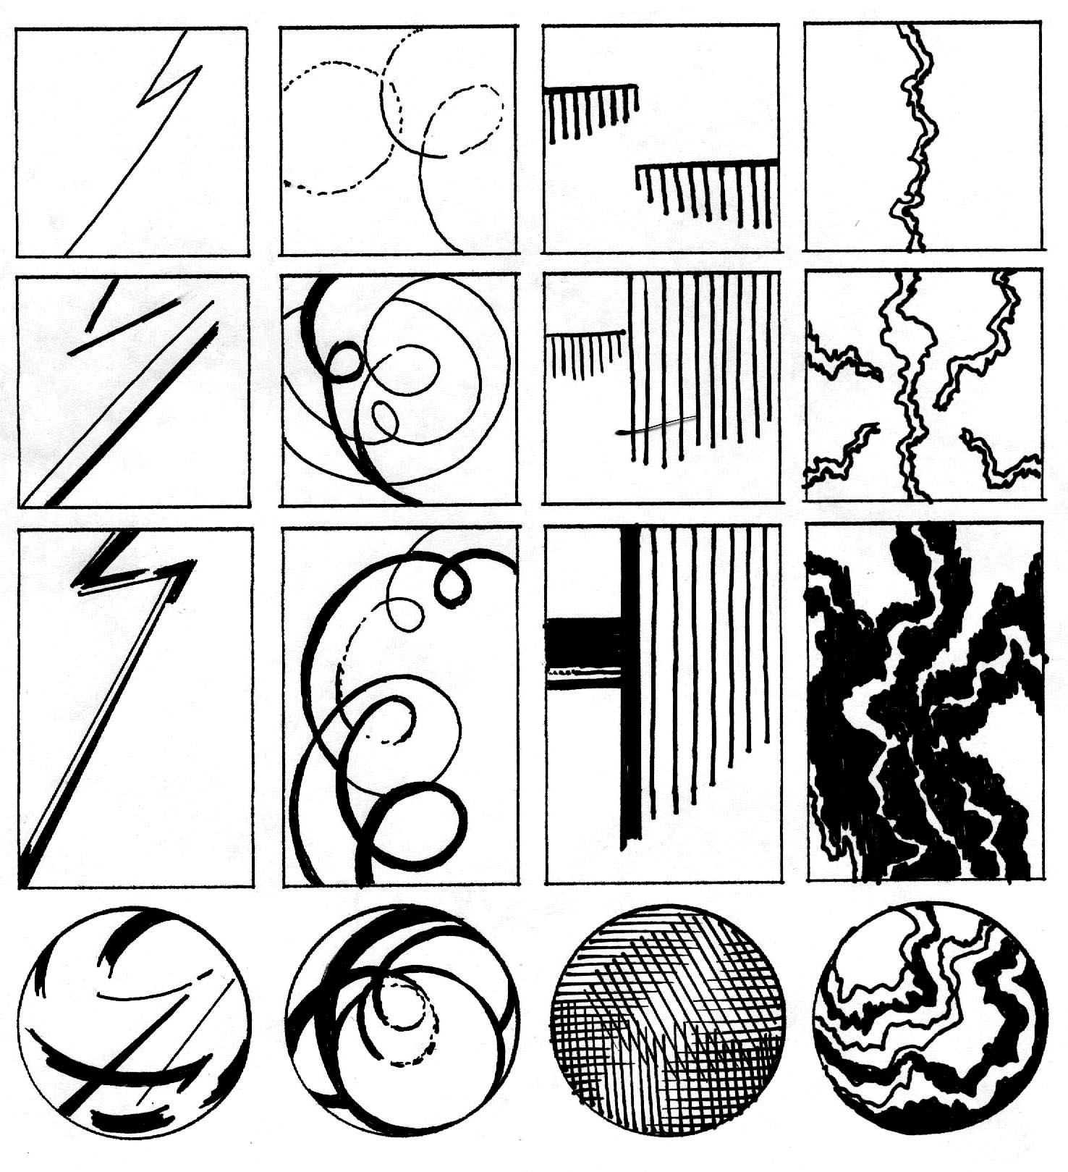
“The art of teaching is the art of assisting discovery.”
-Mark Van Doren, 1965

FOUR LINES, FOUR TIMES

Problem: Using the template provided, explore ways in which four straight, four curving, and four jagged lines can be used to create simple compositions. In the final column, use all four types of lines to create more complex compositions.

Objectives:
- To create simple linear compositions
- To explore uses of the illusion of movement and the illusion of space
- To begin to build the habit of making thumbnail sketches.

Materials: Photocopies of the template (card stock recommended); felt pen

Strategy: Four lines are used in each of the sixteen compositions in this exercise. In the first twelve studies, a single type of line is repeated four times. In the final four studies, three different types of line are used in each composition. Consider:
- What are the advantages of using just one type of line in a composition?
- What are the advantages of working with different kinds of lines?
- What is the effect of variations in line weight?
- How can line velocity be increased or decreased?

Reading: Pages 13 to 22
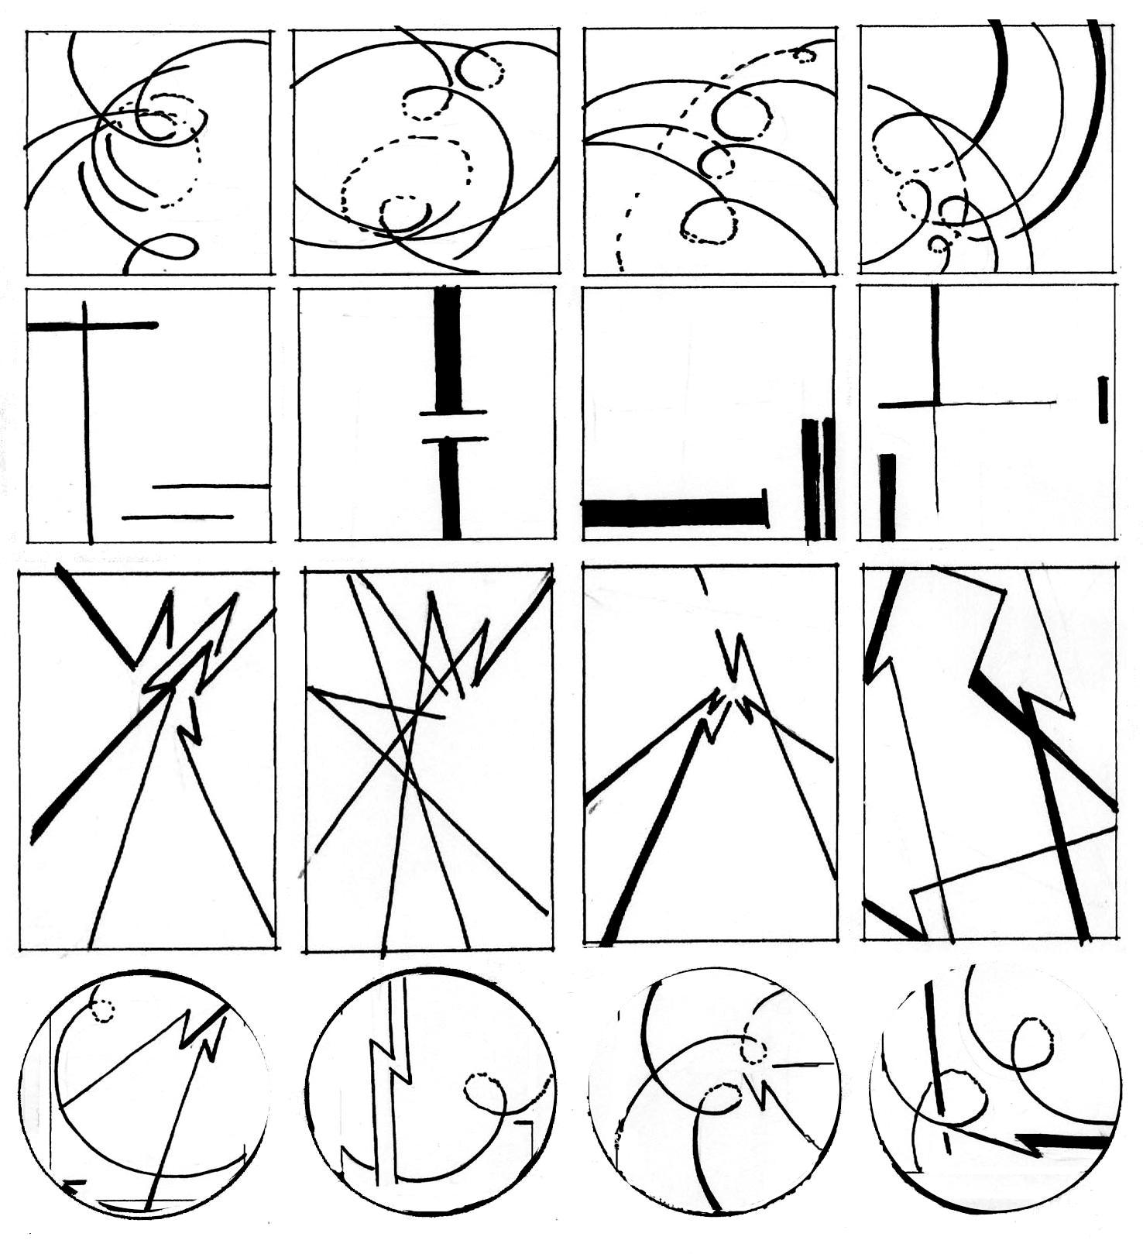
Instructor’s Notes: It has often been said that the first line we draw is the fifth line in the composition. In this exercise, pay particular attention to the four edges of the rectangular format.
It is a good idea to let students explore on their own first. When they have completed a page of studies, start the critique by asking:
• How does line continuity or discontinuity affect the design?
• What happens when a line appears to extend beyond the format edge?
• How can lines be used to move our eyes around the composition?

Timetable: 15 minutes for drawing, 30 minutes for discussion, possibly in teams.
LINE DYNAMICS

Problem: Develop three dynamic, non-objective designs, using line, shape and texture.

Objectives:
- To fully engage the edges of each composition.
- To create an illusion of space.
- To experiment with forms of balance.
- To explore ways of increasing visual impact.

Materials: Black felt markers and four or eight sheets of 18" x 24" drawing paper

Strategy: Use thumbnail sketches to rough draft at least ten ideas.
- Pay special attention to the edge of the composition. When a line or shape intersects this edge, the composition can to visually extend beyond the page and into the viewer’s world.
- Overlap, variations in size, location, and degrees of definition can be used to increase the illusion of space. The illusion of space gives more room for movement, increasing the overall energy in the design.
- Experiment with forms and degrees of balance. Symmetrical balance is often used when stability is needed, while asymmetrical balance is generally more dynamic.

Reading: Chapters 1 and 3

Instructor’s Notes: Working in larger scale, students can more fully explore the inherent dynamism of line. Dynamic designs are generally dominated by diagonals and curves, which tend to suggest movement and imply change. When lines are connected, shapes can be formed, adding variety and complexity to the design.
This seemingly simple assignment can actually provide an overview of the elements and principles of design. To create a dynamic design, students must understand balance and use it effectively. By creating the illusion of space, they can suggest movement from foreground to background. And, a focal point can provide a dramatic pivot point for the entire composition.
As shown in figure 3.22, an empty cardboard box can be used to physically demonstrate the meaning of the words “static” and “dynamic.” Simple blackboard drawings can be used to show various ways to create the illusion of space.
Beyond this basic information, it is best to simply respond to the designs the students produce, especially noting means by which compositions have been unified, describing dominant and subordinate visual patterns, and applauding areas of strength. Consider:
- How deep is the space in the composition?
- How does spatial depth contribute to visual dynamism?
- Is there a dominant movement in the composition?
- If so, how was this movement created?
Timetable: 15-40 minutes per drawing, 15-40 minutes per critique. Continually alternating between drawing and critique works well.

SHAPE INVENTORY

Problem: Using the template provided, place four different kinds of shape in the top row of squares. Invent a series of variations on each shape in the columns below.

Objectives:
- To explore different types of shape
- To demonstrate the unique power of each type of shape
- To expand use of thumbnail sketches.

Materials: Photocopies of the template (card stock recommended) and felt pen

Strategy: Explore the unique power of rectilinear, curvilinear, geometric and organic shapes.

Reading: Pages 22 to 33

Instructor’s Notes: A shape is created when a line connects to enclose an area; an area of color or texture is defined by a clear boundary, or when an area is surrounded. Open shapes are generally buoyant; closed shapes are generally more substantial. Gradation can be used to add the illusion of space. Creating a dialog between the positive shape (or figure) and the surrounding area (or ground) is an essential aspect of design.
After students have experimented on their own, it is useful to describe various kinds of shape and their applications. Note the implications of the format itself: generally, we create a very different design when using a circular format instead of a rectilinear format.
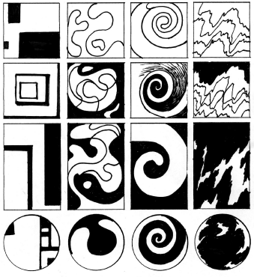
Timetable:
20 minutes drawing, 30 minutes for discussion

THE PARTS AND THE PUZZLE

Problem: Working with a curvilinear shape, a line, and a simple rectilinear shape, create a minimum of six compositions within a 3:4 format. Any 3:4 relationship will work: 3" x 4,” 6" x 8,” 9" x 12.”
Objective: This assignment requires imaginative thinking within strict limitations. You will be put in a box, then invited to break your way out. Seek
- To create the widest possible range of solutions while meeting the limitations
- To use negative shapes to increase compositional complexity
- To fully use every square inch of the composition.

Materials: Four sheets of Coloraid paper (any contrasting colors), Bristol paper, backing and adhesive. This assignment can also be done digitally.
Strategy:
First, be sure you understand the game rules.
- Any type of curvilinear shape can be used, from a circle to an amoeba. Any type of line can be used. The rectilinear shape cannot have more than ten perpendicular angles.
- You must use the same three components in each study. Thus, if you choose a jagged line for the first study, a jagged line must be used in all subsequent studies. If you choose a square for the first study, a square must appear in every study.
- Any component can be multiplied as needed. For example, you could have 2 squares, 2 circles, and two straight lines in one of your studies. However, do not exceed a total of 6 positive shapes.
- Any component can be enlarged or reduced as needed.
- Any shapes that extend beyond the boundary should be cut off.
There are two equally effective approaches to this assignment.
1. Develop at least 20 solutions, via thumbnail sketches, choose the best six, then finalize using Coloraid paper.
2. Cut out at least 20 of your curvilinear shape, 20 lines, and 20 rectilinear shapes in various sizes. Play around for a while, experimenting with various ways of relating the shapes. Then, organize them to create the six compositions required.

Reading: Pages 74 to 95

Instructor’s Notes: Buckminster Fuller, one of the most influential of American designers, described design as “the character of the organization of relationships.” Thus defined, individual components are less important that the interdependent means by which they are organized. This assignment gives students experience with the design process as well as a design product. The seemingly intractable limitations can actually be used to stimulate creative thinking, as they seek to “break out” of the box. Awareness of the interplay between negative and positive shapes, proximity, dominance and subordination, and balance can help students refine their compositions.
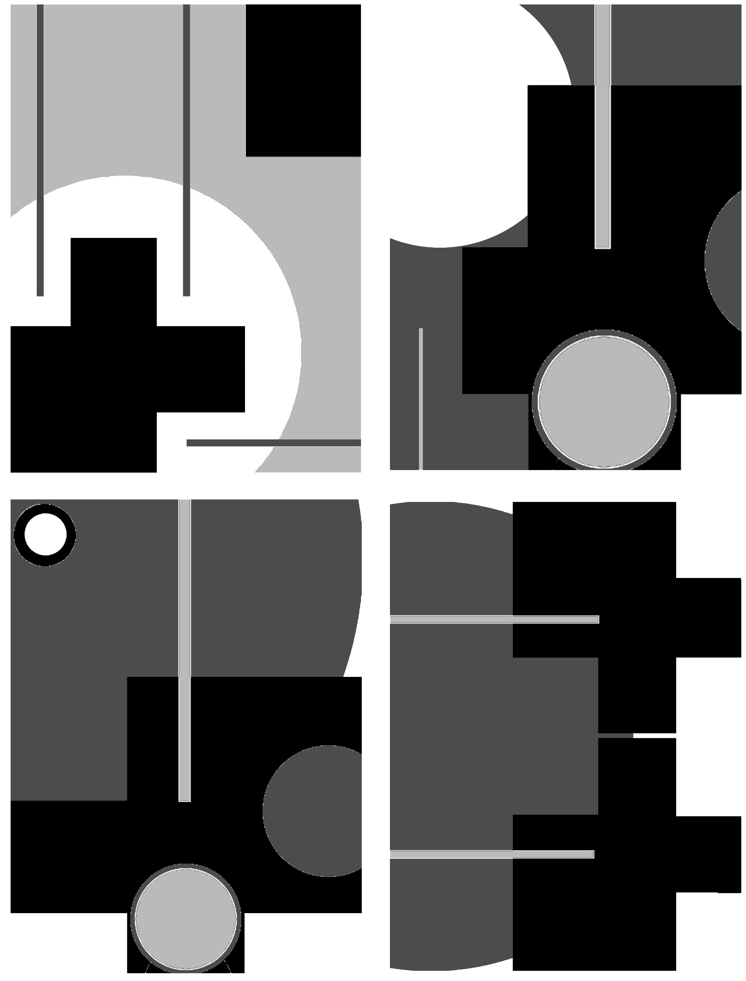
Timetable: 6-9 hours
BALANCING ACT
(Inspired by an assignment in Visual Literacy, by Richard Wilde & Judith Wilde, Watson-Guptill 1993, pages 16-27)

Problem: Using the template provided, organize four squares and one circle in such a way as to communicate two of the following words: trapped, escape, order, individuality, opposition.

Objectives:
- To demonstrate the effect of the format on balance
- To make a direct connection between composition and concept.

Materials: Felt markers or cut paper. This assignment can also be done digitally.

Strategy: Brainstorm at least 40 variations using the template provided, Then, complete 4 refined versions of the design, using a 6"x6" square; a 6" circle, or a 6"x9" horizontal rectangle. The circle and three squares can be any size, and the four shapes can be connected or overlapped as necessary.

Reading: Pages 74 to 95

Instructor’s Notes: This seemingly simple assignment can become remarkably complex. It is best to start with solid shapes, using variations in size, orientation and proximity to convey the four concepts given. To expand the project, more experienced students can experiment with open shapes, gradated shapes, and figure ground reversal.

Timetable: 4 hours trapped escape individuality opposition
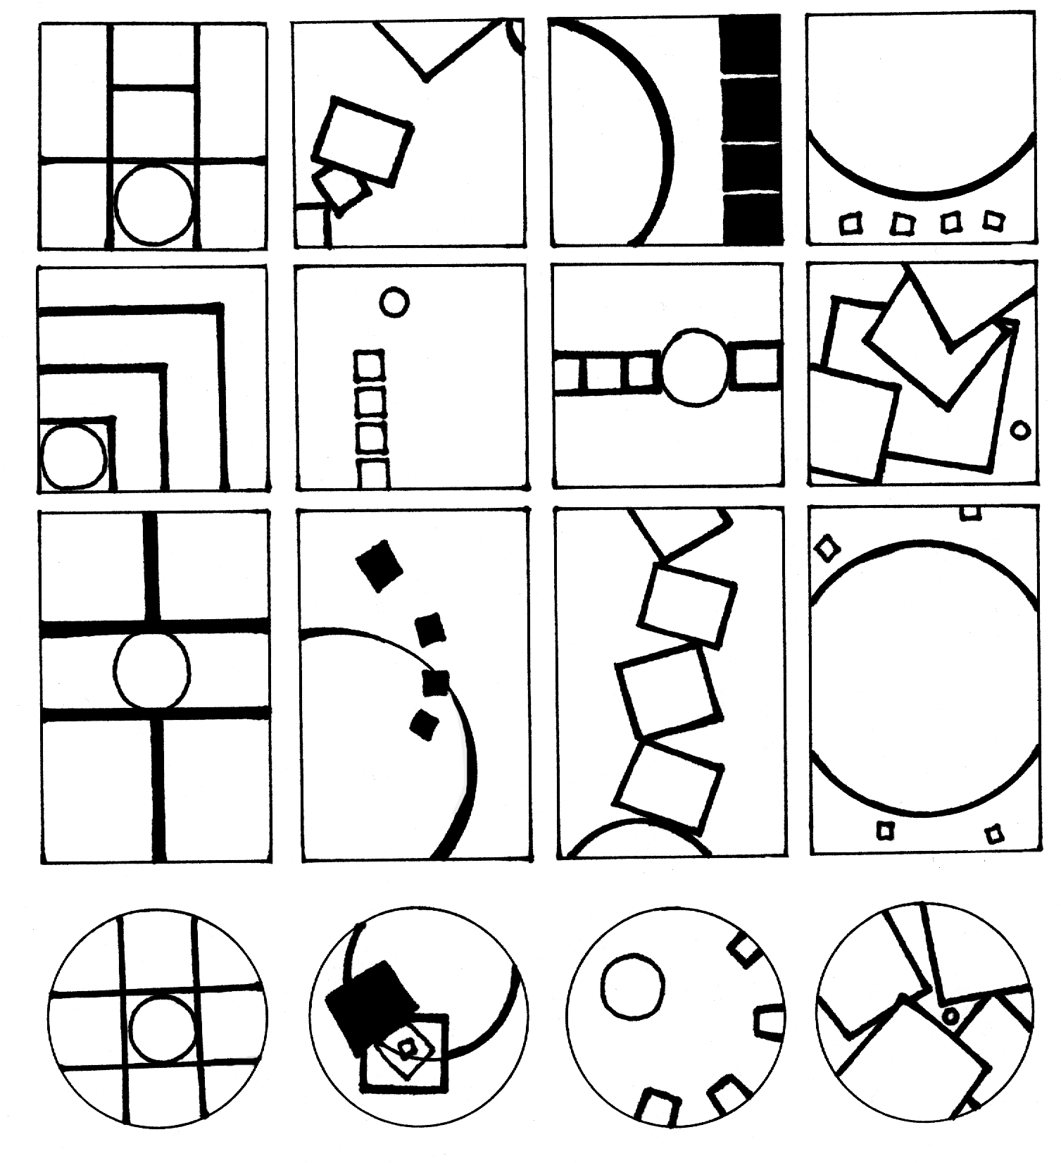

TEXTURE INVENTORY

Problem: Using the template provided, draw four kinds of texture in the first row of squares. Invent a series of variations in the columns below.

Objectives:
- To invent as many types of texture as possible
- To continue to explore the use of different formats.

Materials: Photocopies of the template and writing pens.

Strategy: Experiment with textural density, direction and variety. Try to alter or enhance the viewer’s understanding of the format through the textures used.

Reading: Pages 33 to 38

Instructor’s Notes: Texture determines the surface quality of a two-dimensional shape or a three-dimensional form. Physical texture can actually be felt. Visual texture, which is created using multiple shapes or through simulation of physical texture, can be seen but not felt. Through an appeal to our senses, texture creates a unique connection between the artwork and the audience.
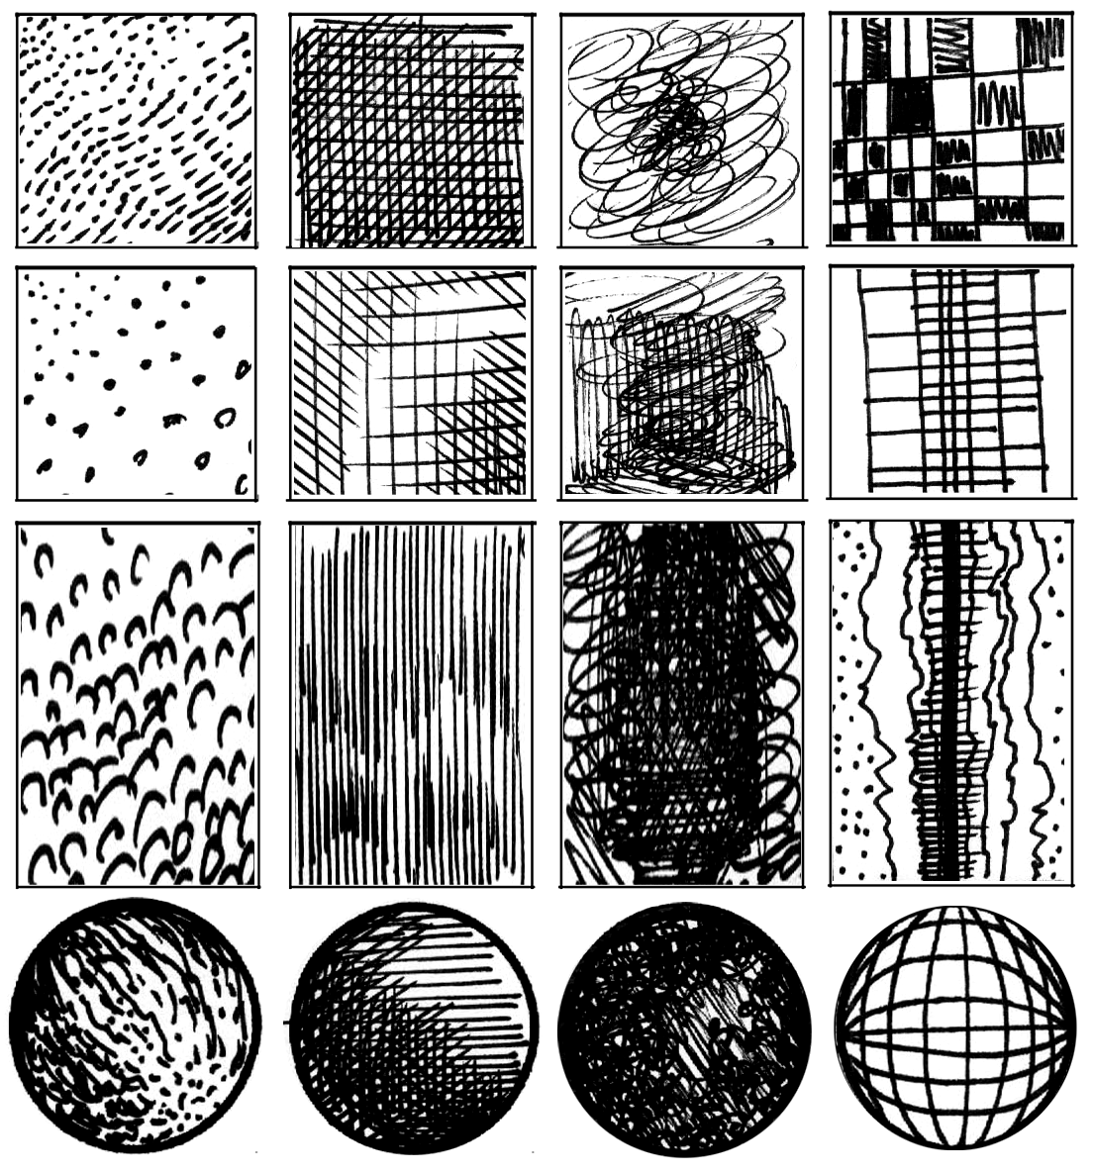

OBJECT LESSON

Problem: Analyze a single object hand-held in depth. Complete three designs:
• Version 1: a black and white analysis of the lines, shapes and textures on the surface and interior of the object,
• Version 2: a black, white and gray study animating the object, creating an implosion, explosion or a spinning effect,
• Version 3: a study in color adding a single word to create a metaphor or analogy.

Objectives: This is the first assignment with substantial conceptual potential. Assessment will be based on:
- Sensitive and eloquent translation of the object into an image.
- Compositional integrity. Is every square inch of the design being used fully?
- Inventiveness. How can an ordinary object become a fascinating design?
- Degree of idea transformation. How much change occurs from version to version?
- Conceptual Expansion. What is the most effective use of metaphor?

Materials: Markers, felt pens, illustration board and various color materials.

Recommended Objects: seed pods, bottles of pills, clock parts, etc.

Strategy:
Version 1
1. Start with a hand-held object that can be opened and is varied in texture.
2. Draw the object from various views. Analyze how it is constructed, noting every detail.
3. Choose the most interesting view or combine several views to create an interesting black and white design. The design can mostly be done with line, can combine lines with solid shapes of black and white, or can combine line, shape and texture (such as dots or networks of small lines). Use every square inch of the format to the best advantage. Note especially how the corners and edges of the design are used.
4. Make 10 photocopies of the resulting design. Make at least two copies at the original size, plus various enlargements and reductions.
Version 2:
1. Cut apart the photocopies, then scotch tape them back together to create a collage. Use superimposition (layering) and repetition to make the object appear to rotate, explode, or implode.
2. Based on this collage, create a second design in black, white and gray.
Version 3:
1. Think of a word that will expand the meaning of your object. What happens when the word “hidden” is combined with a wallet full of ID cards? Or "anger" is combined with a broken doll?
2. In the final version of the assignment, combine the word and the image to create a compelling color version of the object.

Reading: Chapters 1 and 5

Instructor’s Notes: This is a complex assignment, requiring more time and deeper investigation. A thesaurus and a dictionary can help students expand their ideas in the final stage.

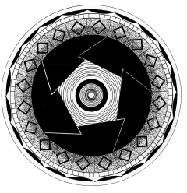

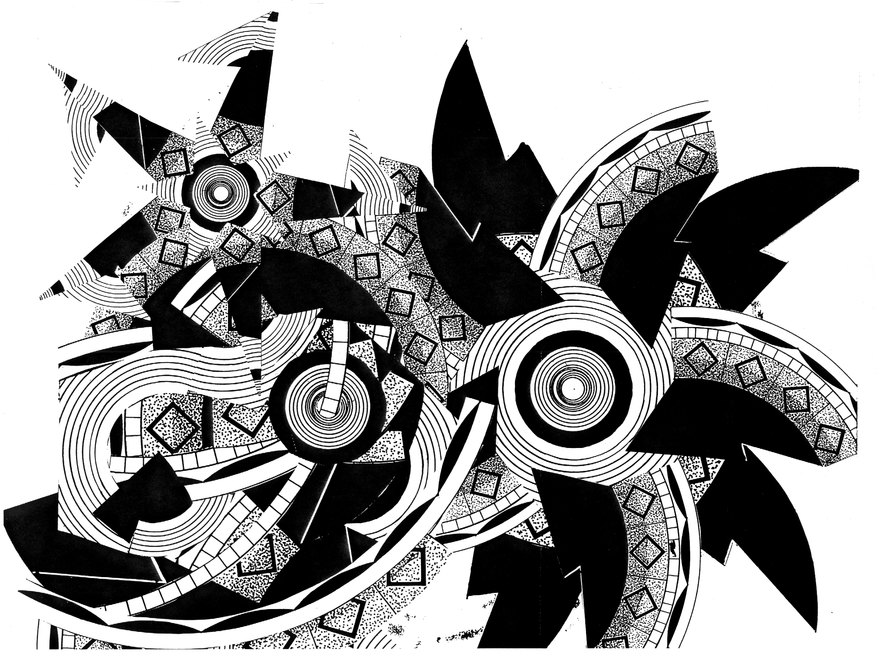
Object Lesson – Step one

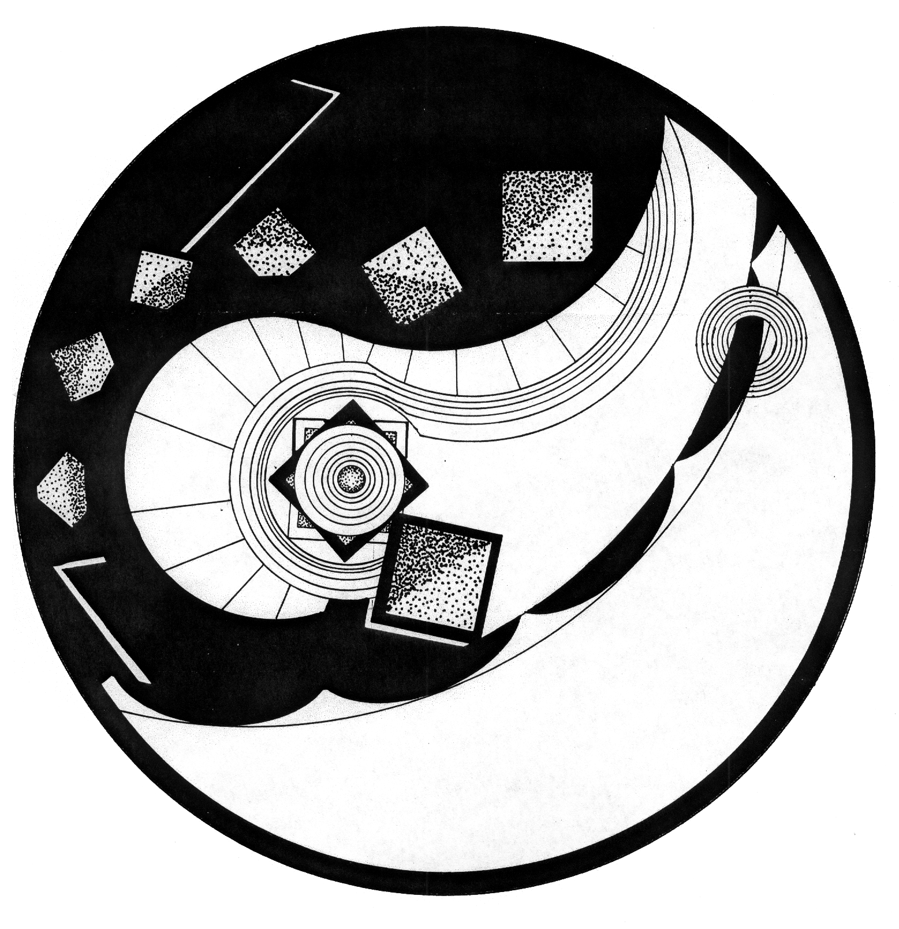

Object Lesson – Step two collage

Object Lesson – Step two design
PAPER CUT PROJECT
Assignment created by Janae Easton, Florida State University

Problem:
Create an 11x17” or larger design, using three layers of paper plus negative space.

Objectives:
- To create an active dialog between positive and negative.
- To create a well balanced composition that utilizes foreground, middle ground, and background.

To evoke texture with variations in line.

To use variations in line and shape to add energy to a composition.

Materials and Directions;
- X-acto knife, and extra blades: You will want to change blades frequently. This will allow for the smoothest cuts, as well as clean lines.
- Matte cutting board: this will allow your blade to sink into the matte, which will allow for a smooth line.
- Glue for mounting paper: many students have suggested using the glue pens to dab small amounts of glue on the back of the finished cut paper.
- Illustration or matte board to mount paper onto
- Canson paper: I have seen the best results with this paper. It has a great weight and comes in a large variety of colors.
- Carbon paper: some students use carbon paper to copy their drawing onto the final paper.

Strategy
1. You will research your subject, bringing in several images of examples of how you want your paper cut to look. The focus will be on positive and negative shapes to create a dynamic cut paper image.
2. Use your drawing skills to create an interesting design, images, or pattern, which may be non-objective, stylized or naturalistic.
3. Copy your design onto your final paper where you will be making the necessary cuts to illuminate the original drawing.
- You will decide if you will use one sheet of paper, or several to layer your image. The final image will be cut from a flat sheet of paper, not folded.
- You will invest a great amount of time in revealing the intricate details of your subject.

Timetable
20 hours in and out of class

Instructor’s Notes
We will look at the history of paper cuts, as well as contemporary examples of artists’ that use cut paper in their own work. Many of the artists we will look at consider space, be it personal, landscape, memory or literal. Think about spaces and your relationship to space as a place to get started.

Artists to look at for further inspiration
Mexican, Amish and Chinese Paper cuts David Thorpe
Kako Ueda, http://www.kakoueda.com/ Simon Periton,
Chris Natrop Paper Forest—a great blog on paper arts

ESSENCE/TOTALITY

Problem: Create an abstract composition based on a complex still life. In your composition convey the essence and/or the totality of the set-up.

Objectives:
- To practice pulling abstract shapes from actual objects
- To explore various degrees of representation.
- To explore personal interpretations of reality.

Materials: 18" x 24" drawing paper and other materials of your choice.

Strategy:
1. Look carefully at the set-up. All of the tables, stools, mirrors, etc. contained within the masking tape line on the floor and extending directly up to the ceiling can be considered part of the problem.
2. Begin recording your thoughts visually. For the sake of clarity, focus first on the question of essence. What qualities distinguish this set-up from any other set-up you have seen? What is the distribution of negative and positive space? Is the set-up dominated by diagonal lines? Is there any apparent pattern in the distribution or orientation of the objects?
3. Next, consider the question of totality. Study the set-up from all sides and if possible, climb inside it. Draw close-ups as well as distance shots. Many small sketches will help you to translate your ideas into images.
4. Then, begin to develop a more refined design. Avoid the two wrong answers to this assignment. First, do not do a conventional, representational drawing: this is a problem in abstraction. Second, do not replace the “boring” tables, chairs, etc. with unrelated subject matter, no matter how thrilling: no tables transformed into race cars, please! This is an abstraction problem requiring scrutiny of the actual objects and their relationships.

Reading: Pages 28 to 33

Instructor’s Notes: There is no such thing as a truly “realistic” drawing. The actual time and space of the physical world can only be suggested when we are working two-dimensionally.

Some artists and designers embrace this separation between drawing and reality and make no effort to create an illusory world on a flat surface. Others embrace the visual world and use perspective and lighting to create a convincing illusion. Most artists and designers use reality as a springboard for their imagination. Excellent artwork can be made using any of these approaches.

The textbook provides these terms to describe the various degrees of representation:
- Representational images are derived from specific subject matter and strongly suggest perceptual reality.
- Non-objective images are created without reference to specific subject matter. No attempt is made to reference the visual world.
- Between these two extremes, abstract images are derived from a perceptual source, but are so transformed that they bear little resemblance to the referent.
This assignment gives students a chance to explore degrees of abstraction and to discuss their personal perceptions of reality.

Be sure that you have at least an hour for constructing the set-up. It needs to be large and complex. Ordinary studio furniture works well; adding a mirror or two will give it pizzazz. Building a dominant movement into the composition (such as a spiral) will help students understand the concept of totality.

Take time at the beginning of class to define the words essence and totality. While these are common words, students generally need help in understanding their visual implications. As the students begin to unravel the problem, encourage, prod and cajole—but do not direct. Many beginners will be unfamiliar with abstraction and confused at first. Ask questions rather than suggesting solutions, and give them lots of encouragement. Showing slides midway through the sessions can help a lot.

Timetable: 3 hours in class, 6 hours for homework.

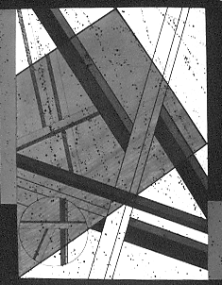
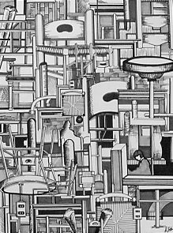
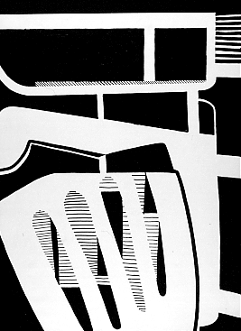

Essence/Totality: exploring abstraction – examples of students’ work.

ARCHITECTURAL ABSTRACTION

Problem: Using the template provided, distill the lines and shapes from three architectural fragments to create a series of elegant line drawings. Each composition should then be drawn a second time to increase its power. In the second drawing, delete all extraneous information.

Objective: To use line in perception-based drawing and to provide a basic introduction to perspective.

Materials: Photocopies of the template (card stock recommended) and writing pens.

Strategy:
1. A 3" x 4" window cut from a 5" x 7" piece of poster board, can help you identify the most promising compositions. Especially note repetitions and intersections among lines and try to use each of the four corners in the composition in a different way.
2. If you have difficulty determining how to draw a line that extends back in space, place your pencil directly in front of your poster board window. Rotate the pencil until it appears to rest on the line you wish to draw, note the angle needed, and transfer it to your drawing.
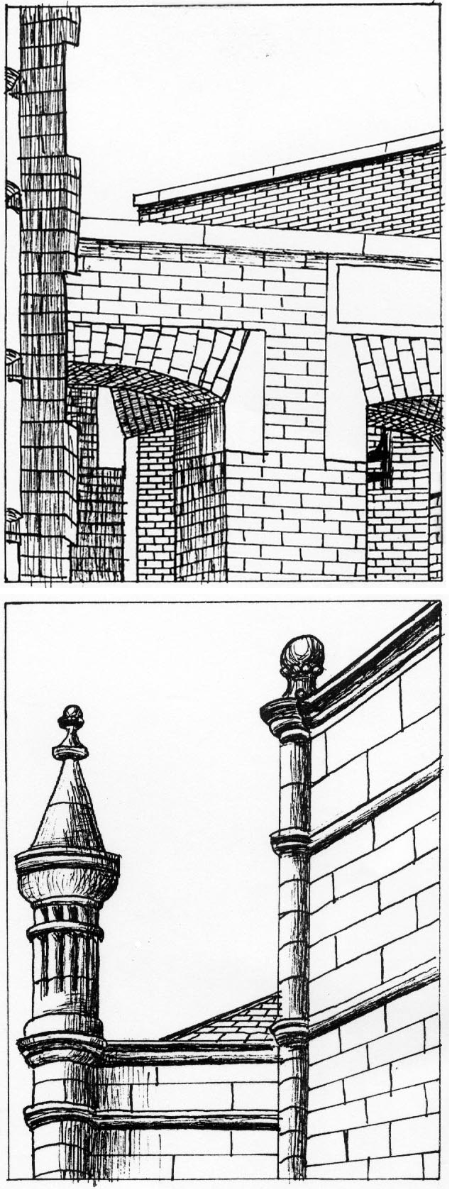
3. Establish a basic composition first, and then refine it in the remaining three boxes. Try creating one composition that is 75% white/ 25% black, another that is about equally black and white, and a third that is roughly 75% black and 25% white. Stippling (shading using tiny dots) can be used to add interest.

Reading: Pages 3-13 to 3-37

Notes: A boundary is the point at which images; objects, ideas or experiences separate or connect. Lines can create boundaries quickly and easily. In this exercise, lines are used to define the architectural boundaries. Encourage students to look for interesting room corners, staircases, rooftops and corridors and note similarities between the previous non-objective work and this assignment in abstraction.
• how is the edge of the format being used?
• what is the effect of variations in line weight?
• how are we visually directed around the composition?
Note differences between the previous non-objective work and this assignment in abstraction.
• Are there any surprises presented by perceptual reality?
• what is the impact of the illusion of space?
• by what means can architectural fragments be transformed into compelling compositions?

Timetable: 30-40 minutes per study. This is an excellent homework assignment.

“He teaches not by speech, but by accomplishment.”
Lao-Tzu, 6th century BC

LABYRINTH COLLAGE AND BOOK

Problem:
Part 1: Transform an interesting building on campus into an 18”x24” visual labyrinth.
Part 2: Redesign this labyrinth image to create a sixteen-page 11”x7.5” book.

Objectives:
- To experiment with the role of chance in the creative process.
- To explore the unique advantages of a multiple-image narrative.
- To expand connections between concept and composition.

Materials: 18”x24” white paper, markers, 3 Prismacolor pencils (including at least one metallic), 1 sheet 22”x30” black Arches paper, photocopies

Strategy: Consider every possible definition and visualization for the word “labyrinth.”
lab-y-rinth: 1: a structure full of intricate passageways that make it difficult to find the way from the interior to the entrance or from the entrance to the center (for example, the labyrinth constructed by Daedalus in which the Minotaur was confined) 2: a maze in a park or garden formed by paths separated by high, thick hedges 3: something bewilderingly involved or tortuous in structure: a complex that baffles exploration 4: a situation from which it is difficult to extricate oneself 5: the internal ear, or its bony or membranous part 5: a body structure made up of a maze of cavities and channels 6: intricate, sometimes symbolic pattern, such as pattern inlaid in the pavement of a medieval church 7: in metallurgy, series of troughs through which water passes for washing pulverized ore.

1. Using a thesaurus, make a list of words and ideas your associate with a labyrinth: confusion, traps, mystery, and so forth. Invent as many approaches and ideas as you can: is a symphony a labyrinth? Is DNA a labyrinth? Is the presidential election a labyrinth?
2. Make at least twenty drawings of various doorways, staircases, room corners, textures and so on. (This can be done using the Architectural Abstraction assignment.) Multiply and combine these drawings to create a complex collage of architectural shapes, then complete an 18”x24” design based on this collage.
3. After an extensive critique of this design, refine and lightly re-draw the image on the front and back of the sheet of black Arches. Re-drawing the full design on the front and an enlarged fragment of the design on the back tends to work well.
4. Begin elaborating on the design, lightly working up the shapes using Prismacolors.
5. When the drawings are about 50% developed, tear the paper into four 7.5”x22” strips.
6. Fold the strips in half and organize in either a dowel book format or a codex book format. At least an hour should be spent organizing the pages—they can be inverted or folded from inside out. Seek visual flow from page to page.
7. Re-draw as necessary to integrate the entire composition and add drama.
8. Bind the book and finalize the drawings.

Reading: Pages 318 to 322 and 344 to 354

Instructor’s Notes:
This assignment consistently results in an astonishing array of inventive books. Some students introduce characters into the setting, creating a simple narrative. Others use the illusion to space to move the viewer through mysterious corridors and down precipitous staircases. Others use light and pattern to create a world of enchantment and beauty. Because the word "labyrinth" is so open to interpretation, the generative potential is great.

TRUE LIES: DESIGNING FICTION

PROBLEM: Use a minimum of twelve photographs to tell a story
OBJECTIVES:
- To research a complex visual idea
- To express this idea effectively using visual narrative
- To strengthen time management skills
MATERIALS: Photocopies or computer prints and other materials as needed

STRATEGY:
WEEK 1: Using library resources, find twelve or more great photographs. Then, using a copier or Photoshop, enlarge, reduce, superimpose and collage images as necessary to make your first version of the story.
DISCUSSION FOCUS: SOURCES
Conceptual Sources. Anything you have ever seen, read, or felt can provide the beginning point for this project
Visual Sources: Anything in the library is fair game. The twelve basic source images must be derived from books or magazines, not from the Internet. This will improve image quality and give you an opportunity to explore library offerings.
Verbal Sources. Do you need background information on your topic? Oral histories and documentary videos can be especially useful.

WEEK 2: Present your images and ideas in a small group discussion. Bring three questions and one great example of a visual narrative to this meeting. Then, continue work, expanding and refining your idea.
DISCUSSION FOCUS: STRUCTURE
Narrative structure. What sequential organization will best convey your idea? Should the story be told from a particular point of view? To what degree need characters be developed?
Format. What is the best structure? A codex book? A family album? A file folder? A triptych of three hinged panels? Consider what you want to show, how to show it, and when to show it.
Editing. How many images are needed, and how complex need they be?
Openings and Closings: where does the story begin and end? Why?

WEEK 3: In the small group discussion, present your final draft as a rough cut--all images and ideas developed and format determined. Final refinements and construction should be the only remaining tasks.
DISCUSSION FOCUS: DRAMA
Image manipulation. How can the source images be transformed and integrated into the final piece? To what degree should images be enlarged, blurred, or combined?
Repetition. Photocopies are inherently repetitive. Can this be used to increase visual or emotional impact?
Pivot points and focal points. If you are working with a single large mural, is there a specific focal point? If you are working with a book or video, is there a pivot point, a moment in which the direction of the story is altered?
WEEK 4: Critique. The results will be quite varied, and everyone will want substantial feedback on his or her project. Use this time to hone your critiquing skills! Consider:
- What stories most intrigue you? Why?
- How compelling are the images presented?
- Was the re-structure chosen appropriate for the idea or emotion presented?
- If you were to re-do the project, how would you strengthen the results?
Reading: Chapters 5 , 12, 13 Timetable: 30 hours, in and out of class
HOMAGE TO HOCKNEY
Inspired by an assignment by Gail Hoffman, Syracuse University

Problem: Make at least 36 photographs of a single person or a single site at various times of day. Take the film to a commercial lab and get at least 72 prints made from this roll. Cut and paste the resulting prints to create a complex collage.

Objective: To explore relationships between time and space.

Materials: One 36-exposure roll of film, 72 color prints, adhesive and illustration board

Strategy: First look at your surroundings. What buildings are most interesting? What happens in the laundry room? What different positions does your roommate take as she studies for an exam? Dynamic subject matter makes this problem easier to solve, so look for sites you can traverse or for subject matter that moves.
Then, consider the type of composite image that will best express your subject matter. Some of the options include:
• A panoramic scene,
• A small object that will appear monumental,
• An interior, showing all four walls,
• A person in motion, seen from various positions.

Reading: Pages 3-30 to 3-37

Instructor’s Notes: This assignment is both simple and complex. The photographic process itself heightens awareness of time and space. When the images are combined to create the collage, proximity, continuity and closure become as important as time and space. The assignment can be expanded by using additional photocopies of the source images or by working digitally.

Timetable: 3 hours for the photography, 4-6 hours for the collage

“More important than the curriculum is the question of the methods of teaching and the spirit in which the teaching is given.”
-Bertrand Russell, 1926

SAMPLE SYLLABUS: COLOR THEORY FOUNDATIONS

ART 2XXX: Section 10, FALL 07 Monday/Wednesday 9:05-11:35, FAB 107
Professor Jane Doe jdoe@fsu.edu Office Hours: Monday/Wednesday 11:45-12:30

Course Description: Experiments in color perception combined with uses of color in visual communication and visual expression.

Course Format: Lecture, experimentation, facilitated discussions and hands-on work.
This course is divided into two parts. Roughly half of the time will be devoted to color exercises and experiments. These studies will include work with hue, value, saturation, warm and cool interactions, and push/pull. The remaining half will be devoted to a series of assignments using color to expand communication and expression.

Outcomes:
Upon successful completion of this course, students will be able to:
- Articulate an understanding of the historical evolution of color theory including discussion of Albers, Itten, Hofmann, and Munsell;
- Demonstrate how visual communication and expression are affected by color choices;
- Effectively use color theory to expand critical and creative thinking;
- Use color to strengthen personal artwork.

Recommended Text:
Color: A Workshop Approach, David Hornung, McGraw-Hill. 2005

Assessment: Grades are based on four major factors.
- Perceptual Sensitivity. Is the work coloristically inventive? Have you gone beyond clichés? Do your color choices effectively advance your conceptual intentions?
- Compositional Cohesion. Is every square inch of the composition fully engaged? Is the image appropriately unified? Energized? Balanced? Well crafted?
- Learning Process. Did you use class time effectively and come prepared? Did you take risks? How many solutions did you invent for each problem?
- Critical Thinking. How substantial were your contributions to team meetings and critiques?

Attendance: Attendance is required. Your grade will drop by one letter for every unexcused absence beyond three. It is impossible to fully “make up” missed demonstrations or critiques, and getting the information second-hand is inadequate. Arriving late also derails learning. If you miss more than 8 hours of class for any reason, you are likely to receive a final grade of C- or below. For details on University approved excused absences, go to: http://www.fsu.edu/~fasenate/attendance.html.

Grades will be defined as follows:
A = Outstanding competence. Expansive investigation of ideas; excellent composition and/or construction. All assignments completed on time, with at least one extra credit project done well. Insightful contributions to critiques. Goes well beyond minimum requirements.
B = Above average competence: Substantial investigation of ideas, very good composition and/or construction. All assignments completed on time, good contributions to critiques.
C = Average competence. Assignments done competently and completed on time.
D= Marginal work, due to two or more late projects, limited investigation of ideas, poor craft, incoherent compositions, minimal contribution to critiques. May have more than 3 absences.
F = Unsatisfactory work. Course failure due to minimal idea development, poor craft, disjointed compositions, lack of participation, late assignments. May have over 6 absences.
Note: One project will be accepted one day late without penalty. One additional late project will be accepted with a one letter-grade penalty for each day it is late.

Attention: Please silence your cell phone during class. If you are in the midst of a family crisis (such as a parent in the hospital), put it on vibrate and let me know that you may have to leave during class.
Incompletes: A grade of Incomplete can only be assigned to students with an otherwise passing grade who are unable to complete the course due to some serious illness or personal tragedy. Incompletes are not given lightly.

ACADEMIC HONOR Policy: The Florida State University Academic Honor Policy outlines the University’s expectations for the integrity of students’ academic work, the procedures for resolving alleged violations of those expectations, and the rights and responsibilities of students and faculty members throughout the process. Students are responsible for reading the Academic Honor Policy and for living up to their pledge to “. . . be honest and truthful and . . . [to] strive for personal and institutional integrity at Florida State University.” (Florida State University Academic Honor Policy, found at http://dof.fsu.edu/honorpolicy.htm.)

AMERICANS WITH DISABILITIES ACT (ADA):
IF THERE IS ANYONE WHO NEEDS AN ACCOMODATION DUE TO A DISABILITY, PLEASE BRING IT TO THE INSTRUCTOR’S ATTENTION.

Students with disabilities needing academic accommodation should:
- register with and provide documentation to the student Disability Resource Center;
2. bring a letter to the instructor indicating the need for accommodation and what type. This should be done during the first week of class.

For more information about services available to FSU students with disabilities contact the
Student Disability Resource Center, 97 Woodward Avenue, South, Florida State University, Tallahassee, FL 32306-4167 (850) 644-9566 (voice) (850) 644-8504 (TDD) sdrc@admin.fsu.edu http://www.fsu.edu/staffair/dean/StudentDisability/
(This syllabus and other class materials are available in alternative format upon request.)

Materials:
Gouache: lemon yellow, golden yellow, ultramarine blue (deep), sky blue, alizarin crimson, scarlet, burnt sienna, yellow ocher, Payne’s gray, raw umber, large tube of permanent white
9x12” two-ply vellum Bristol board, water container and paper towels, ½ inch flat aquarelle brush, permanent glue stick, scissors and a utility knife, plastic cup palette, toolbox, portfolio.

PROJECTED SEQUENCE OF LECTURES AND ASSIGNMENTS
WEEK 1: Seeing Color. Introduction of Subtractive and Additive systems, experiments with incandescent, florescent and natural light, introduction to simultaneous contrast and Bezold effect.

WEEK 2: Characteristics of Color. Experiments with variations in hue, value and saturation.

WEEK 3: Color Systems and Traditional Harmonies. Focus on Itten and Munsell systems; monochromatic, complementary, analogous, split complementary and quadratic systems.
WEEK 4: The Power of Disharmony. Experiments with chromatic and achromatic grays, unexpected juxtapositions, shifts in proportion.

WEEKS 5 & 6: Combining Compositional and Coloristic Strengths. Use skills gained so far to dramatically re-invent and strengthen a previous project that you did in black and white.

WEEK 7: Simultaneous Contrast. Expanded studies, based on Albers assignment sequence.

WEEKS 8, 9: Push/Pull: Color and Space. Discussion of work of Hans Hofmann, experiments with warm and cool colors, variations in contrast, saturation, juxtapositions, proportions.

WEEKS 10 & 11: Invented Landscape. Using simultaneous contrast and push/pull, create an abstract landscape painting starting from an observed site.

WEEKS 12-15: Capstone Project. Create a series of three to nine variations on a theme, any subject, any medium, using color as a primary force in communication and expression. Each design must be able to exist in and of itself and as part of a more elaborate or ambitious design. The structural basis for each design and as a series will demonstrate your understanding of the basic elements of design according to the principles of color and design with which you have been working all semester.

SUGGESTED READING
Agoston, George A., Color Theory and Its Application in Art and Design, Springer-Verlag, Berlin and New York, 1979
Albers, Josef, Interaction of Color. Yale University Press, New Haven and London, 1963.
Bailey, Adrian, and Holloway, Adrian, The Book of Color Photography. Alfred A. Knopf, New York, 1979
Berry, Susan/Judy Martin, Designing With Color: How the Language of Color Works, North Light Books, Cincinnati, OH, 1991
Birren, Faber, Color Psychology and Color Therapy. University Books, New Hyde Park, New York, 1961
Chijiiwa, Hideaki, Color Harmony, Rockport Publishers, MA, 1987
Cunningham, Ben, A Life with Color, JPL Art Publishers, Texas, 1989
Forest, John, The Natural History of the Traditional Quilt, University of Texas Press, Austin, Texas 1995
Itten, Johannes, The Art of Color. Reinhold Publishing Corp., New York, 1961
Libby, W.C., Color and the Structural Sense. Prentice-Hall, Inc., Englewood Cliffs, New Jersey, 1974.
Kandinsky, Wassily, Concerning the Spiritual in Art. Wittenborn Art Books, Inc., New York, 1947
Klee, Paul, The Thinking Eye. Wittenborn Art Books, Inc., New York, 1961
Munsell, Albert H., A Color Notation. The Munsell Color Co., Baltimore, 1926
Norman, Richard B. Electronic Color, New York: Van Nostrand Reinhold, 1990.
Osborne, Roy, Lights and Pigments: Color Principles for Artists. Harper & Row, Publishers, New York, 1980.
Stewart, Mary, Launching the Imagination: A Comprehensive Guide to Basic Design, fourth edition. McGraw-Hill Publishers, New York, 2008.
Wong, Wucius, Principles of Color Design. Van Nostrand Reinhold, New York, 1987. Zettl, Herbert. Sight, Sound, Motion: Applied Media Aesthetics. 4th ed. Wadsworth, Belmont, California, 2004

COLOR CAPSTONE PROJECT GUIDELINES

Problem: Design and complete an ambitious project requiring at least 30 hours of work, in class and out, over a three week period, leading up to a final critique during exam week.

Objectives: In this project, you will need to demonstrate the following:
- Extensive idea generation, resulting in numerous alternatives;
- Clear decision-making. Of the alternatives you invent, which will best convey your idea?
- Capacity to turn concepts into compositions;
- Self discipline and effective time management.
Materials: Your choice

Strategy: Assess your strengths, weaknesses, and interests. What would you most like
to explore in this final assignment? Create an assignment that is challenging and intriguing! Write up a clear, concise proposal, describing the project, suggesting questions to address, and determining how the work can best be completed.

Here is an example:
VISUALIZING THE INVISIBLE MAN Jane Doe janedoe@fsu.edu ART 2XXX

Description: I plan to complete a series of five 18x24” pastel drawings based on the concept of invisibility as defined by Ralph Ellison in The Invisible Man. The first and last images will serve as a prologue and epilogue, from the narrator’s point of view. The remaining three images will be designed to express the points of view of the three major characters in the book.
Primary Concerns:
- How many ways can I visually suggest invisibility?
- How can cropping and focus suggest invisibility on a more psychological level?
- How can I show the power plays that are so closely related to the concept of invisibility in the book?
- Should they work in any narrative way, or should each stand alone?
Time Management:
- Week One: Idea Development and Rough Drafts
- Week Two: Completion of two drawings.
- Week Three: Completion of three drawings.
- Week Four: Final Critique

HIDDEN MEANINGS #1

Problem:
Part 1: Using a 3" x 5" card and three letters or numbers as stencils, create a 8"x10.5" linear design in which some shapes are revealed while others are concealed.
Part 2: Expand the assignment, using letters and phots that inherently carry meaning.

Objectives:
- To create a lively dialog between figure and ground
- To experiment with closure, emphasis, and visual movement
- To integrate concept and composition.

Materials: Bristol paper and a mechanical pencil with HB lead. This assignment can also be done digitally

Strategy, Step 1:
1. Begin by tracing ten or more shapes on a 11”x14" piece of bristol paper, using the 3" x 5" card and the letters or numbers. Don’t worry too much about details at first. Just generate a lot of raw material by drawing too many shapes.
2. Delete about half of all of the lines and draw a border around the most interesting 8"x10.5" fragment. Consider which shapes are the most important and how the orientation and location of shapes can direct the viewer’s eye. Use overlap, transparency, and variations in size to emphasize some shapes while concealing others.
3. Then, add lines and shapes to create a balance between unity and variety.
4. Critique the results. How does the viewer navigate through the design? What areas dominate? How is this dominance established?

Strategy, Step 2:
Now, add content. Using the same work process, create a second design based on meaningful letters and shapes. For example, the word "stress" may be accompanied by an image of a clock, a calendar page and a pack of cigarettes. The word "identity" may be accompanied by an ID card or driver's license and an enlarged finger print. To create a strong connection between Step 1 and Step 2, it is best to work with fairly flat shapes, such as the objects you might find on your desktop. Once again, use various compositional strategies to reveal some aspects of the design and conceal others.

Reading: Pages 74 to 83 and 92 to 95

Instructor’s Notes: Determining the dominant and subordinate aspects of a design can greatly improve communication. Just as verbal chaos results when twenty actors all try to speak at once, so visual confusion can result when all shapes in a composition are emphasized equally.
Every square inch in a design contributes to the overall effect. The negative shapes define and support the positive shapes; the positive shapes define and support the negatives. Likewise, subordinate shapes increase the prominence of the dominant shapes while the dominant shapes provide a context for the subordinate shapes.
The design process is fully engaged in this assignment, as shapes are generated, then refined or discarded based on their contribution to the design as a whole. Intersections among shapes create focal points or visual pivots. Shared edges create visual continuity.

As the designs evolve, try to help students identify muddled areas and suggest alternatives. Consider:
- What strategies can be used to create bridges among visual elements? Look carefully at the orientation, character and size of each shape. Any similarity will add unity.
- How can spatial depth add to the composition? Overlap and size variation can increase the illusion of space.
- is the negative space being used fully?
- What shapes do not fit in the overall design? Deletion can be as important as addition in a design of this kind.
- How does the viewer navigate through the design? Is there an obvious visual pattern or are there many paths to follow? What is the advantage of each approach?

Timetable: 3 hours for each part.

HIDDEN MEANINGS #2

Problem: Assign values to either design developed for HIDDEN MEANINGS #1

In the first variation, use solid black, white and grays in roughly equal amounts. In the second variation, gradate all shapes, using black, white and grays. In the third variation, make roughly 65% of the design dark and 35% of the design light.

Materials: Photocopies on card stock and acrylic paint, markers, colored pencils or gouache. This assignment can also be done digitally.

Objective: To demonstrate the dramatic impact value can have on a design.

Strategy: You will need at least eight copies of the basic design: four for the assignment itself and four to ruin. It is important to value the “failures” as highly as the successes: in general, we learn more from the designs that fail than from the designs that work!
If the problem will be completed manually, photocopy the linear design on card stock (which is much heavier than ordinary paper) and color in the shapes using markers, colored pencils, or paint. If the problem will be completed digitally, scan the linear design and use the paint bucket or gradation tool to fill in the shapes.

Reading: Pages 39 to 45

Instructor’s Notes: The context in which a value is placed greatly affects its impact. Contrasting values can bring energy to a design and increase the illusion of space. A solid white shape tends to advance when it is placed in an otherwise dark composition; a solid black shape tends to advance when it is placed in an otherwise light composition. Gradated shapes can create illusionistic volumes, which suggest three-dimensional forms.
The addition of value can substantially change the linear composition created for Concealing/Revealing #1. Shapes, which were previously hidden, can be emphasized through the values chosen; shapes that were previously emphasized can now be hidden.
It is wise to encourage students to explore a wide range of options so that they clearly see how the addition of value changes the composition.
Timetable: 2 hours if done digitally; 8 to 12 hours if done manually. This is a good homework assignment to follow HIDDEN MEANINGS #1.
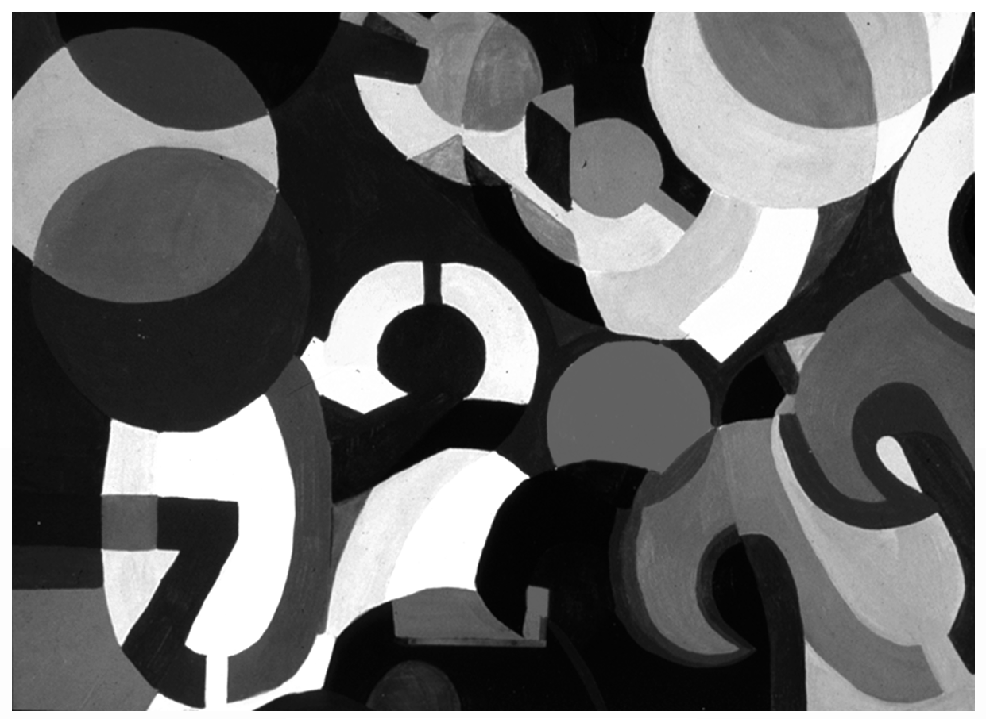

HIDDEN MEANINGS #3

Problem: Assign colors to one of the designs developed for HIDDEN MEANINGS #1, part 2.Use flat, gradated, and transparent shapes as necessary to create at least six distinctively different designs.
- Same hue, different value
- Same hue, different intensity
- Same value, different intensity
- Same intensity, different value
- Two additional studies of your choice.

Objectives:
- To demonstrate understanding of basic color vocabulary.
- To increase compositional complexity through color.
- To experiment with push/pull
- To explore the expressive implications of color.

Materials: Photocopies on card stock, with paint or markers. For a wider range of variations, this assignment can also be done digitally or with acrylics.

Strategy: By using a combination of solid, transparent, and gradated shapes, you can produce a wide range of solutions. Try to change the visual dynamics and meaning in the design through the colors chosen.

Reading: Pages 63 to 71, Chapter 7

DUALITIES

Problem: Create a 300 square inch painting that shows two sides of your personality. Include at least some areas of disharmonious color, gradation, visual texture, and transparency.

Objectives:
- To integrate line, shape, texture, and color in a complex composition
- To explore expressive uses of composition
- To translate personal insight into public communication.

Materials: Paint and illustration board.

Strategy: Hard-edged painting helps to clarify design relationships and is a “safe” way to create a polished product. A looser style of painting and the addition of collage can become chaotic, but the results are often more personal. Choose the best strategy for the ideas you wish to express.
This will be an extended project, and time management is essential.
- Week 1: Bring a pencil layout of a design, using the paint-by-number style we used to lay out the HIDDEN MEANINGS project. If you feel confident about your idea and direction, you can lay this out directly on illustration board. If you have a lot of questions about your design and approach, lay it out on paper, at least in half scale. You can refine it after the critique.
- Week 2: Paint at least 50% of the design. Extended progress report with team of 5 students.
- Week 3: Completed project due.

Reading: Chapter 3

Instructor’s Notes: The personal quality of this assignment tends to motivate students. Confusing personal expression with public communication is one hazard, however. Because the painting is personally significant, students may believe that it is automatically meaningful to a wider audience. Providing students with a list of assessment criteria can help clarify the importance of good composition, regardless of the content.
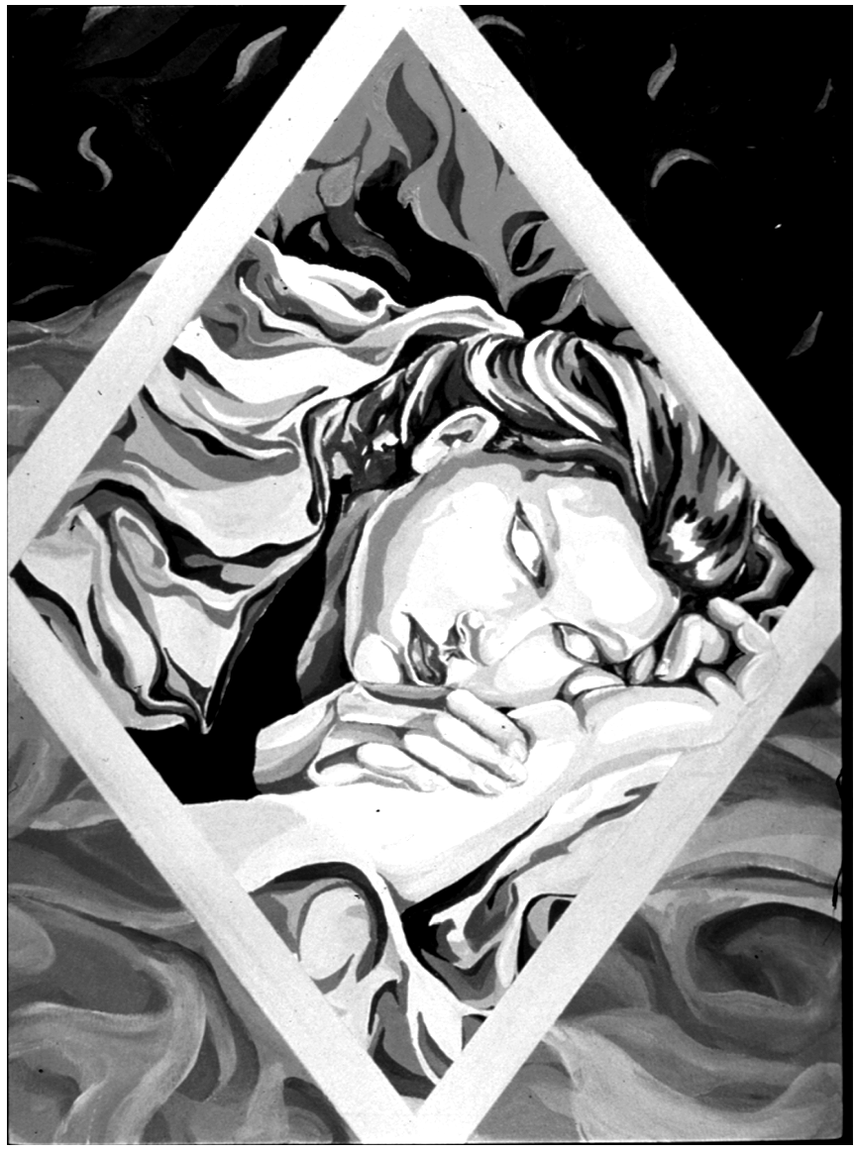
Some of the questions I usually ask are:
• What do you want to say? What aspects of your personality are being shown?
• What range of emotions have been included in the image? Have they been conveyed in a conventional manner (such as red for anger) or is color being used in a more innovative way?
• In the hard edged paintings, is the craft clean and crisp?
• In the progress reports, did you actively contribute, or simply sit on the sidelines, as a passive observer?
• How ambitious and independent was the creative thinking during this project?
• What did you learn about yourself and others?
Timetable: 12 to 20 hours

Notes to the Beginning Teacher:
The Perils and Possibilities of Three-Dimensional FOUNDATIONS

For several reasons, Three-Dimensional Design is an especially challenging class to teach.
- Three-dimensional concepts are often harder to grasp than comparable two-dimensional concepts.

- Three-dimensional Design usually requires working with unfamiliar tools, materials
and processes.

- Three-dimensional Design requires a good deal of manual skill.

It is wise to describe these challenges to students up front, and then describe ways they will be addressed during the course. As an instructor, you can improve

1. Start with simple problems you are confident you can teach effectively. The following list
of assignments includes problems of varying complexity. Start with simple, low-tech problems, then add complex problems as you become more experienced.

2. Work out the problem yourself step by step before you assign it. Ideally, it is best if you actually do the problem as if you are one of your own students. This helps you understand assignment objectives and provides an opportunity to find the pitfalls. Please note that the average student requires at least twice the time it takes for you to do the same task.

3. Schedule the more technical and conceptual parts of the problem for class time and the busy work for homework. Many three dimensional activities and processes are unfamiliar to students and they will require your direct supervision to get started. Be sure your students thoroughly understand what you require before dismissing class. Explicitly list the technical, compositional, and conceptual objectives of each assignment.

4. Do not assume anything! A detailed explanation of tools and processes such as measuring, cutting, gluing, is essential.

5. Pay attention to safety issues! Most three-dimensional assignments require the use of
tools that, if not used properly, can cause serious bodily harm. Safety precautions are a
high priority.

Sample 3D FOUNDATIONS Syllabus

ART 1XXX: Section 10, FALL 07 Monday/Wednesday 9:05-11:35, FAB 107
Professor Jane Doe jdoe@fsu.edu Office Hours: Monday/Wednesday 11:45-12:30

Course Description: Experience in designing and constructing expressive three-dimensional forms using a variety of materials and methods.
Class Format:
Studio course, including construction, critiques, demonstrations, and presentations.

Course Objectives: Upon course completion, all students should be able to:
- Define and effectively manipulate the elements and principles of 3D design to create non-objective, abstract, and representational compositions;
- Use a wide variety of idea generation strategies confidently;
- Create projects that are structurally sound, using wire, board, wood, and clay;
- Use a band saw, drill press, sanders, lathe, and basic hand tools effectively;
- Speak and write critically about personal and peer artworks and propose alternatives.

Recommended Textbook:
Launching the Imagination: A Comprehensive Guide to Basic Design, OR
for transfer students, Launching the Imagination: 3D
Additional Readings: See Foundations Reserve List, especially Elements of Design

Assessment Criteria: Grades will be based on three major factors.
- Skill acquisition and application. Has each element and principle of design been used fully? How fully and effectively do your projects engage the third dimension? (40%)
- Idea Development. How effectively have you used maquettes and other idea generation strategies? How wide a range of possibilities did you explore? (35%)
- Learning Process. Do you come to class prepared and receptive? Do you take risks? How substantial and consistent are your contributions to class discussions? (25%)

Attendance: Attendance is required. Your grade will drop by one letter for every unexcused absence beyond three. It is impossible to fully “make up” missed demonstrations or critiques, and getting the information second-hand is inadequate. Arriving late also derails learning. If you miss more than 8 hours of class for any reason, you are likely to receive a final grade of C- or below. For details on University approved excused absences, go to: http://www.fsu.edu/~fasenate/attendance.html.

Grades will be defined as follows:
A = Outstanding competence. Expansive investigation of ideas; excellent composition and/or construction. All assignments completed on time, with at least one extra credit project done well. Insightful contributions to critiques. Goes well beyond minimum requirements.
B = Above average competence: Substantial investigation of ideas, very good composition and/or construction. All assignments completed on time, good contributions to critiques.
C = Average competence. Assignments done competently and completed on time.
D= Marginal work, due to two or more late projects, limited investigation of ideas, poor craft, incoherent compositions, minimal contribution to critiques. May have more than 3 absences.
F = Unsatisfactory work. Course failure due to minimal idea development, poor craft, disjointed compositions, lack of participation, late assignments. May have over 6 absences.
Note: One project will be accepted one day late without penalty. One additional late project will be accepted with a one letter-grade penalty for each day it is late.
Incompletes: A grade of Incomplete can only be assigned to students with an otherwise passing grade who are unable to complete the course due to some serious illness or personal tragedy. Incompletes are not given lightly.

Honor Code. Students are expected to uphold the Academic Honor Code published in The Florida State University Bulletin and the Student Handbook. The Academic Honor System of The Florida State University is based on the premise that each student has the responsibility (1) to uphold the highest standards of academic integrity in the student's own work, (2) to refuse to tolerate violations of academic integrity in the university community, and (3) to foster a high sense of integrity and social responsibility on the part of the university community. Please see the following web site for a complete explanation of the Academic Honor Code. http://www.fsu.edu/Books/Student-Handbook/codes/honor.html http://www.fsu.edu/Books/Student-Handbook/

Basic Supplies:
• 9”x12" sketchbook • 90 degree angle • mat knife
• X-acto knife • masking tape • scissors
• paint brushes, as needed • Elmer’s glue • ruler
• Personal planner or calendar • sandpaper • scotch tape
• 16”X20" self-healing cutting surface • long nose pliers • pencils

PROJECTED ASSIGNMENTS
SECTION 1: BASIC ELEMENTS AND PRIMARY PRINCIPLES
Week 1 and 2: From 2D to 3D
Head Case, using tunnel book and slotted structures. Reading: C8.
Written Assignment: Biographical statement

Week 3: Dominant and Subordinate.
Expanded 3D composition and construction, using one line, one to six planes, and one simple volume. After producing a series of drawn and constructed sketches, we will complete a single refined study demonstrating compositional dominance. Reading: C9.

Weeks 4 & 5: Balance and Proportion.
Exploration of variations in orientation and deliberate use of the base. Reading: C11.

SECTION 2: MOVEMENT AND SEQUENCE. Expanded use of tools and materials.
Weeks 6, 7, and 8: Linear Athlete or Becoming Borg
Transformations using wire and plaster gauze. Reading: C4.

Weeks 9, 10, 11: Transformation Reading: C5 and C6
Learning basic woodshop skills and researching non-Western art and design

SECTION 3: PHYSICAL AND CEREBRAL

Weeks 12, 13, 14, and 15: Collaborative Capstone Project, such as
Audio Assemblage, Thirty Second Marble, or Superhero Mask Reading: C12

Week 15: Final Reviews / Final Critique

Biographical Statement due next class meeting
Write a two to three-page paper introducing your background. Write freely about your life, education, or art. Consider: How long and for what reason have you made art? What were your major interests in high school? What are the sources of your ideas? Under what conditions do you learn the most? What gives you most confidence/motivation?

Research Topic: due during week 4
Write a two to three page paper researching a contemporary three-dimensional artist or designer. This could include background information, exhibition history, thematic focus, and cultural relevance. Choose an artist or designer you admire but don’t already know well. Try to find a unique person who is pushing the limits and visual understanding of what three dimensional design can be.

AMERICANS WITH DISABILITIES ACT (ADA):
IF THERE IS ANYONE WHO NEEDS AN ACCOMODATION DUE TO A DISABILITY, PLEASE BRING IT TO THE INSTRUCTOR’S ATTENTION.

Students with disabilities needing academic accommodation should:
- register with and provide documentation to the student Disability Resource Center;
2. bring a letter to the instructor indicating the need for accommodation and what type. This should be done during the first week of class.
For more information about services available to FSU students with disabilities contact the
Student Disability Resource Center, 97 Woodward Avenue, South, Florida State University, Tallahassee, FL 32306-4167 (850) 644-9566 (voice) (850) 644-8504 (TDD) sdrc@admin.fsu.edu http://www.fsu.edu/staffair/dean/StudentDisability/
(This syllabus and other class materials are available in alternative format upon request.)

WOOD SHOP ORIENTATION BY OLIVER SHEMM

STANDING TOOLS
Band Saw- Your best friend. The band saw is great for cutting curving lines in the wood. Depending on how thick the wood is you have to decide on the Band saw you will use. We have a heavy duty Band saw as well as small band saw in the 3D room.

Drill Press- The drill press does a good job of drilling a multiple number of holes in an object. It is essential that you clamp the piece in order that it does not move around on you as you drill.

Belt Sanders and Such- The belt sanders are self explanatory given that they sand. However you must make sure that you remove any long hair and sleeves or any hanging fashionable accoutrements from the region of the belt sander as it is hungry for their consumption..

Miter Saw The miter saw is very skilled at cutting both regular angles as well as compound angles. You must hold the item you are cutting in a strict manor and never be lacks when you are cutting. Be aware at all times where your fingers are and the wood you are cutting.

Table Saw- The table saw is a beast that is to be used rarely and only under supervision. If your are to endeavor to have a relationship with this tool you must respect what is does. It cuts straight and the fence must always be used. No free hand cutting is allowed!

Lathe- The Lathe is designed to turn a square piece of wood that is horizontal into a round cross-section. There are chisels that accompany it and are stashed in a nearby cabinet.

HAND POWER TOOLS
Screw Gun (Cordless). Drills a hole as well and screws in a screw at the same time. It is your friend and the invention of the keyless chuck when mastered is liberating.

Orbital Sander- It sands areas that are smaller but not small. You must move the head of the sander to match the surface of the object you are sanding. There are different grits of discs that will smooth your surface as you go up. For example, 80 grit is very rough, but 220 is fine.

Angle Grinder- This tool consists of a disc that spins at very high rpms. The disc is perpendicular to the handle and can both remove wood and metal depending on the disc surface. The grit can be as low as 36 and will remove great quantities of material. Be careful of hair and clothes as well as toque when you use this tool.

Dremel Tool. It is a tool that you hold in one hand and does detail work. Depending on the bit you use you can sand, carve, rout, and basically define a design and area for your piece.

Router. This tool can remove straight lines of wood and also an area of wood while fixing the depth. It has a great amount of torque and must be used in a counter clockwise direction if the edge you are cutting is closest to you. There are a myriad of bits you can use. Ask and you shall receive.

Drill- This tool is the mother of the screw gun. Most drills have chucks and chuck keys. The chuck is the three toothed holder of the bit. Drills are used when a multiple number of free hand holes are to be drilled. If the placement of the holes are even consider the Drill press. There are multiple number of bits, ranging from large holes (paddle bits) to regular bores.

Belt Sander- This tool is designed to smooth out large areas of flat wood. It too has different grits to move from rough to smooth.

Circular Saw- (Not Available) Cuts a straight line. The offspring of the table saw that can be used in the field.

Jig Saw- This tool is a hand held version of the Band Saw and does essentially the same thing except at a different orientation (upside down). There are different blades for different materials. Curves straight lines and large circles can be created.

All these tools are based on friction. You push the bit, blade, pad etc. Into the wood and it removes material.(reductive process) you can feel when you are pushing the bit, blade, pad to fast because it will start to slow down. Watch and feel as you practice, where is the sweet spot where it both removes material and does not bog down?

REMEMBER

1. Respect the design of the tool. Use the right tool for the task.

2. Be aware of where your fingers are at all times.

SAMPLE ASSIGNMENT SEQUENCE
SECTION 1: ESSENTIAL ELEMENTS AND PRIMARY PRINCIPLES. Introduction to composition and construction, using one line, one or more planes, and one simple volume.

Weeks 1 & 2: Dominant and Subordinate
Exploring formal relationships through drawing and construction.
Written Assignment: Biographical statement
Reading: LTI chapter 4 and 5.

Week 3: Negative and Positive
Create a dialog between substance and space. Study #1: 50/50 negative/positive; Study #2, roughly 70% negative; Study #3: roughly 70% positive.
Written Assignment: Cause/effect critique.
Reading: LTI chapter 6

Weeks 4 & 5: Balance and Proportion
Exploration of variations in orientation and more deliberate use of the base, adding multiple planes.
Written Assignment: 2-page Research Paper
Reading: LTI chapter 7.

SECTION 2: MATERIALS AND METHODS

Weeks 6, 7, and 8: Linear Athlete or Becoming Borg
Transformations using wire and plaster gauze.
Written Assignment: Visual Vocabulary: 3D Elements
Reading: LTI Chapter 8.

Week 9: Discovering Mass. Exploring subtractive sculpture.
Reading: LTI chapter 9.

Weeks 10, 11, 12: Wooden Wizardry Learning basic woodshop skills and researching non-Western art and design.
Written Assignment: Visual Vocabulary: 3D Principles

SECTION 3: PHYSICAL AND CEREBRAL

Weeks 13,14, 15: Capstone Project, such as Audio Assemblage, Superhero Mask, Book Transformed, or Abstracted Object, Fragmented.
Reading: LTI, Chapter 10 and 11

Week 16: Final Reviews / Final Critiques

DOMINANT AND SUBORDINATE

Problem: Create three preliminary dominance studies, each using one plane, one line and one volume. Select the best, and re-construct it, focusing on craft as well as composition.

Objective: To begin to learn the basic principles of design, to become familiar with 3D drawing, and to understand the importance of compositional hierarchies.

Materials: Bristol paper, cardboard or chipboard, glue and masking tape, Exact-o-knife.

Strategy:
In your sketchbook, do at least 10 drawings exploring various compositional possibilities.

All of the elements must meet at right angles, including the base. Only one of the three elements can touch the base.

To see how your designs will look constructed, make a series of quick 3D maquettes using cardboard or bristol paper. Don't worry about refined craft at this stage--just try out ideas.

Each preliminary sketch must have a different dominant element. (One sketch will have a dominant plane, the second will have a dominant line, and the third a dominant volume.)

Finalize your project using cardboard or chipboard. Select one of your preliminary studies, the revise and refine it, using glue rather than tape. Excellent craft will greatly strengthen the overall effect. A final coat of paint is the crowning touch.

Reading: pages 175 to 193

Instructor’s Notes:
Have the students begin by cutting and taping together thin strips of cardboard to create the line, two pieces of square or rectangular cardboard for the plane, and six pieces to make a cube or rectangular box for the volumetric shape. A more advanced example of the project might be to use shapes that are more organic or more geometrically complex.

The initial studies can be constructed using masking tape. Each must include a base. Have the students tape the edges evenly for a more streamlined look, leaving even amounts on each side of an edge. This helps to establish basic craftsmanship.

The final maquette must NOT have any tape. Use the tape to hold the pieces together while they glue the inside edges. Remove the tape from the cardboard. Be sure not to damage or rip the cardboard with the tape. Stress craftsmanship: No glue marks, tape damage, all elements at right angles, etc.

Timetable: 15-18 hours, including sketches for homework.

NEGATIVE AND POSITIVE

Problem: Create a dialog between multiple lines, planes volumes and space.
Study #1: 50/50 negative/positive; #2: roughly 70% negative; #3: roughly 70% positive.

Objective: Building off of the basic principles presented in Dominant and Subordinate, we will now create a dialog between positive and negative.

Materials: Cardboard or chipboard, glue and masking tape, and Exact-o-knife.

Strategy:
All elements can connect or dissect each other at different angles. Thus, more complex relationships can be developed.

Explore dominant and subordinate negative spaces.

Be more inventive with the base. What role can it play?

Several maquettes can be made to determine the best composition.

The final design will be made using chipboard for the base and must be completely glued together. A coat of paint is the crowning touch.

Readings: pages 175 to 199

Instructor’s Notes:
Inspire the students to use more organic or geometrically advanced shapes. This may call for a demonstration of different techniques, such as scoring the cardboard to get a more pliable surface used for curving shapes.

Brainstorm ways to create negative space.

Suggest that students use shapes from nature or their surroundings as inspiration.

The final design must NOT have any tape. Use the tape to hold the pieces together while gluing the inside edges. Remove the tape from the cardboard. Be sure not to damage or rip the cardboard with the tape. Stress craftsmanship: No glue marks, tape damage, all elements at right angles, etc…

Timetable: 15-18 hours.

THREE-DIMENSIONAL BALANCING ACT

Problem: Create a complex composition using curvilinear and rectilinear forms.


Objective: Building off of the basic principles presented in the preceding two assignments we will now begin work with more complex composition. Dominance and the dialog between positive and negative will be stressed in this assignment, along with balance, scale, and proportion.

Materials: Cardboard or chipboard, glue and masking tape, and Exact-o-knife.

Strategy:
- Forms can connect or dissect each other at any angle.
- Be more inventive with the base.
- One to two rough maquettes should be made to determine the best composition
- A final will be made using chipboard for the base and must be completely glued together.

Reading: Chapter 8

Instructor’s Notes:
• Inspire the students to use more organic or geometrically advanced shapes. This may call for a demonstration of different techniques, such as scoring the cardboard to get a more pliable surface used for curving shapes.
• Encourage students to use shapes from nature or their surroundings as inspiration.
• The final maquette must NOT have any tape. Use the tape to hold the pieces together while they glue the inside edges. Remove the tape from the cardboard. Be sure not to damage or rip the cardboard with the tape. Stress craftsmanship: No glue marks, tape damage, all elements at right angles, etc. Timetable: 15-18 hours.
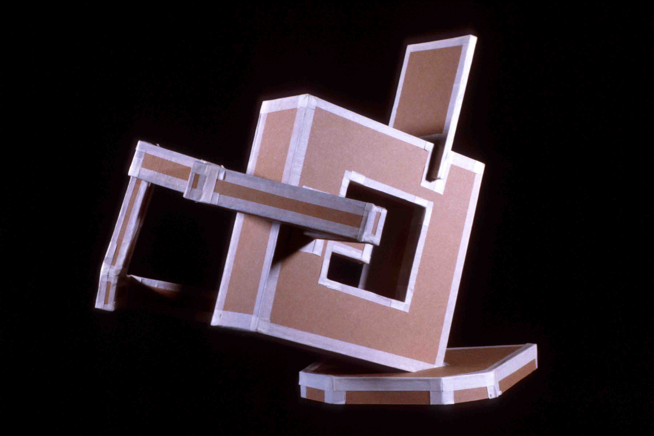
SPHERES OF INFLUENCE #1
Assignment created by Rick Paul, Purdue University

Problem: Build a 12" sphere with a tolerance of plus or minus 1/4" that will roll freely down a 12-degree inclined plane. You are limited to using found (not new) corrugated cardboard; no glue or additional materials may be used.

Objective: The objectives of this problem are two-fold. First, to design and build form with a curved surface from a planar material. Secondly, to divide and organize the interior space of a sphere.

Materials: Corrugated cardboard from used boxes

Strategy: A sphere is an example of a solid with a complex surface that bends in two directions. Materials like wood, paper, cardboard and sheet metal do not bend to form a complex surface. Nevertheless, these planar materials can be used to describe a spherical form. It is easy to make a sphere that will meet the criteria of the problem. The real design issue is how to divide the space within the sphere and which shapes will be used to do so.
Our attitude toward a material may be prejudiced by cultural bias or past experiences with the material. No material is inherently “good” or “bad,” “beautiful” or “ugly,” acceptable or distasteful. This problem also challenges you to examine a discarded material objectively.
1. Begin your work by examining the corrugated cardboard carefully. Is it a homogeneous material or does it have component parts? Does it have grain or can it be used without regard to orientation? What is necessary to bend it? How might you incorporate the printed information, if any, into your design?
2. Making three to four half-scale preliminary models to arrive at a unique solution. Your objective during this modeling process is to discover what shapes to use, how to arrange them and what process you will use to attach these shapes together.
3. Construct your final solution. Keep the creative juices flowing during this process as you become more familiar with the material.

Reading: pages 175 to193

Instructor’s Notes: This problem introduces students to model making as a way of developing ideas. Using models, students can discover unique solutions and invent various forms of construction.
Levels of difficulty:
Most difficult:
• No shape passes through the center of the sphere.
• Shapes are folded to make secondary shapes.
• The scrap cardboard has been selected for its surface printing and this printing has been effectively incorporated into the design.
• A secondary interior volume, such as a cube at the center, is incorporated into the design.
• Method of construction is unique; how the object is held together is integrated into the design.
Average difficulty:
• No shape used passes through the center of the sphere. Method of construction goes beyond making use of slots.

Limited difficulty:

• The sphere is described by circles of the same size all intersecting at a line passing through the center.
Timetable: Two to three hours of presentation and model making in class and three hours of work out of class.
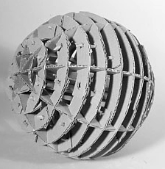
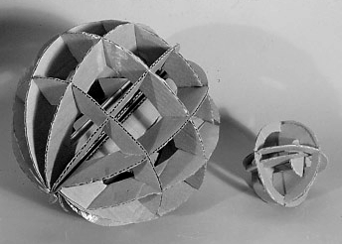
Spheres of Influence #1 – examples of student work using cardboard and no adhesives.

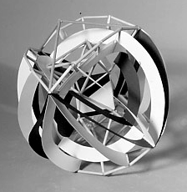
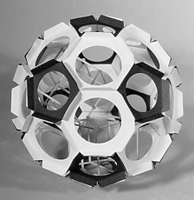
Spheres of Influence #2 – examples of student work using planes and linear elements

SPHERES OF INFLUENCE #2

Problem: Using 1/8”, 3/16” dowels or ¼” balsa wood square stock and black and white poster board, construct a 12 inch sphere. Your sphere must contain a second simple real or implied volume such as a cube, pyramid, cone, or cylinder.

Objectives:
• To make a unified composition using linear and planar elements.
• To experience and understand the difference between real and implied volumes
• To rationalize the relationships between two volumes within one composition including placement, proportion and scale.

Materials: Balsa or 1/8” 3/16” dowel rods, black poster board and white poster board.

Strategy:
1. Begin by experimenting with ways to attach poster board to the dowel or square stock. Notice that a variety of joints may be necessary to solve this problem. For example, sticks may be attached on a surface, along an edge of a surface or meeting a surface at an angle. Each type of joint should be thought out before considering your design. A glue gun works well but the resulting joint may not be strong enough. White glue may necessary to ensure strong enough joints. Remember that the strength of a glue joint depends on how much gluing surface is shared by the pieces you are gluing together. Look for ways to increase the amount of glue surface between the stick and planar pieces you wish to glue together. In some cases your design may require a poster board tab that encase the stick or gussets between a stick and poster board.
2. You can start the design process with a circle between 9” and 12” in diameter. Cut a simple shape (square, circle or triangle) out of the circle. Experiment with folding the resulting shape one or two times along “logical” lines to make the piece three-dimensional. Add sticks and planes as needed to establish the two volumes required to solve the problem. Black and white shapes should be arranged to unify to your composition. Some compositions are more obvious than others. Asymmetrical compositions are more interesting but also more challenging.

Reading: Pages 175 to 193

Instructor’s Notes: Learning how to join dissimilar materials is an important part of this problem. Encourage ambitious students to design interesting fasteners to join stick to plane. These fasteners must be integrated into their design. A good solution to this problem will make equal use of linear and planar as structural elements. I have found it helpful to keep the amount of the material used to a minimum. Stress that glue should not be used as a material to fill gaps– a good glue joint should have little glue showing. Based on the amount of surface area between crossing sticks it is unrealistic to expect such a joint to have any strength. Crossing sticks require some type of gusset to be held together.

Timetable: Two to three hours of presentation and model making in class and three hours of work out of class.

HEAD CASE: EXPLORING PLANAR CONSTRUCTION

Problem: Combining architecture and anatomy, create a six to ten- plane tunnel book or slotted book, measuring up to 12"x12"x 24" in size.

Objectives:
• To explore the interplay between space and planar structure.
• To demonstrate the structural versatility of the plane.
• To introduce use of tabs and slotted structures.

Materials: Twenty 5”x8" cards, two sheets of poster board or Bristol paper, one 18”x24" sheet of two-ply chipboard and one 18”x24" sheet of three ply chipboard, Elmer's glue, double-sided tape, glue stick and photocopies.

Strategy
- Find an interesting photograph of an architectural site, or take at least 24 photographs of a public building that is spatially complex. Explore the space thoroughly, especially noting entrances, exits, transitions, spatial sequencing, and staircases.
- Choose one photograph to serve as a beginning point for a tunnel book. It needs to present four well-defined spatial layers. A compositional frame (such as an entry arch) is also helpful, both visually and structurally.
- Make twelve 5”x8" copies of the photograph on card stock or glue the copies to index cards.
- Distill the image into four layers of space and structure: foreground, middle ground #1, middle ground #2, and background. Cut out these "layers of space" from the cards, being sure to leave a 1" border on the bottom and sides. In a tunnel book, the first plane has the most cut away. As you move toward the back of the tunnel, less and less is removed, until the final plane is solid. An accordion structure is then attached to the right and left sides. A double tunnel book can be entered from both ends, with the solid wall positioned at the center of the book.
- Make two tunnel books or two slotted books, exploring the distance between the planes. These prototypes will then be critiqued.
- After the critique, develop a more extensive double tunnel book or a slot machine book, combining the most interesting qualities of multiple photographs.
- Finally, combine these with a simple structure of a human head, so that the tunnel book creates an entry into the mind.

Reading: pages 175 to 199

Instructor’s notes:
For more complex structures, get a book on pop-up book construction.

Sheets of Plexiglas or acetate can be used to create a very different planar effect.

CALDERESQUE SELF-PORTRAIT
Assignment by Rick Paul, Purdue University

Problem: Make a life-sized three-dimensional bust using 60” of soft steel wire. You may include personal attribute in your portrait that makes you distinctive such as eyeglasses or hat.

Objective: to distill three dimensional design down to its most essential form

Materials: soft steel wire, pliers with side cutters, needle nosed pliers.

Strategy:
• Before you begin, make a list of significant physical features and details you want to include in your self-portrait.
• Make a list of objects you may want to include in your self-portrait. There are no restrictions as to what objects you may be included. You are welcome to listing objects slightly out of context, such as a distinctive shoe, or fish, which speak about you and your interests.
• Make several continuous contour and continuous blind contour drawings of yourself.
• Make several continuous contour drawings of you and your object together. How might the placement or scale of you object add additional meaning to your portrait?

Reading: Pages 175 to 189

Instructor’s Notes: Alexander Calder’s simple wire sculptures are perfect examples of how to eloquently and efficiently use wire to describe objects with spatial lines. The key to solving this problem successfully is to use the wire in the most efficient way, i.e. use as little wire as possible to describe a maximum amount of visual information.

Consider:
What are the similarities and differences between drawing in space with wire and drawing with a pencil on a two-dimensional surface? It may be necessary to use knots to hold your wire portrait together. If you used knots, did you incorporate them into your design or did they appear simply where convenient? Was “line quality” one of your design considerations? Did you consciously use specific shapes in your design? Is the unity of your design simply the result using one piece of wire or did you organize specific design elements to achieve unity?
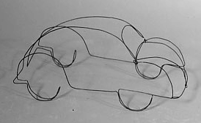

LINEAR ATHLETE or EDITORIAL CARTOON
Assignment Designed by Anthony Fontana and Travis Jensen

Problem: Option 1: Using wire, express the movement and balance inherent in athletic motion. Option 2: Create an “editorial cartoon” in wire, commenting on current events.

Objective:
• To introduce the figure and explore ways it can be expressed three dimensionally.
• To heighten visual and spatial awareness by limiting the amount of information needed to communicate an idea.
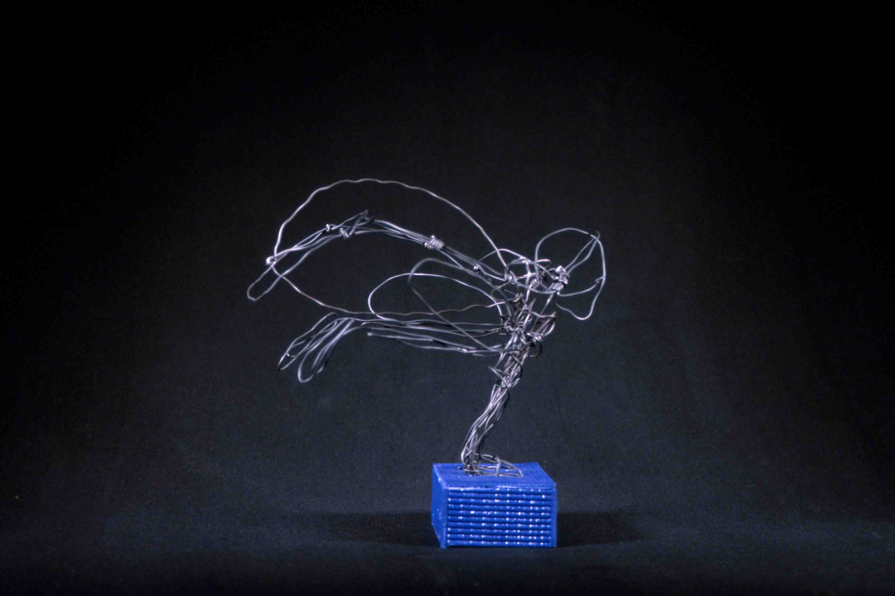
• To distill a gesture down to its essentials.

Materials: 18 and 24 gauge wire, needle nose pliers

Strategy:
- Find or create visual studies of athletes in motion or look at cartoons on the opinions page in the Chicago Tribune.
- Do a series of expressive or descriptive line drawings of these references in your sketchbook. Where should the greatest density of line occur? Structurally and compositionally, where should heavier wire be used?
- Look at examples of expressive line drawings. This will help connect 2D to 3D approaches to gesture.
- Do not make an exo-skeleton of the model but use line to express the posture and tension in the figure. More wire should be used in areas of extreme torque, muscle, or weight. Less wire should be used in areas of extreme motion.
- Use smaller amounts of wire for details.
- Develop an appropriate base for your figure or figures.

Reading: pages 175 to 193

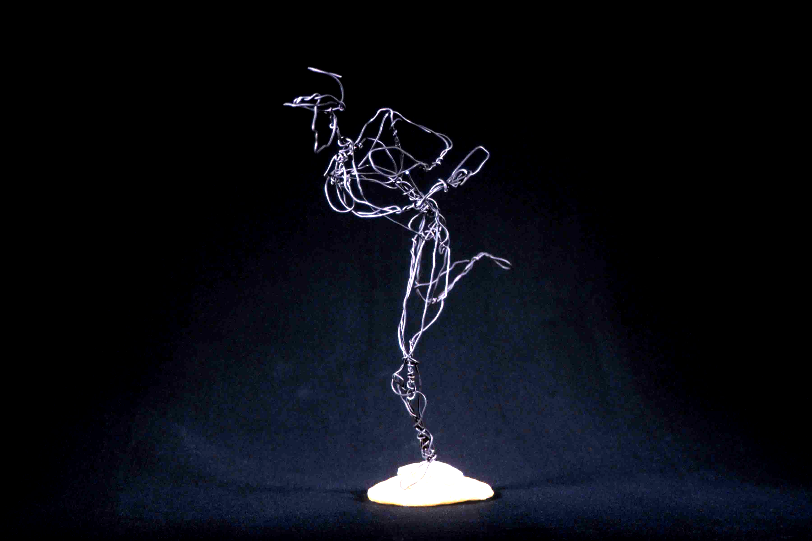
Instructor’s notes:
• Spend the first day “playing” with the wire. Having the students make linear sketches of their peers allows you to point out problem areas early. This also familiarizes the students with the wire. Begin by handing out pieces of wire no longer than 12 inches. Have one of the students model in front of the class. Give the students sixty seconds to capture the essence of the model. Repeat this process with 24” wire in the same time frame. They must convey the shape posture of the whole body. This forces the student to be conscious of the decisions they are making.
• Demonstrate how to connect two pieces of wire by wrapping one around another without leaving a barb.

Timetable: 12-18 hours

BECOMING BORG

Problem: Create one or more studies of hands using plaster gauze and wire. In these studies, explore the transition from human to machine, based on the Star Trek Borg civilization.

Objective:
• To compare and contrast linear notation in two and three dimensions.
• To investigate the effect of materials on meaning.
• To explore body language.
• To learn basic construction skills.

Materials: ebony pencils and drawing paper, materials, plaster gauze, 14, 18 and 24 gauge galvanized wire, one found object, if needed.

Strategy:
1. Create a series of drawings of body parts in pencil. Consider: Where does the human end and the machine begin? What is the most eloquent dialog between a wire “skeleton” and the plaster gauze “skin”? If a found object will be incorporated in the structure, what structural and conceptual role should it play?
2. To de-bug technical problems, make a rough life-sized wire “drawing” in space.
• What is the best way to create junctions?
• Technically, how can the gauze and wire work together effectively?
• How much wire is needed to create a sturdy sculpture?
3. Determine the best way to “stage” your sculptural idea. A vertical plane, a plinth, or a base may be used as a support. The sculpture may wrap around the support, extend outward, be suspended, etc.

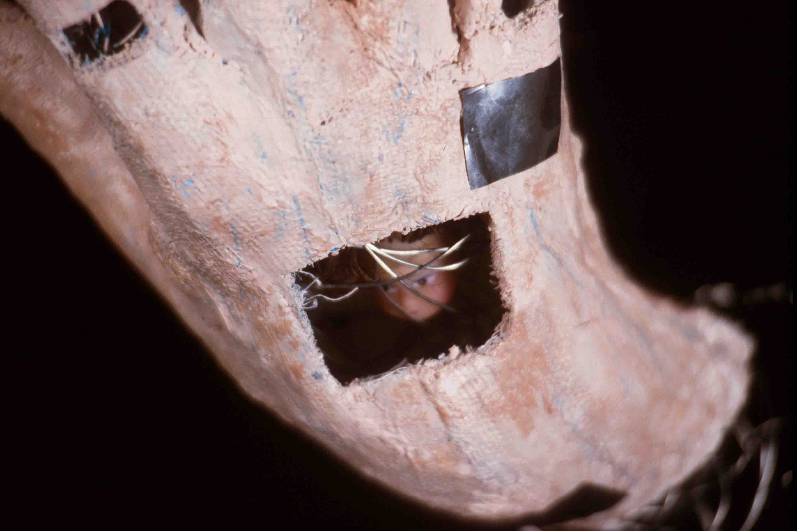
Reading: Chapter 10 Timetable: 15-18 hours

DISCOVERING MASS
Assignment created by Rick Paul, Purdue University

Problem: Part 1: Make a complex sculptural object from foam rubber.
Part 2: Carve a replica of your foam object from a plaster block.

Objective: To explore a subtractive process and investigate uses of mass.

Materials: Foam rubber scraps, “Sharpie“ marker, string, wire, corrugated cardboard, duct tape or masking tape, simple hand carving tools, 10 pounds of number one molding plaster.

Strategy:
1. Create a sculptural object from scraps of foam rubber. Cut, twist, fold and tie the foam rubber into an interesting form that has concave as well as convex surfaces. Draw a 1/2” grid on the foam before starting. This grid helps to reveal how surfaces are stretched and distorted. It may be necessary to insert a stiff wire in the foam rubber to retain a desired form.
2. Construct a corrugated box with the same proportions as your foam rubber model. To do this, place your model on a piece of paper and draw the smallest rectangle possible around it. Measure the height of the model. Build a corrugated box proportionate to these dimensions. Use duct tape to make your box strong and watertight. Wrap the top perimeter of your box twice with duct tape to reinforce it.
3. Fill the box with plaster. You may need to brace the box with heavy objects (bricks or blocks of wood) to better maintain its shape while the plaster sets. Store your block in an airtight plastic bag to keep it damp while carving.
4. Carve the plaster object. Using charcoal or ebony pencil, begin by drawing 6 profile drawings on each of the sides of your block. Be careful not to favor a single view or side as you proceed with your carving. Carving sides in a regular sequence helps to accomplish this.
5. Use 220 grit wet/dry paper and water to sand the surface to a high polish.
Reading: Pages 193 to 195
Instructor’s Notes: Get foam rubber scraps from a foam rubber dealer. Encourage students to experiment with cutting and tearing and otherwise manipulating the foam. For part 2, it may be necessary to scale the model up or down to a workable size. Do not let students sand their carvings in a sink as plaster will clog drains. Sand plaster outside using a water hose or over a floor drain.
Timetable: One hour to work with foam rubber maquette, one hour to construct the container and cast a plaster block, four to six hours to carve the plaster.
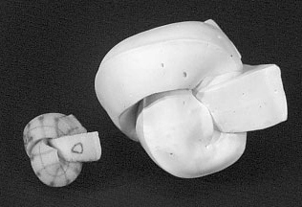

TRANSFORMATION

Problem: Transform a 24” long plank of 2" thick pine into a walking stick or wizard’s staff. For extra credit, build in a second "transformation," through a series of changes from the top to the bottom of the stick or staff.

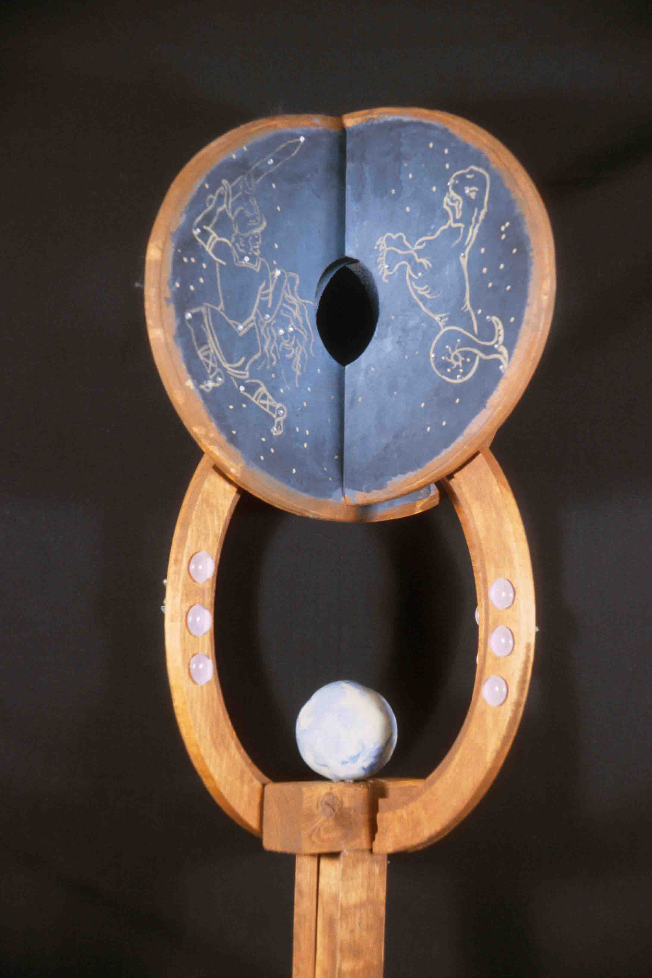
Objective: This project is designed to give you an introduction to the woodshop. By mastering a drill press, sander and band saw, you can greatly expand your capabilities for two-dimensional as well as three-dimensional work.

Materials: wooden plank, sand paper, glue, screws. All basic materials will be supplied.

Strategy:
As with all 3D work, this project will require both conceptual and structural research.
1. Find and print out at least 6 examples of walking sticks or staffs, using the Internet and/or library resources. Hint: Many nomadic cultures use walking sticks or staffs extensively and staffs have all kinds of ceremonial implications.

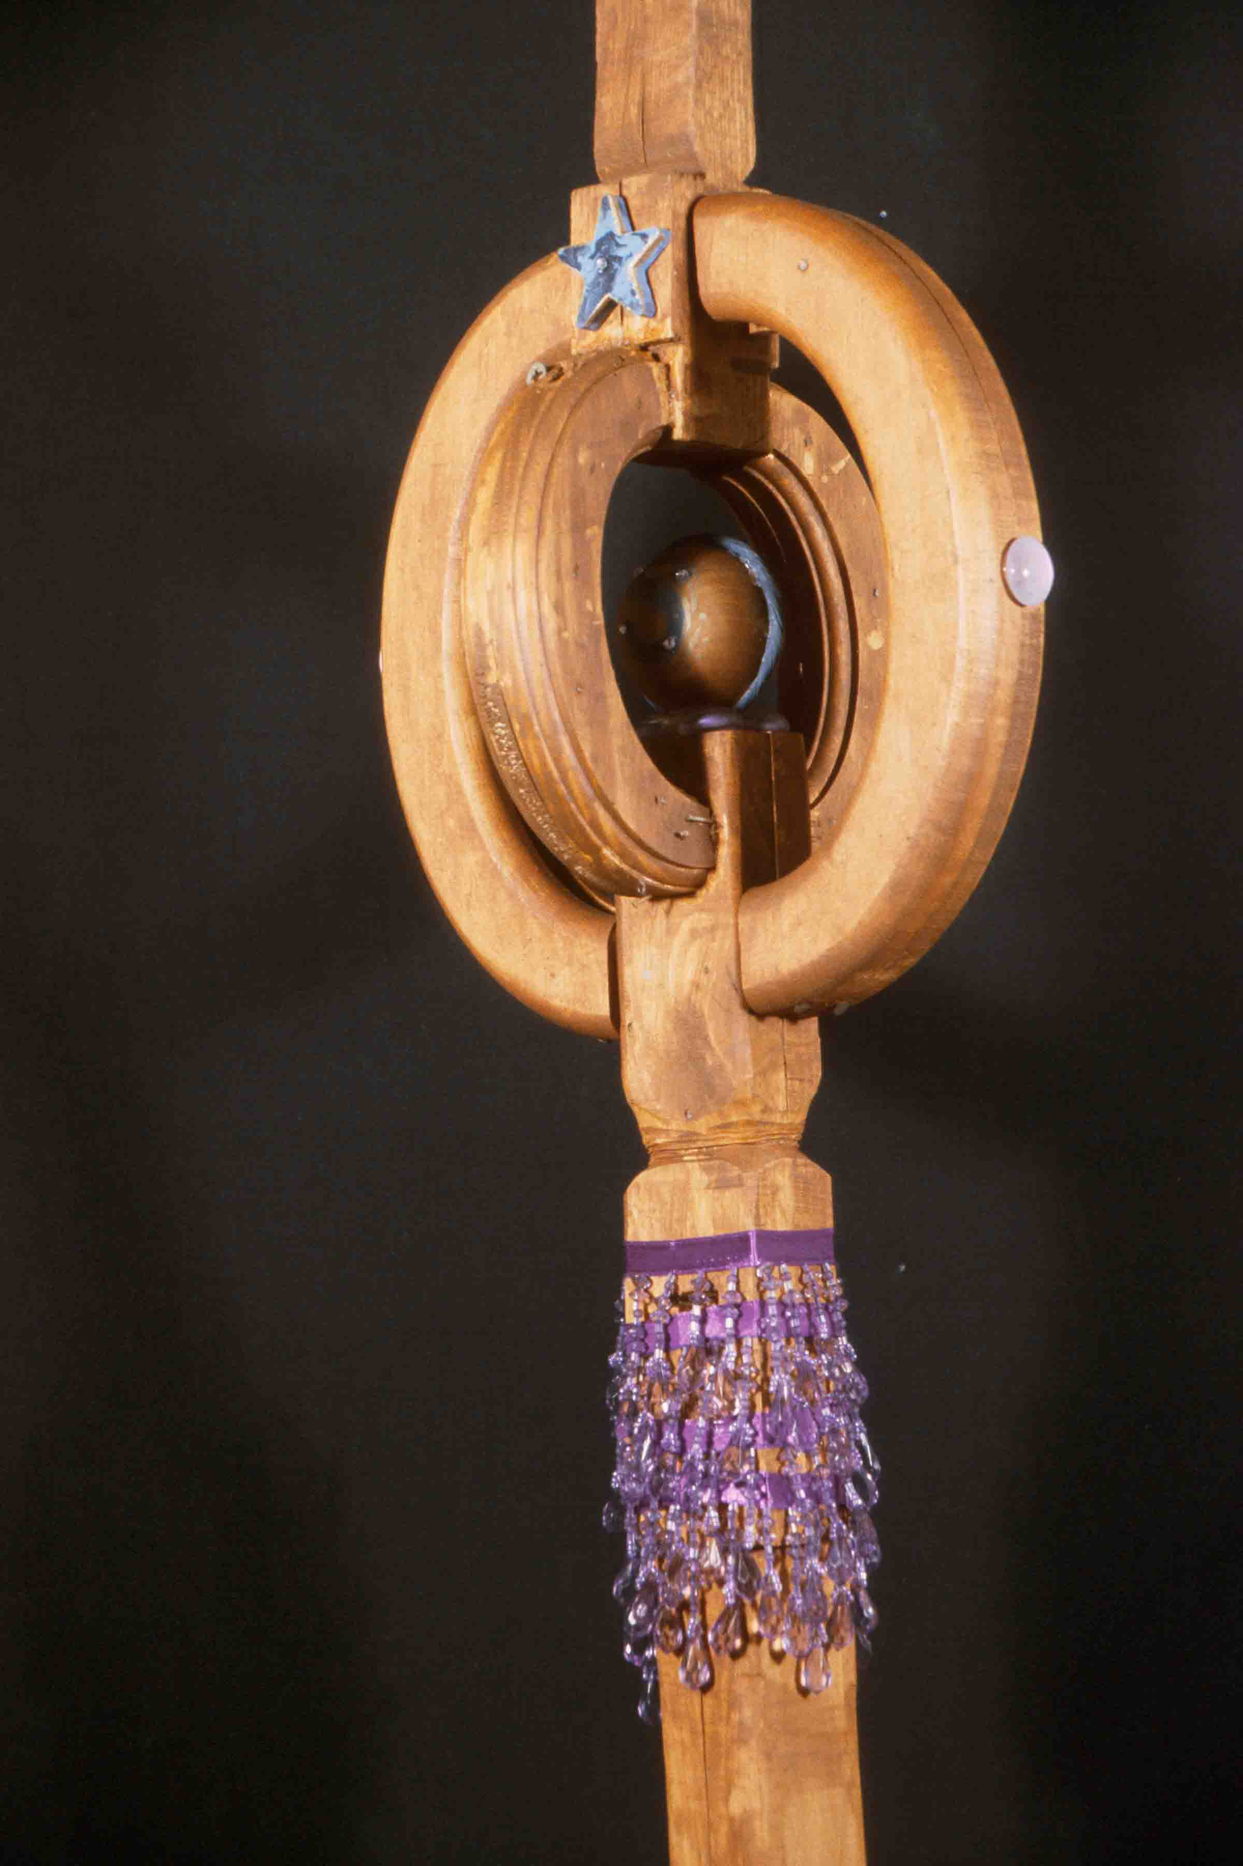
2. Draw at least 10 rough ideas, then choose the best for further development

3. We will then head up to the woodshop, for an introduction to the equipment. Pay close attention to everything the technician says, and follow the technician’s advice. Used properly, the equipment is safe and easy to use.

4. Using a piece of scrap wood, extensively experiment with all of the tools. Re-design your project, based on the skills you have learned. Make the piece, being especially attentive to composition, function, balance, and physical connections. Finally, paint or stain the wood.

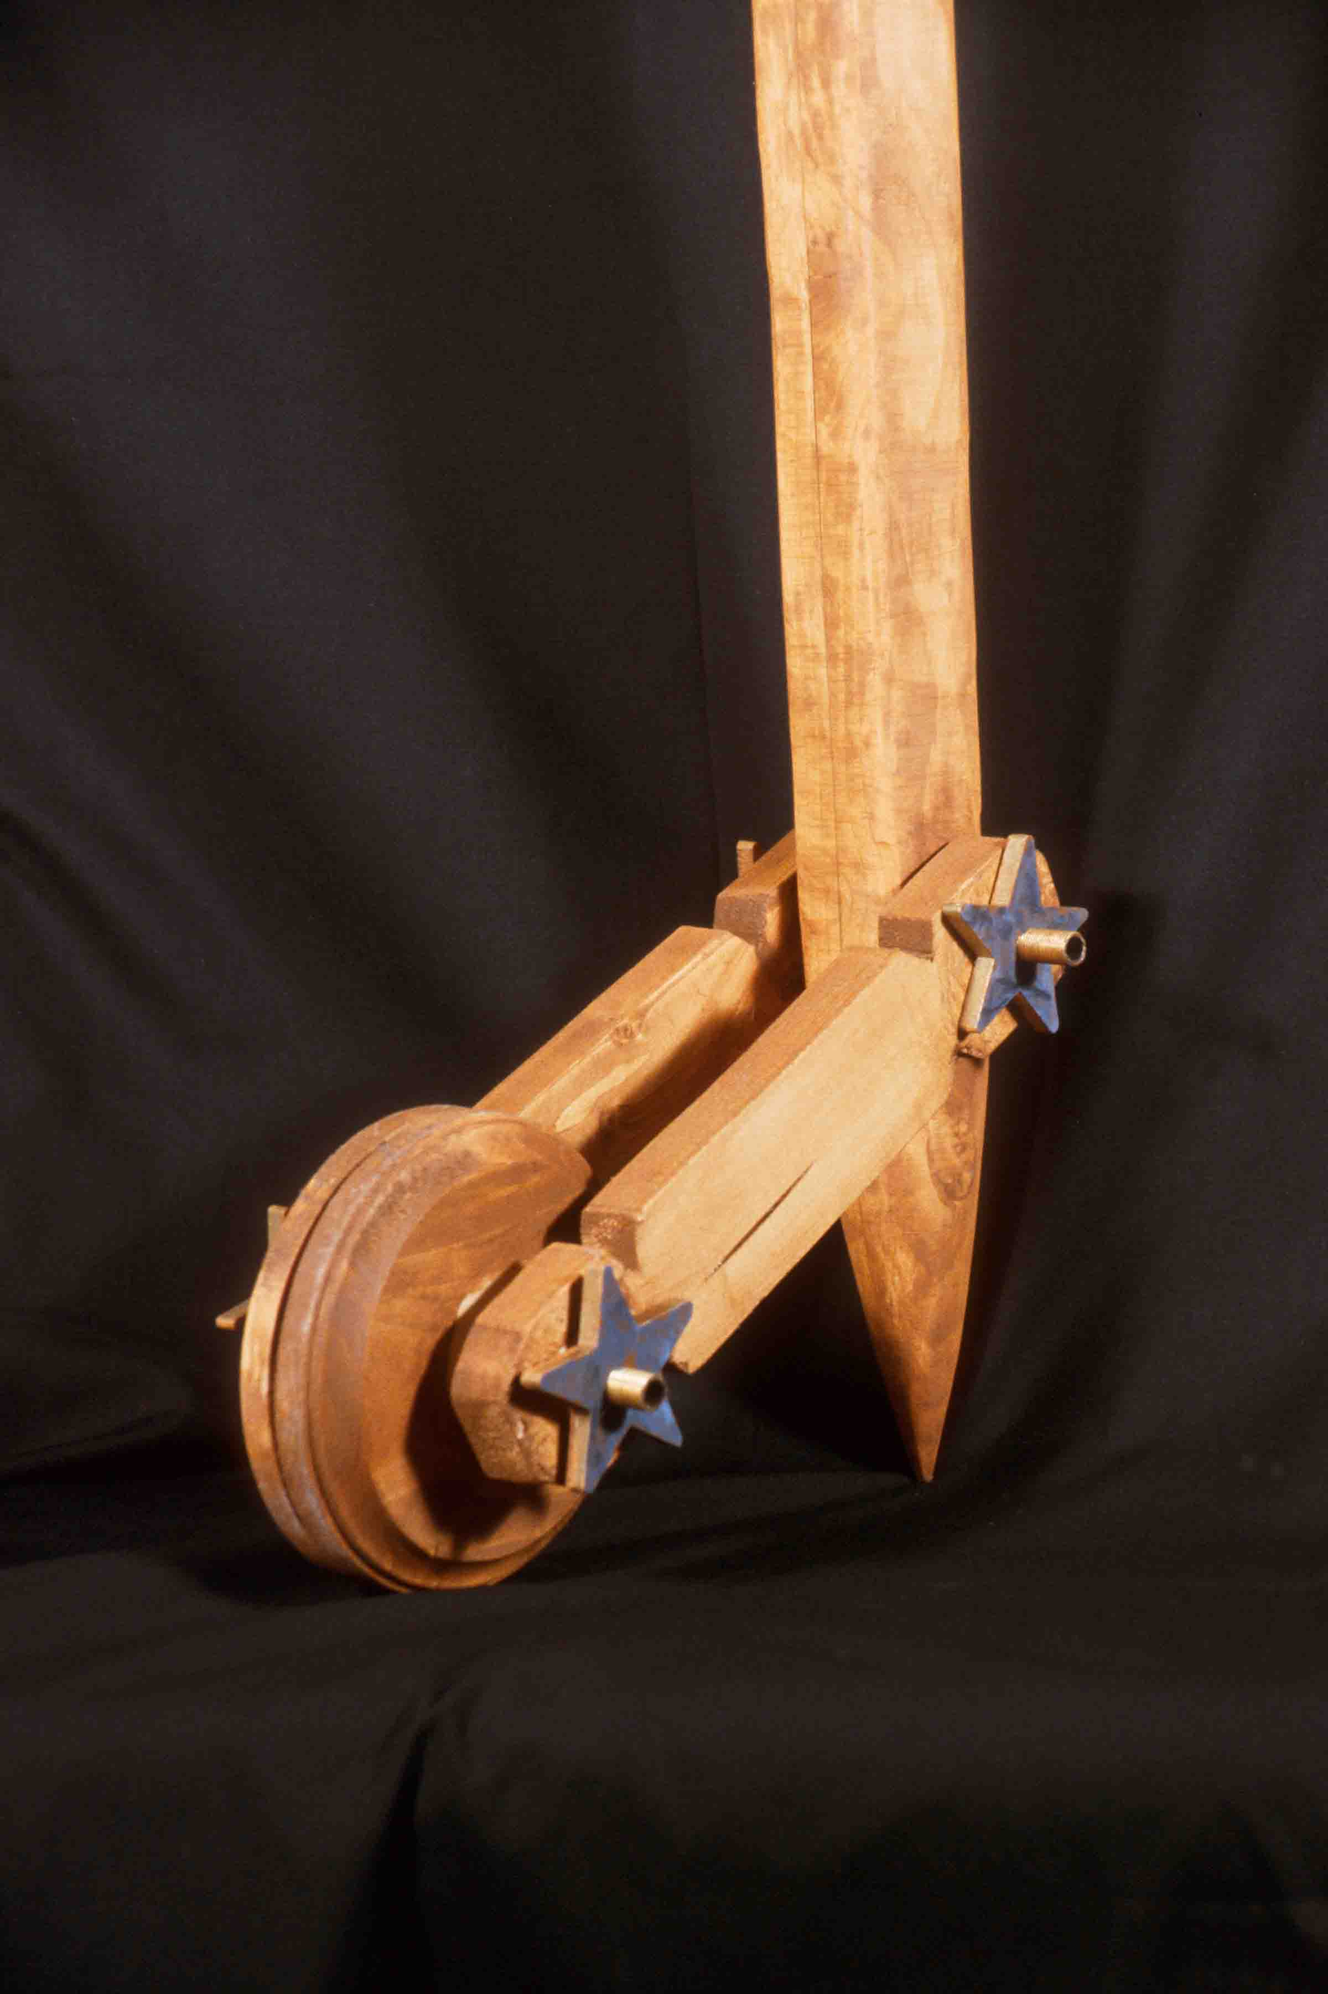
Assignment Criteria:
• Did you really transform the plank? Do we still "see" the plank, or do we now see a staff?
• Is it functional? Is there a good handgrip? Is the stick strong enough to provide support, but light enough to carry easily?
• Are the conceptual and compositional “connections” appropriate and effective?
• How about the craft, including sanding? Does the project meet an appropriate degree of refinement, detailing, etc.

Readings: Review Part 3

Timetable: 18-24 hours.

SUPERHERO MASK / HEADGEAR DESIGN
Assignment created by Anthony Fontana

Problem: Construct a mask or a piece of headgear that represents the attributes of:
- A person you consider your hero
- A superpower you would like to have (such as flying, x-ray eyes, etc.)
- A political or moral value you would stand up for.
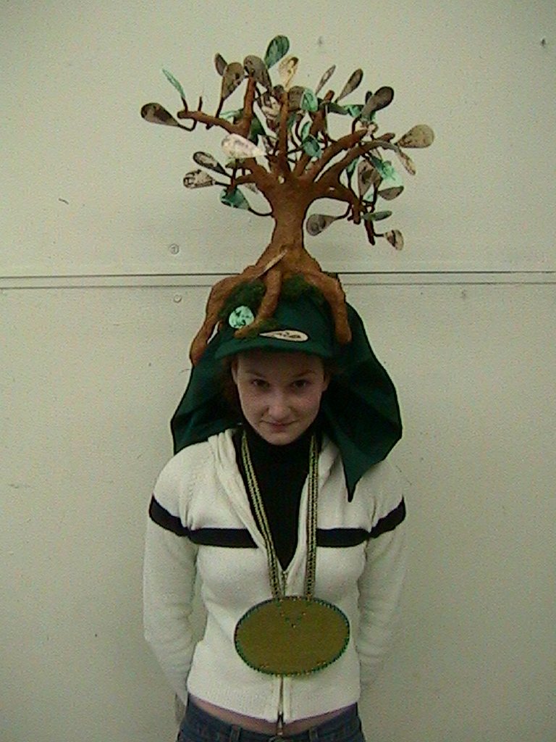
Some of the options can also be combined (example: combine a father as a hero, who was an anti-war protestor during Vietnam, and you can make “Father Peace.”) Each piece must be wearable, at time of presentation.

Objective:
• To explore new materials.
• To connect materials and meaning.
• To introduce an aspect of performance.

Strategy:
1. Brainstorm ideas. Come up with multiple solutions to the problem. Refer to LTI: Chapter Five. Any idea may be viable, no matter how strange it may seem!

2. Write a description of your Superhero. This may include a fictional or non-fictional history of the Hero, his/her attitude, personality, or general interests.

3. In your sketchbook draw out ideas for how to convey your concept in three-dimensional space. Do not limit yourself, but pay strict attention to what materials you will use to portray that superhero. For example the Man of Steel’s helmet would probably not be made out of yarn.
Consider ways to make your piece stand out from the typical comic book superhero. It can have moving pieces or multiple parts. Think about hairstyles and hat designs. Go to the library for research. You can also make an accessory object (such as a weapon) to go with your headgear. This would count as extra credit.

4. Once you have a design for your helmet or mask, do a drawing on 18”x24” drawing paper with colored marker or colored pencil. It should incorporate multiple views of the piece and may include the bio. This will be a companion piece for your project.

5. Gather the materials needed and begin assembling your artwork. Pay strict attention to detail. In the movies we don’t see the glue holding the Penguin’s nose on or a string holding Cyclops’s glasses to his head. Good craft helps make your mask believable.

6. Wear mask. Photos will be taken of you wearing your mask or headgear.

Instructor’s notes:
Have the students work in teams of three to four. Meet with the teams and have students share results from each stage.

Reading: Chapters 5, 7, 10, and 11 Timetable: 20-30 hours, depending on complexity

AUDIO ASSEMBLAGE
Assignment created by Anthony Fontana

Problem: Using found materials, create an assemblage that can be used as a musical instrument.

Objective:
- To explore ways to combine and unify disparate source materials.
- To connect art and music.
- To expand ideas through collaborative thinking.

Materials: Open: be inventive! Cardboard, chipboard, wood, wire, and plaster are all available for use. Collect objects from your daily habits to incorporate into the project.

Strategy:
1. Spend time listening to the sounds you hear on a normal day. The noise your shoes make on different surfaces, the sound of a soda popping as you open it or even the music of tearing up your junk-mail can be inspirational. Brainstorm in your sketchbook. Make at least 10 thumbnails of your ideas. Think about those things that make noise and how you could 1) make them into an instrument and/ OR 2) how they can be transformed into art.

2. Make a detailed drawing (18”x24”) of the purposed idea using color markers or pencils. Title your piece and give detailed descriptions of the purpose of each element. You can also include a smaller drawing of a reverse angle view of your piece.

3. Collect the objects you will need to make an instrument. Decide what materials you will use to connect or unify all the sounds together.

4. Begin construction of your instrument. Craftsmanship is VERY important! Remember, you are unifying all of your sound-making elements into one piece.

Reading: Chapters 5, 7, 10, and 12

Instructor’s Notes:
Have the students focus on creating a central area that produces a range of similar sounds. For example, different sized bottles can make similar sounds but at different tones.
Encourage students to collect items from their daily habits or routines. These objects can be used to produce sound or embellish your instrument.
Some students shy away from being loud or musical with their piece. Encourage them with lots of positive feedback and teamwork, as necessary.
Avoid the cliché! When unchallenged half the class may show up with glass bottles and a fork. Stress the importance of innovation!
Show slides of tribal, cultural, or electric instruments. Sometimes the redesign of an already familiar instrument can be very effective.
Introduce installation works. An audio assemblage does not have to be an object.

Timetable: 20-25 hours, depending on complexity.

MYTHS AND MASKS
Assignment created by Linda Vanderkolk, Purdue University

Problem: Create a three-dimensional wearable mask for a specific occasion. Use photocopied images to add content to your mask.

Objective:
• To transform planar material into a functional & representational 3-D object.
• To effectively use low relief and simulated texture as applied surface design.
• To effectively convey content.

Materials: White poster board, high-quality bond typing paper, heavy-duty paper stapler, glues, string or elastic, photocopier or scanner access and theme-related objects.

Strategy:
1. Brainstorming. Name activities during which masks are customarily worn. Name ceremonies, rituals, events, or traditions where masks are not worn but could be. Name daily events or common activities where you’ve never considered wearing a mask. Then select an occasion for your mask and the content of your mask. It may be serious, humorous, poignant or sarcastic.
2. Build your mask. Begin with a single sheet of 18”x24” poster board. Use paper manipulation techniques (cutting, scoring, curling, folding, tabs, etc.) to transform it into a three-dimensional form. Take measurements of your own head to insure your mask is wearable.
3. Surface embellishment. Create computer printouts or photocopies to apply to your mask. What interesting items (related to your content theme) could you copy? Consider these characteristics when selecting printed matter to apply to the mask’s surface:
visual or literal content value patterns
aesthetic interest repetition

illusionary 3-D Texture rhythm
negative & positive shapes style
computer or photocopy quality texture values

directional attributes inventiveness
You may wish to have more than one copy of some images. The textures/images should cover at least 70% of the mask’s surface. Some of your copied material should be applied in a manner that creates additional relief. If black paper is additionally allowed, it should cover no more than 30% of the mask. Think carefully about your mask’s composition and be sure to look at it from a variety of viewpoints. Faces are generally symmetrical. Does the mask’s form or surface decoration need to be symmetrical? When your mask is finished, attach strings so it may be worn or hung on the wall.
4. Give your mask a title that addresses the content of the mask. Write this title and your name on the interior of the mask.

Reading: Chapters 5 and 8

Instructor’s Notes:
• Show examples of artists who use titles to add content to their art.
• Show examples of art with simulated texture information that reinforces the artist’s content intent.
• Show examples of masks with textures and/or humor from various cultures (Native American, African, etc.), especially any with materials related to the masks’ purpose. Examine 2D mask patterns that become 3-D forms.
• Can the mask be constructed without the use of glue, tape, or staples? Heavyweight paper could possibly be substituted for the poster board. Students can practice with a sheet of 18”x24” newsprint, but stiffness will matter for some techniques. Best use of a single sheet may not mean starting with the center of the mask in the middle of the page. Use leftover paper for additional attachments. Students may wish to construct forms related to images they will be applying (watering-can nose, computer-shaped head, etc.)
• Have them look at the value pattern of their decorations from a distance.
• Rather than randomly or flatly adhering all copies to the mask’s surface, create new relief or emphasize the 3-D form with value choices. (Dark textures in areas relating to shadows on a form & lighter ones relating to highlights can strengthen the dimensional appearance). Inform them that only black and white will be allowed (or decide to allow color).
• Give due dates for completion of each step. Make copies outside of class time. Before applying textures, compare and critique construction, creativity, craftsmanship and form.
• Papers applied to the surface can reinforce weak construction.
• Caution students that no adhesives should show.

Topic for critique:
• Ask students to identify examples where the following have been used effectively:
texture shape rhythm
value line visual flow
repetition expression pattern

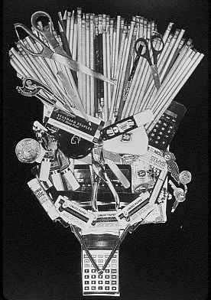

Timetable: 3 to 4 hours of class time, 2 to 5 hours outside of

BOOK TRANSFORMED
Assignment created by Linda Vanderkolk, Purdue University

Problem: Transform a used hard-covered book into a new object.

Objectives:

• To explore the original book’s form, construction method, and materials.
• To consider the book’s literal content as resource.
• To create a dramatically new form with a minimum of new materials.

Materials: Several used books, glue gun and glue and miscellaneous hand or power tools (e.g., awl, clamp, drill, sander, band saw, etc.)

Strategy:
1. You are limited to using the materials of one book and adhesives. Begin by thoroughly examining your book for its materials, content and form. List these aspects and any other physical characteristics or formal qualities you discover.
2. You may cut, tear, or otherwise rearrange any parts of your book to solve the problem. To jumpstart your imagination, visualize the results that these actions could have on a book:
remove crush wrap sew bend divide
bind bite glue sand shred cut
imbed scratch drill rip incise wedge
pleat Xerox fold explode cook coat
curl gouge staple crumple soak wax
score twist tape burnish weave nail
prick burn knot knit carve shoot
burrow patch erase mark sandwich intersect
alternate extrude skewer pleat peel elongate

You may find power tools helpful. If shop tools are used, be sure you have been taught how to use them safely.
3. Now that you’ve experience the variety of forms your new object can take explore a content related object or scene to depict. Use creative, elegant and/or subtle ways to address content instead of obvious stereotypes or cute clichés. Be sure to create a strong overall form rather than focusing only on decorative aspects. Forget how you are normally asked to treat books. Don’t forget that you are designing a new object!

Reading: Chapters 11 and 14

Instructor’s Notes:
• Introducing the problem before students select books will enhance the aesthetics and content of solutions.
• Schedule this to coincide with community book sales, give specific used book sources in your location, or buy bags of books at local library sales in anticipation.
• Encourage students to purchase several inexpensive books so they can experiment freely.
• Use hard-backed books only. Dissect one book in class to discover how books are made. Ask students to identify and list those aspects they specifically have to work with (i.e. absorbent, heavy, gilt-edged, flexible, delicate, miniature, mass, planes, colors, shapes, textures, lines, paper, cloth, cardboard, gauze, folds, corners, etc.). Use a preliminary book to experiment with cutting and construction methods. Consider subtraction, manipulation, addition, and rearrangement. List tools that may be applicable. If power tools are used, teach safety precautions. Specify exactly what you consider an adhesive. (Acrylic medium? Thread? Wax?)
• Show book-artist video segments (i.e. Inner-Views, 1986), slides of artwork incorporating books (i.e. Ann Hamilton’s text as balls of yarn), or imaginative handmade books for inspiration.
• “Straddling” is an idea that artists sometime use to increase viewer interest. (The transformational midpoint that connects both book and new object may be more intriguing than either ‘blatantly-still-a-book’ or ‘can’t-tell-it-ever-was-a-book’.)
• Remind them to consider the viewpoint, details, characteristics, etc. of their object depiction possibilities, rather than starting with their first thought. Ask that they sketch ideas before they begin transforming.
• This problem could be a partner or group assignment if time is limited.

Timetable: 2 to 3 hours of class time, 2 to 3 hours outside of class.

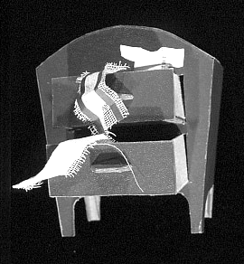

ABSTRACTED OBJECT FRAGMENTED
Assignment created by Rick Paul, Purdue University

Problem: Build a fragment of a common object out of Bristol board and other paper products. Even though your result is an accurate replica of an object fragment, the object it represents should not be recognizable.

Objective: The primary objective of this problem is to use your design skills to disguise an object and mislead the viewer. Through selection and a change in scale and materials, your object should be translated into a pure form, without a conceptual reference. In this project you will also learn the techniques and skills necessary for building a detailed object and practice ways of organizing work when solving complex problems.

Materials: Two ply Bristol board and glue or strong double-stick tape.

Strategy: The complexity of this problem requires a step-by-step procedure.
1. Select a unique and interesting object. Mechanical objects (can openers, staplers, tools) are especially well suited to this problem because they are generally dominated by crisp edges and definite masses. Organic objects (seed pods, fruit, sports equipment, etc.) are generally dominated by complex curves and thus more difficult to construct. Your object should be large enough to measure parts accurately to 1/32 of an inch.

2. Determine the fragment you wish to construct. Look for interesting joints and junctions, the overall flow between composite forms, variations in texture, and so forth.

3. Make your fragment by using flat planes to cut through the object. Using masking tape, mask off and eliminate the part of your object you are not building. Use the ground plane as a cutting plane, a dramatic surface from which you object rises. Cutting your object in a logical manner does little to disguise it, so cut your object in an unexpected way.

4. Make working drawings of your fragment from various viewpoints. These drawings should include accurate measurements.

5. Determine the scale for your construction. Your finished project should measure no more than 16 inches in one direction. With this in mind, divide the longest distance on your fragment into 16 to determine a scale multiplier. Use this multiplier and the dimensions on your working drawing to determine the size of the parts to be constructed.

6. Construct your solution. Complex fragments can often be made with one primary structure combined with smaller additions.

Reading: Chapter 9

Instructor’s Notes: This is a difficult problem that requires good organizational skills as well as good compositional skills. Carefully demonstrate cutting, scoring and gluing, especially showing how to glue a curved plane to a curved shape. Encourage students to use tabs where possible to expedite construction.
In developing the design, encourage your students to pay particular attention to the relationship between the primary structure and the base plane. The way in which the object is sliced at the base can make all the difference between a really imaginative solution and a more prosaic solution. Some designs may even extend out from the wall or down from the ceiling if constructed carefully enough.
Timetable: 12-15 hours. Allow two to three hours to introduce problem, determine fragment and make working drawings.
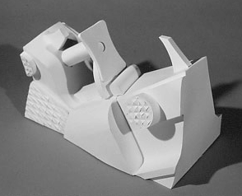

Abstracted Object – example of student work, squirt gun trigger.

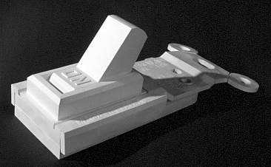

Abstracted Object – example of student work, light switch.

